SIMON DIEDONG DOMBO UNIVERSITY OF BUSINESS AND INTEGRATED DEVELOPMENT STUDIES

ASSESSING THE INCIDENCE OF FLOODS AND SOCIAL VULNERABILITY TO FLOODING IN THE WA MUNICIPALITY OF THE UPPER WEST REGION, GHANA

BENJAMIN NAAH

2023

SIMON DIEDONG DOMBO UNIVERSITY OF BUSINESS AND INTEGRATED DEVELOPMENT STUDIES

ASSESSING THE INCIDENCE OF FLOOD AND SOCIAL VULNERABILITY TO FLOODS IN THE WA MUNICIPALITY OF THE UPPER WEST REGION, GHANA

BENJAMIN NAAH

(MPHIL. DEVELOPMENT MANAGEMENT)

(PG0007421)

THESIS SUBMITTED TO THE DEPARTMENT OF GOVERNANCE AND DEVELOPMENT MANAGEMENT, FACULTY OF PUBLIC POLICY AND GOVERNANCE, SIMON DIEDONG DOMBO UNIVERSITY OF BUSINESS AND INTEGRATED DEVELOPMENT STUDIES, IN PARTIAL FULFILLMENT OF THE REQUIREMENTS FOR THE AWARD OF A MASTER OF PHILOSOPHY IN DEVELOPMENT MANAGEMENT

FEBRUARY, 2023

DECLARATION

Student
I hereby declare that this thesis is the result of my own original work and that no part of it has been presented for another degree in this university or elsewhere:

BENJAMIN NAAH ………………………. ……………………………

(Name of student) Signature Date

Supervisors
We hereby declare that the preparation and presentation of this thesis was supervised in accordance with the guidelines on supervision of thesis laid down by the Simon Diedong Dombo University of Business and Integrated Development Studies.

PROF. EMMANUEL KANCHEBE DERBILE ……………… …………….
(Principal Supervisor) Signature Date

DR. MICHAEL PERVARAH ……………………… ……………………….
(Co-Supervisor) Signature Date

ABSTRACT
The growing incidence of floods and its devastating impacts across the globe and all sectors is widely acknowledged. The dominant explanation for this trend is climate change and rapid urbanisation. Whilst some scholars are explicit about the causes and the devastating effects of floods, suboptimal representation is made on the incidence of flood and social vulnerability to flood. This study examined the effects of flooding and how vulnerability to flooding is socially differentiated in the Wa Municipality of the Upper West Region of Ghana. Using an exploratory sequential mixed methods approach, the study employed focus group discussions, key informant interviews and a survey involving 270 participants from selected communities in the Wa Municipality.The study revealed increasing incidence of flooding in the Wa Municipality and that this phenomenon is largely caused by inadequate drainage infrastrcutre and systems, inappropriate management of waste and poor planning of buildings. The major impacts of flooding include destruction of residential buildings, road infrastructure injury and disruption of household livelihoods. The findings also showed that households that are located within the 300m buffer zones are more vulnerable to flooding compared to those located on highlands. Furthermore, the study revealed that vulnerability to flooding varied among social groups with children being the most vulnerable, followed by women, the aged, the physically challenged and men, in that order. The study recommends that adaptation planning to floods through the local government system should prioritize and or target households settled along flood-prone river banks in the municipality with a special focus on children and women, the aged, and the physically challenged for achieving inclusiveness and sustainability in adaptation capacity.

ACKNOWLEDGEMENTS
The successful completion of this thesis came about as a result of immense contribution made by several people, without which the work would not have materialized. Therefore, I deem it necessary to express my profound gratitude to the following people:
I would first express my profound gratitude to the German Academic Exchange Service (DAAD), particularly the UBIDS Team for the award of scholarship and research grants for this study.
My optimum appreciation goes to my supervisors; Prof. Emmanuel Kanchebe Derbile, the Pro Vice Chancellar and Coordinator for the German Academic Exchange Service (DAAD), UBIDS and Dr. Pervarah Michael for their thorough supervision and priceless comments during the entire study process.
Particular thanks go to the households and key informants for their voluntary information which made it possible to accomplish this piece of work. I am grateful to my field assistants who assisted me to collect data from the field. Also, I am indebted to Kenneth Tengapoe for specialist assistance in the buffer zone analysis. A warm appreciation to all those who supported to see this thesis accomplished.
Glory be to Almighty God for a successful compilation of this thesis report.

DEDICATION
To the memory of my father, to my mother and the entire family for their support throughout my education.

TABLE OF CONTENTS

DECLARATION i
ABSTRACT ii
ACKNOWLEDGEMENTS iii
DEDICATION iv
TABLE OF CONTENTS v
LIST OF TABLES viii
LIST OF FIGURES ix
LIST OF ABBREVIATIONS xi
CHAPTER ONE 1
INTRODUCTION 1
1.1 Background of the Study 1
1.2 Problem Statement 4
1.3 Research Questions 8
1.4 Research Objectives 9
1.5 Significance of the Study 9
1.6 Scope of the Study 10
1.7 Organisation of the Study 10
CHAPTER TWO 11
LITERATURE REVIEW AND THEORETICAL FRAMING 11
2.1 Introduction 11
2.2 Incidence and causes of Floods 11
2.3 Flood and the Types of Floods 16
2.4 Effects of Floods 20
2.5 Social Vulnerability to Floods 23
2.6 Theoretical and Conceptual Framing 28
2.6.1 Indicator-based flood vulnerability 29
2.6.2 Action theory of adaptation 34
2.6.3 Conceptual framework 36
2.7 Conclusion 42
CHAPTER THREE 44
METHODOLOGY 44
3.1 Introduction 44
3.2 Study Area and Context 44
3.3 Research Methodology 47
3.3.1 Philosophical Underpinnings 48
3.3.2 Research Design and Processes 51
3.3.3 Methods of Data Collection and Analysis 54
3.4 Secondary Data Review 60
3.5 Research Validity and Reliability 61
3.6 Ethical Considerations 61
CHAPTER FOUR 63
DATA ANALYSIS AND DISCUSSION 63
4.1 Introduction 63
4.2 Data Analysis and Presentation 63
4.2.1 Socioeconomic Background of Participants 63
4.2.2 Incidence and Causes of Floods in the Municipality 65
4.2.3 Effects of Floods and Recovery 76
4.2.4 Vulnerability to Floods 86
4.3 Results and Discussions 106
4.3.1 Incidence and causes of floods in the municipality 106
4.3.2 Effects of floods and recovery 109
4.3.3 Social vulnerability to flooding in the Municipality 113
4.4 Conclusion 119
CHAPTER FIVE 121
CONCLUSION AND RECOMMENDATIONS 121
5.1 Introduction 121
5.2 Conclusions 121
5.3 Recommendation 122
REFERENCE 125

LIST OF TABLES
Table 2. 1: Effects of Flood 22
Table 3. 1; Sample frame and size 59
Table 4. 1; Sociodemographic characteristics of respondents 64
Table 4. 2: Incidence of floods 69
Table 4. 3: Causes of floods in the Wa Municipality 71
Table 4. 4: Effects of flood on households in the Municipality 77
Table 4. 5: Effects of Floods on Men 93
Table 4. 6: Effects of Floods on Women 95
Table 4.7: Effects of floods on children in the Municipality 98
Table 4. 8; Effects of floods on the aged 100
Table 4. 9; Effects of floods on the physically challenged 102

LIST OF FIGURES
Figure 2. 1; Indicator-Based Flood Vulnerability Analysis 29
Figure 2. 2; Action Theory of Adaptation 34
Figure 2. 3; Conceptual Framework 38
Figure 3. 1; Map of Wa Municipality 45
Figure 3. 2; Rainfall Pattern 46
Figure 3. 3; Exploratory Sequential Mixed Method Research (Creswell, 2009, 2012) 54
Figure 4. 1; Field picture showing flooding in Kumbiehi taken on 01/08/22 67
Figure 4.2: Pictures showing Buildings on waterways 73
Figure 4.3: Indiscriminate Dumping of Waste and Choked Drains 74
Figure 4.4: Lack of Constructed Gutters/Drains 75
Figure 4.5; Narrow Drainage/Gutters 76
79
Figure 4.6: Picture of Collapsed of Buildings 79
Figure 4.7: Effects of Flood on Farms in the Municipality 80
Figure 4.8; Difficulty in Accessing Road linking Mangu and the New Regional Market of Wa 82
Figure 4.9; Difficulty in Accessing other parts of Kumbiehi (01/08/2022) 82
Figure 4.10; Duration of households’ flood recovery 83
Figure 4.11: Map Showing Flood-prone Areas in Wa Municipality 87
Figure 4.12: Map Showing 300m Buffer Zones of Mangu and Kambali of Wa Municipality 89
Figure 4.13: Map Showing 300m Buffer Zones of Kumbiehi and Konta of Wa Municipality 90
Figure 4.14; Difficulty of School Children Accessing a Road 97

LIST OF ABBREVIATIONS
ADREM ……………………… Academy of Disaster Reduction and Emergency Management
CBD …………………………. Central Business District
FGDG ………………………. Focus Group Discussions Guide
FGDs ………………………... Focus Group Discussions
GDP ………………………… Gross Domestic Product
GIS …………………………. Geographic Information System
GMet ………………………... Ghana Meteorological Agency
GSS …………………………. Ghana Statistical Services
IBFEWS …………………… Impacts-Based-Flood-Early-Warning-System
KIIG ………………………. Key Informant Interviews Guide
KIIs ………………………... Key Informant Interviews
NADMO ………………….. National Disaster Management Organisation
PPD ……………………….. Physical Planning Department
SPSS ……………………… Statistical Package for Social Sciences
UN ………………………... United Nations
UTM ……………………… Universal Traverse Mercator

CHAPTER ONE

INTRODUCTION

1.1 Background of the Study
The global incidence of floods is widely acknowledged. Flooding as a climate-related natural disaster is devastating all sectors across space (Mensah & Ahadzie, 2020; Ochieng et al., 2017). It has increasingly become an issue worldwide due to its undesirable spatial, social, economic, and environmental impacts (McLennan, 2021; Mensah & Ahadzie, 2020). The impacts of floods are felt by both developed and developing countries. Since 1980, 4,588 flood disasters have been recorded across 172 countries where more than 250, 000 people lost their lives, and damage exceeded $ 1 trillion, accounting for 40% of natural catastrophic losses during that period (McLennan, 2021). In 2019, the world recorded 143 major floods which accounted for more than 45% of the total major disasters of the year (ADREM et. al., 2020) of which Asia recorded the highest statistics with 42 floods across 22 countries while Africa experienced 38 floods across 21 countries (ADREM et al., 2020; Red Cross, 2020) and the United States suffered economic losses of more than $20 billion from flooding in 2019 (ADREM et al., 2020). Likewise, flooding has extremely devastating effects on physical structures and further degrades the economic position of people residing in low areas and informal settlements (Kikwasi & Mbuya, 2019).
Urban vulnerability to flooding increased by 1,000% in Europe over the past 150 years while Sub-Saharan Africa lost an amount of US$300 billion to floods in 2017 (Jongman, 2018). Despite the catastrophes of flooding, its risks are systematically undervalued and societal disregard of flood risk contributes to underinvestment in flood protection and inadequate purchasing of insurance (McLennan, 2021). Globally, the trend of urbanisation in flood areas has been steep and continues to increase, mostly in Asia and Africa (Jongman, 2018).
Urbanisation has become a global challenge transforming human settlements. Urbanisation increases the frequency of run-off during a heavy downpour in cities because the available drains lack the capacity to manage the high run-off. This results from man-made alterations in the hydrology through agricultural activities and the development of watercourses. The construction of housing and road infrastructure endorses the restriction of floodplains and increases waterproof surface areas. Thus, the development of houses, roads, and railway lines, without adequate drainage channels, tends to divert movements of run-off to other areas (De Silva & Kawasaki, 2020; Pyatkova et al., 2019).
Urban areas are locations where basic services, infrastructure, ecological systems, and people relate in close quarters. Thus, as a result of the inherent proximity in urban and peri-urban communities, risks arising from meteorological disasters like floods and the causal vulnerabilities which increase them, tend to affect more residents and easily have knock-on effects (UN-Habitat, 2019). Many urban and peri-urban communities located in vulnerable zones are exposed to inundation. Howevre, these areas provide some economic opportunities such as fertile farmland, resource for economic development and water, and serve as corridors for transport (John, 2020; Mavhura et al., 2017; UN-Habitat, 2019). This supports the projection that the world’s urban population of 71% (2.8 billion people) will be living in low lying zones, described as those located less than 10 meters above mean sea level by 2025. Meanwhile, the sea level is projected to rise to 98 millimetres by 2100 (UN-Habitat, 2019). This means that the rise in sea level is a threat to both urban and peri-urban communities across borders.
In Africa, floods affected 7 million people and 1,273 lives were lost, the highest number ever since 2006 (Red Cross, 2020). Arguably, spatial design has been frequently blamed for the failure to exert effective adaptation strategies in reducing climate change impacts in urban Africa (Cobbinah et al., 2019) because the main causes of flooding in secondary cities are revealed to be poor urban design and development, poor and inadequate drainage systems, poor environmental attitude and extreme rainfall (Mensah & Ahadzie, 2020; Rainey et al., 2021).
In Ghana, the incidence of floods is virtually annual, which adversely affects livelihoods and infrastructure, causes injuries and loss of lives and displaces many residents (Husain et al., 2018; Mensah & Ahadzie, 2020; Sarmah et al., 2020). Ghana exprienced an exceptional flood incident in November 2010, affecting fifty-five communities which rendered 700,000 residents homeless. This flood also affected 3,234 houses and submerged about 23,588 farmlands. The estimated economic lost of the November 2010 flood was about $116,340.22 (Mensah & Ahadzie, 2020). Similarly, on 3rd June 2015, the fire-flood disaster in Ghana claimed about 152 lives and destroyed other livelihoods(Mensah & Ahadzie, 2020). The incidence and intensity of floods in Ghana have increased in recent years, affecting millions of people and causing an increase in economic losses as well as poverty. The increasing urban sprawl coupled with inactive urban planning systems(Cobbinah et al., 2019) has made urban and peri-urban communities more vulnerable to the current and anticipated impacts of climate-related disasters. Climate change and changes in the physical environment have exposed many communities to flooding and significant spatial and social constraints in adapting to floods. The scales of exposures generate vulnerability with several forces that restrict adaptive capacity in both urban and peri-urban communities (Napogbong, 2019), whilst anthropogenic radioactivity has altered the global water cycle, and more intense and extreme precipitation associated with flooding is expected worldwide (Hirabayashi et al., 2021).
Given the exposure and vulnerability of communities, adaptation to flooding is mandatory. Although floods are affecting inhabitants, social vulnerability to flooding is not well understood in Sub-Saharan Africa. Social vulnerability has been described to include the demographic and socioeconomic elements that affects the resilience of a household (Flanagan et al., 2011). In disasters like floods, the socially vulnerable are most likely to be adversely affected and have low recovering capacity. When social vulnerabilities to flooding are effectively addressed, it will reduce the human and economic losses. This study contributes to an understanding of social vulnerability to flooding in the Wa Municipality and how such understanding can inform local-level planning for reducing disaster vulnerability.

1.2 Problem Statement
The incidence of extreme meteorological conditions across the globe demonstrates the uneven impacts of flooding in cities, even within a comparatively small settlement (Nur & Shrestha, 2017; Thomas et al., 2019). Climate change exacerbated by human activities has contributed to the increasing flood vulnerabilities in households worldwide (Hirabayashi et al., 2021; Pathak et al., 2020). Flooding has damaged lives, livelihoods, and infrastructure and degraded the environment. Urban communities that reside in low areas, close to rivers, and highly susceptible areas are those extremely exposed to flooding(Munyai, 2017). Whilst other scholars in urban development planning and management have been explicit about the causes of flooding(Manawi et al., 2020; Mensah & Ahadzie, 2020), and the devastating effects or impacts of floods within the urban landscape (Ara, 2019; Echendu, 2020; Husain et al., 2018); suboptimal representation is made on social vulnerability to flooding in secondary cities (Boakye et al., 2018; Dottori et al., 2020; Nassor & Makame, 2021) particularly Ghana, in the growing incidence of urban sprawl (Coq-Huelva & Asián-Chaves, 2019; Rubiera-Morollón & Garrido-Yserte, 2020; Yiran et al., 2020).
The vulnerability of a household to flooding is the result of poor quality and quantity of building materials which are mostly influenced by income, location of the houses, and inadequate drainage system(Kiowas & Mbuya, 2019; Shah et al., 2020). Farmers are largely recognized as the most vulnerable groups due to the susceptibility of most farmlands and the ineffective post-flood management strategies (Ara, 2019). Farmers' vulnerability to flooding could be climatic (drought, rainstorm, and floods) or non-climatic (sand mining and bush fires) which is exacerbated by urbanization and its related consumption patterns in housing demand (Derbile et al., 2021). Also, low socioeconomic values have aggravated the vulnerability of most communities (Munyai, 2017). A study revealed that socioeconomic and demographic characteristics, building materials, past floods experience, and social networks are the major factors influencing vulnerability to flood in Pakistan (Shah et al., 2020). Mavhura et al. (2017) found that the biophysical vulnerability of a community was partially influenced by the construction of a dam whose basin encroached farmlands and the built-up area and the inhabitants both upstream and downstream suffered high vulnerability to flooding.
Flood vulnerability has serious impacts on social, health, cultural, economic, and environmental well being and affects sustainability of development (Kim et al., 2017), mostly in undeveloped countries like Ghana where poverty is high, coupled with poor urban planning and development (Cobbinah et al., 2019). Flood vulnerability is the function of sensitivity, exposure, and the ability to adapt. A lower capacity to adapt relative to susceptibility, and exposures results in higher vulnerability, whilst a higher capacity to adapt lessens the impacts susceptibility and exposures and has the chance of minimizing vulnerability (Thomas et al., 2019). The levels of flood vulnerability vary greatly among the individuals within the community and in households. Evidence showed that communities' and households' vulnerabilities to flooding are shaped by their biophysical impacts of flood tragedies and the limitation inherent in the adaptive capacity and social susceptibility of the residents. Thus, the poor and marginalized groups are mostly vulnerable due to their low resource status to adapt (Nur & Shrestha, 2017). This has prompted scholars to investigate the coping, mitigation, management, and adaptation strategies to flooding (Mohanty et al., 2020; Mondal et al., 2021; Nassor & Makame, 2021; Rainey et al., 2021). Communities or individual households employ various strategies to control and manage flood disasters. Studies found that urban authorities resort to demolishing houses in areas of extreme vulnerability while encouraging resettlement of residents from flood-prone areas (Elliott et al., 2021; Owusu & Obour, 2021). This action is reactive rather than proactive and may disrupt the social networks of households, individuals, and their livelihoods. Nassor and Makame (2021) found that communities adapt to flooding by temporary relocation, construction of platform around houses, building of steps at the entrance as barriers, using car tires to block water, and arranged stones and sand-bags around houses, whilst others construct fence walls around their houses, and create local minor drainages, and erect walls of steel and concrete or blocks and mortar to mitigate penetration of the water into their homes in Tanzania.
Afriyie et al. (2018) in their study on weather extremes and households’ asset vulnerability and adaptation in rural Ghana found that households’ assets such as farmlands, housing, human health, and financial investments were vulnerable to flooding. Their findings unveiled that households were actively adapting by receiving early warning flood information, adapting various methods of farming, and by diversifying their livelihoods. Owusu and Obour (2021) uncovered that some urbanites in Ghana controlled floods water by desilting drainage canals, while others located on or near floodplains temporarily vacate their homes during the rainy seasons. The authors added that urbanites resort to the erection of temporary structures like wooden structures or containers to erection of expensive and permanent buildings. Some urban communities’ and inhabitants’ coping strategies include relocation and protection of assets as well as construction of drainage canals(Mensah & Ahadzie, 2020). Flood adaptation strategies employed at the household level play a significant role in reducing communities’ vulnerability. Effective flood adaptation actions demand a comprehensive knowledge about the effects and vulnerability of the inundation on the livelihoods of residents, particularly the poor who are more vulnerable.
Since most of the studies on flood vulnerability were conducted in other Sub-Saharan African countries (Hamidi et al., 2022; Hosseini et al., 2021; Naz & Saqib, 2021; Pathak et al., 2020), there is a significant demand for empirical exploration on the social vulnerability to floods in Ghana. In Ghana, the few studies conducted on flooding have not looked at the social vulnerability to flooding. These studies were centered at the southern zones of Ghana. For instance, Mensah and Ahadzie (2020) methodologically reviewed the causes of floods, the impacts of floods and the coping methods in Accra, while Owusu and Obour (2021) and Boakye et al.(2018) were interested in households’ adaptive strategies to flooding in urban communities in Accra, Twum and Abubakari (2019) focused on the factors that determine the households’ flood coping strategies in informal Accra, and Poku-Boansi et al. (2020) explore the smart options for the management of flood menace in the informal zones of Accra. Almoradie et al. (2020) assessed the existing flood controlling practices to identify the lapses as well as the opportunities that can improve resilience in Ghana. Ansah et al. (2020) showed interest in the meteorological investigation of flooding in Ghana. Others like Dekongmen et al. (2021) assessed flood vulnerability in the Accra Metropolis and Afriyie et al. (2018) were most interested in climate extremes and families’ livelihoods vulnerability and their adaptation in the rural areas of Ghana, whereas Derbile et al. (2021) analysed smallholder famers’ vulnerability to various ecological stressors in the Wa Municipality.
Despite the growing investigations on flood vulnerability, geographically little is known about the incidence of flood and social vulnerability to floods in Ghana, especially, by location of settlements, gender, children, the aged and the physically challenged. Because vulnerability to flooding is spatially and socially differentiated, and the effects of floods is unevenly distributed among households, understanding the differences in households’ vulnerability to floods among men, women, children and the aged is vital for planning flood adaptation for creating sustainable communities. Therefore, this study explored the incidence of social vulnerability to floods and the implications for sustainable adaptation strategies in the Wa Municipality of the Upper West Region, Ghana.

1.3 Research Questions
What is the incidence, cause and effect of flood, and how is vulnerability to flooding socially differentiated in the Wa Municipality of the Upper West Region, Ghana?

Sub-Questions
- What is the incidence of flooding and causes of floods in the Municipality?
- What are the effects of floods on the socioeconomic development of the Municipality?
- How is vulnerability to flooding socially differentiated in the Municipality?

1.4 Research Objectives
This study seeks to explore the incidence, cause and effect of flood, and how vulnerability to flooding is socially differentiated in the Wa Municipality of the Upper West Region, Ghana.
Sub-Objectives
- To assess the incidence and causes of floods in the Wa Municipality
- To examine the effects of floods on the socioeconomic development of the Municipality
- To examine the social vulnerability to flooding in the Municipality

1.5 Significance of the Study
The exploration is expected to be of immense significance to policymakers, urban practitioners, and researchers. Firstly, the study will help policymakers, particularly the local government and rural development with valuable information to enhance a course of action that will improve upon spatial planning, management of urbanization in the changing climate, and effective adaptation to floods. Second, the study will unearth supporting and limiting factors for effective collaboration among urban planning and development institutions to improve flood adaptation strategies toward making cities and human settlements inclusive, safe, resilient, and sustainable. Finally, it is envisaged that this investigation contribute knowledge to the current discussion on social vulnerability to flooding.

1.6 Scope of the Study
This study was geographically carried out in Wa Municipality, Upper West Region, Ghana. The Municipality has been experiencing perennial flooding in every raining season. The Wa Municipality situational report on floods in 2018 revealed that, many houses, farms and roads were submerged in the floodwaters. The most flooded areas within the Municipality were Mangu, Kambali, Kpaguri, Kumbiehi, Chokor, Dobile, Konta and Water Village (New Hospital Area). Over 1,439 persons were displaced across the Municipality while 120 houses with 734 rooms were affected (NADMO-Wa, 2018). This has necessitated the study on how residents of the Municipality are adapting to the situation.
Contextually, the investigation emphasizes on the incidence and causes of floods, the effects/impacts of floods on the socioeconomic development, and how vulnerability to flooding is socially differentiated within the flood-prone segments in the Wa Municipality.

1.7 Organisation of the Study
This study is organised into five Chapters. Chapter one focuses on the background of the study, problem statement, research questions and objectives, significance and scope, and organisation of the study. Chapter two contains a review of relevant literature, theories and presentation of a conceptual framework of the study. The profile of the study area and methodology are presented in Chapter three. Chapter four contains the results and discussion. Chapter five presents the conclusions and recommendations of the study.

CHAPTER TWO

LITERATURE REVIEW AND THEORETICAL FRAMING

2.1 Introduction
This chapter presents a review of relevant literature on vulnerability, floods, types of floods, adaptation, adaptive capacity, the incidence of floods, and the causes, impacts of floods. The chapter further presents a review of relevant theories (Indicator-Based Flood Vulnerability Analysis and Action Theory of Adaptation) that underpin the study. The section concludes with a conceptual framework that guides the study.

2.2 Incidence and causes of Floods
Incidence of floods
Globally, ﬂooding has been a threat to human health and security, and livelihoods due to climate change(Adelekan et al., 2015). Evidence demonstrations that the proportion of the population affected and the economic or livelihood damage due to flood hazards are increasing at an alarming rate (Ara, 2019; McLennan, 2021). This increment is a result of the global climate change giving rise to temperatures resulting in a warmer climate. Global temperature is projected to increase at an average of 2.1°C by 2050 (Naazie et al., 2021). The rise in temperature by anthropogenic radioactivity has altered the global water cycle resulting in more intense and extreme precipitation-associated flooding worldwide(Hirabayashi et al., 2021). Extreme precipitation upsurges the likelihood of ﬂoods incidence as a result of the intensity in the universal water cycle anticipated under climate change (Adelekan et al., 2015; Hirabayashi et al., 2021). The rainfall intensities, timing, volume, precursor situations of a river and the drains (Şen, 2018), as well as the infringement of valleys (Aabeyir & Aduah, 2014; Wahab & Falola, 2017) and inadequacy of flood response plans, have the potentials to increase flood damages. Other factors contributing to ﬂooding incidence include unplanned rapid urbanization, poor watershed management, and alteration in land cover, particularly in ﬂood plains(Adelekan et al., 2015).
Flooding incidence across the globe has made a remarkably negative impact across all sectors in both developed and developing countries (McLennan, 2021; Munyai, 2017). Floods claim many lives and increase economic losses in the world compared to other hazards. Flood disasters since 1980, have been recorded across 172 countries and more than 250, 000 lives were claimed and the damage exceeded $1 trillion, accounting for 40% of natural catastrophe losses (McLennan, 2021). The United States in 2019, suffered economic losses of more than $20 billion from flooding (ADREM et al., 2020). Evidence also specified that flood disasters are the main threat to the global Gross Domestic Product (GDP) (Munyai et al., 2021). These are context specific, which means their impacts as well as vulnerability depends on exact situation. This specifically highlights need for assessment of flood vulnerability at all sectors including individuals, households, communities, districts, and regions (Munyai, 2017; Munyai et al., 2021). Urbanisation and settlement development have increased the extent and frequency of flood incidence(Adelekan et al., 2015; Munyai et al., 2021). Across the world, many countries, regions, and households are exposed to flooding due to their geographical locations to watercourses and lowlying areas which normally exacerbate flood vulnerability(Munyai, 2017).
A floodplain is an even surface adjacent to a mainstream canal which is occasionally flooded by floodwater (Şen, 2018). The flood-prone areas are land adjacent to a river, valley, or stream that is exposed to periodic inundations. Flood increases several distresses to households settling adjacent the main watercourses. Urban development and agricultural activities have positioned many buildings, households, and livelihood structures on flood-prone areas. In most countries, sensitive natural landscapes are replaced with physical structures such as roads, and buildings and ecologically unfriendly activities like mining, and farming among others rendering the natural land system less able to control runoffs during heavy downpours resulting in flooding (Şen, 2018). Thus, the development of houses, industry, public buildings, and farms on floodplains creates room for flood disasters. Aabeyir and Aduah (2014) argued that the encroachment of floodplains is a result of the economic benefits inhabitants derive.
The African continent is ranked second after Asia in flood disasters in relations to the flood events, the affected areas, and the magnitude of human and livelihood destruction (Ansah et al., 2020). This is because, in most African cities, poverty, informality, and societal susceptibility to inundation events are inseparable(Amoako et al., 2017; Munyai, 2017). In 2009, a torrential rainfall affected about 600,000 people across 16 West African Countries and the largely impacted countries were Senegal, Niger, Burkina Faso, and Ghana (Ansah et al., 2020). Africa's flood vulnerability has been to some extent linked to the unplanned urban development, urban poverty, and encroachment of streams (Adelekan, 2015; Amoako et al., 2017). This makes many African countries more vulnerable to flooding and incapable of coping with, mitigating or preventing the impacts. The socioeconomic factors like household’s income, employment, dwelling types as well as the spatial features of African countries which include the relief features and drainage capacity also contribute to flood disasters(Munyai, 2017; Munyai et al., 2021). South Africa's exposure to flooding is 83.3% possibility of floods occurring in a given year and the levels of vulnerability are largely high due to socioeconomic and geographical factors (Munyai et al., 2021).
Ghana has been experiencing perennial flooding which devastates lives, livelihoods, and infrastructure and displaces many inhabitants (Husain et al., 2018; Mensah & Ahadzie, 2020; Sarmah et al., 2020). Ghana in 2010 recorded an unprecedented flood incident that affected 55 communities and displaced 700,000 people, destroying 3,234 houses while 23,588 acres of farmlands were submerged. The total loss was estimated by NADMO to be US$116,340.22 (Mensah & Ahadzie, 2020). Similarly, in the history of Ghana, the most devastating flood incidence was recorded on the 3rd June 2015, when there were heavy rainstorms coupled with an explosion which claimed about 152 lives, destroy livelihoods, and displaced many inhabitants (Mensah & Ahadzie, 2020; Ansah, et al., 2020). This gives credence to the ranking of flooding as second after epidemics to natural catastrophe in Ghana (Dekongmen et al., 2021; Owusu & Obour, 2021). However, it is exacerbated by the increasing urban sprawl coupled with inefficient urban planning systems (Cobbinah et al., 2019) making urban and peri-urban communities located in floodplains more vulnerable to the impacts of the current and anticipated flood. Flooding in Ghana has become a perennial issue in the urban, peri-urban and the rural communities. Communities located in lowlying areas like rivers basins, lakes, and coasts, are potential flood-prone zones and are more susceptible to flooding (Dekongmen et al., 2021). Climate change and the physical environmental changes have exposed many communities to flooding and significant spatial and social constraints in adapting to flood hazards. In the coastline of Ghana, the occurrence of floods has increased, and residents found it difficult to cope due to the variability in rainfall patterns (Dekongmen et al., 2021). The incidence and intensity of floods have increased in recent years in Ghana affecting millions of people and causing an increase in economic losses as well as worsening poverty levels.
Causes of Floods
Floods are mainly caused by the quantity of precipitation and its distribution in the drainage zone. There are three elements influencing the occurrence of floods which include; the intensity of rainfall, the features of drainage basin, and the subsurface of the soil and ecological compositions (Şen, 2018). Generally, floods can be ordered based on the events of their occurrence. For example, winter rainfall floods, snow-melt floods, seasonal convectional storm-induced floods, sea surge and tidal floods, rising groundwater floods, tsunamis, urban sewer floods, dam-break floods (Schanze et al., 2006). These are threats in areas of human concentrated settlement otherwise there is less risk in natural ﬂood-plains (Şen, 2018). Scholars have discovered varying causes of floods in the rural, peri-urban and urban settlements. Adetunji and Oyeleye (2013) found that there are poor waste management practices among the populations of Apete which blocked the inadequate drainage systems available, and a high rate of housing construction along watercourses causing flooding. Similarly, Mensah and Ahadzie (2020) specify that the main causes of flooding are poor and inadequate drains, poor urban planning, poor environmental attitude, and excessive precipitations. Ilam-Vazhuthi and Kumar, (2020) ascertained that flooding is caused by urbanization and meteorological factors. Amoako and Boamah (2015) classified the causes of floods into three dimensions; the intensity of rainfall and improper management of run-off water, urbanisation and slum development, and the impacts of climate change and variability. Ansah et al. (2020) employed the weather research and forecasting model to explore the meteorological conditions of flood and discovered that low surface pressures with a significant quantity of moisture influx gave rise to storms increase recording rainfall of 114.6 mm and 90.1 mm in Kumasi and Accra respectively. Hirabayashi et al. (2021) stipulated that an increasing anthropogenic radiative force has changed the water cycle of the universe and is projected to result in extreme precipitation related flood. Floods are produced by the combination of two distinctive primary and secondary physical causes (Şen, 2018). The main ingredients necessary for the primary causes are the intensity of rainfall, durations, excessive rainfall, while the characteristics of the drainage system such as the geomorphology, geology, and vegetation are the secondary causes. The essential elements are the drainage area, the density of the drain, slope, the channel length, and the duration of concentration, among others (Şen, 2018). The researcher, therefore, categorises the causes of flooding into climate-related conditions (comprising of meteorological and hydrological factors) and urbanisation which comprises all human activities including farming that influence climate change and intensify the incidence of flooding.

2.3 Flood and the Types of Floods
Flood is a natural menace widespread across the globe. Floods are described to be a transitory covering of land by water that is outside its usual limits. They happen in both huge and small rivers and at the coast (Schanze et al., 2006). A flood is viewed as excess water ﬂowing onto previously drylands which is often associated with heavy rainfall (Doswell, 2003). In the same view, a ﬂood is water overﬂowing from a river, stream, or main canal into areas that does not usually experience inundations. Şen (2018) described flood as an extreme runoff water after an intensive rainstorm incident on a drainage basin. There are two main elements in this definition; the occurrences of floods are based on rainfall intensity and the features of the drainage system. A flood is the abundance of water that runs speedily and covers a large land size, which has never been flooded before (Hosseini et al., 2021).
This study identifies with the perspective of the flood as the abundance of water after intensive rainfall on the land surface more than the carrying capacity of the natural and man-made passage systems such as the rivers, valleys, streams, canals, gutters, or culverts. A flood is water that overflows the boundaries of the waterway or valley, and other water basins. It is the accumulation of runoff water after a heavy downpour over areas that are normally not submerged. This becomes a threat in densely developed settlement or human activity intense areas resulting from land-use and urban sprawl.
Types of Floods
Naturally, flooding presents various degrees of hazard to individuals, assets, and the environment, and is differently categorized due to the location, the velocity and depths, duration and other threats related to flooding (Schanze et al., 2006; Şen, 2018). Various scholars have categorized floods based on the differences in situations that trigger the flooding. The different types of flooding have different potentials to damage humans and livelihoods due to the characteristics of the process, natural conditions of the affected areas, and the vulnerability of the exposed elements(Şen, 2018). The common types of floods acknowledged in this study include; coastal flood/storm surge, river/fluvial flood, and flash/pluvial flood (Attipoe, 2014; Bubeck et al., 2017; Miller & Hutchins, 2017). In brief, Okaka and Odhiambo (2018) explained flash floods as flooding that occur from a short intensive rainfall, and river flood happen as a result of rivers overflowing their banks, whilst coastal flood mostly result from a combination of high tides or storms.
Coastal inundation is the seawater covering the land areas within the coast. This occurs when the water level of the sea increases above its normal, and mainly result from rainstorm causing an overflow onto the land(Okaka & Odhiambo, 2018). It results from a combination of factors such as high tidal levels and rainstorm resulting from low-barometric pressure worsened by strong winds. The coastal zones are mostly submerged resulting from waves overflowing the defence or severe tsunamis, or tropical cyclones. The impacts of coastal floods increase contingent on the storms the occurrence during an increase in tides. This type of flood normally overwhelms low-lying lands and often causes loss of life and properties(Attipoe, 2014).
River or fluvial floods, unlike flash floods, usually unfold over days or even months. Several flash flood events can occur within a river flood. The hydrological features mostly contribute to the incidence of fluvial but fluvial floods most often are not that subtle to them compared to flash floods. While specific rainstorms may result in flash floods, river floods are typically results from unchanging weather pattern (Doswell, 2003). The river flood is also referred to as a basin-wide flood. The main trigger of river floods is heavy rainfall along with snowmelt that lasts for a long duration often for days or weeks while filling the basin area. As a result of the high accumulation of water, the soil water retention capacity reaches its marginal utility and the drainage system of the basin overflows its banks (Nazeer, 2019). River floods arises when the carrying capacity of a the river is exceeded, the excess water flows into the adjacent low lands or floodplains. The incidences of fluvial or river flooding depend on some features like the forms of the flooded area and the climatic situations which are exacerbated by anthropogenic actions like deforestation due to urbanisation contributing to a river flooding through the increase in surface runoff (Attipoe, 2014). River or fluvial flooding occurs when there is an increase in the levels of the water in a river, lake, valley or stream, which overflows its boundaries onto the adjacent banks and neighbouring areas. The severity of a fluvial flood can be determined by the duration and intensity of rainfall in the river catchment area. Miller and Hutchins (2017) noted that, fluvial inundating is a normal course crucial for any active river or floodplain systems but indication shows that urbanisation has increased the magnitude and the incidence of flooding. Similarly, this type of flood that occurs along the rivers is a natural event. These types of floods happen when there is spring rain combine with molten snow and the river basins overflow banks. River floods also result from heavy rainfall for a prolonged period of days over a large area (Rashetnia, 2016). The occurrence of fluvial floods depends on the interaction between the depth of the river and its capacity to discharge the volumes of runoff water that flows per time unit. Also, these factors depend on the dimension of the river and the slope of the river’s passage. It occurs when the river discharge increases giving rise in the height of the water level such that it overflows the river banks(Attipoe, 2014). Thus, fluvial floods arises when the river is filled above its carrying capacity by snowmelt, rainfall, or excessive runoff from upstream.
Flash or pluvial floods are among the unpredictable disasters for individuals to evacuate due to their rapid onset and destructive features(Fujimi & Fujimura, 2020). Pluvial flooding emerges where surface runoff exceeds the infiltration rates and drainage capacity often during high-intensity short-duration storm rainfall events (Miller & Hutchins, 2017). Pluvial or flash floods are those flood events where the increase in water is either during or within a few hours of the rainfall.
Doswell (2003) and Twumasiwaah (2016) described the time duration across space as six hours or lesser. A Flash flood is referred to as an off-plan flood which practically occurs anywhere. It is usually triggered by a short and intense rainfall. Spatially, flash floods occur at a small area resulting from thunderstorms and at large areas caused by a tropical storm(Nazeer & Bork, 2021). Flash floods occur within small catchments, where the drain is very short and many hydrological features like the topography, the slop of the land, soil and vegetation types and the rainfall precursor influence the incidence of flash flood (Doswell, 2003). The runoff speed increases in steep topography with vast potential for destruction while on even grounds it accumulates on the surface and fills depressions (Nazeer, 2019). Similarly, a pluvial or flash flood is the most hazardous type of flood, due to the combination of destructive power with incredible speediness and unpredictability, and short warning time (Samsuri et al., 2018). Flash deluges happen just after a short period of intensive rain and flow down a dry watercourses at speed that is more than 1.5m/s faster than an individual can escape(Şen, 2018). Thus, pluvial flooding can occur either in urban or peri-urban areas, and even at areas without water bodies. Pluvial or flash floods typically strike the urban areas and linear features such as roads and railways lines at the downstreams of the drain since they are very challenging in forecasting. The most frequently impacted areas are the lowlying land bounded by highlands and adjacent floodplains(Şen, 2018).

2.4 Effects of Floods
The impact of floods largely spans space and time and is experienced by individuals and societies. Though some of these impacts have been investigated, little is acknowledged about the intricate procedures and the longterm impacts (Bubeck et al., 2017). Floods impact negatively on humans, their livelihoods, and the natural environment through the huge power of moving water. The populace that has no experience of the flood may not appreciate the dangers of moving water and the energy associated with this moving water. Flooding is water moving faster than normal, resulting from the weight of an increased volume of water upstream, leading to a rise in the pressure gradient that energises the ﬂow (Doswell, 2003). The immediate effect of these floods are the direct losses caused by the interaction among floodwaters and assets, cultural heritage, and the inhabitants, resulting in loss of lives, livelihoods, infrastructure, injuries, and displacement of people (Bubeck et al., 2017; Husain et al., 2018; Mensah & Ahadzie, 2020; Sarmah et al., 2020). Flooding has increased income inequality by 123% among flood victims despite government compensation(Izevbuwa & Adeolu, 2015). Floods hurt the ratio of profit to sales in the manufacturing industry and this tends to increase for firms located in municipalities that experience floods with less incidence(Yamamoto & Naka, 2021).
Floods not only devastate homes, agriculture, and public goods but the threat to human health and safety increases in its worst form(Husain et al., 2018). Floodwaters contain silt and possibly toxic microorganisms and dissolved chemicals. These compromise the supplies of drinking water, resulting in shortages of potable water, and long-term costs of reinstating potable water service to inhabitants of ﬂooded areas. In addition, the mud and debris after flooding can be costly to clean up, and are as well a health hazard, particularly where there are decomposed bodies of drowned wild and domestic animals as well as a human carcasses in the debris(Doswell, 2003). Likewise, the contaminated floodwater containing pathogenic bacteria is typically accountable for high health risks and increases the death toll. Floods are therefore recognized as one of the natural disasters that impact human health (Husain et al., 2018). Equally, the occurrence of floods has worsened the health status of inhabitants counting water-borne diseases, animal bites, and injuries mainly among the poor (Songsore, 2017). Situations where ﬂoodwaters drive wild animals into the dwellings of human located within the ﬂood zone, may create a serious conflict, particularly where these animals are poisonous and violent.
Broadly, the impacts of floods are distinguished as direct and indirect or tangible and intangible. Direct flood effects caused where there is direct contact of the floodwaters and the inhabitants, and their assets, such as buildings, farm crops, or animals. The indirect effects of floods happen after the flood incident within time and space. The effects of floods are further differentiated regarding tangible and intangible effects. The tangible effects are quantifiable in monetary terms while the intangible effects are most difficult to quantify in monetary terms due to none existence of market prices such as the destruction of cultural heritage and long-term health effects (Bubeck et al., 2017). This is shown in table 2.1 below.

Table 2. 1: Effects of Flood
Column1 | Tangible/market goods | Intangible/nonmarket goods
Direct | The physical effect of floodwater on assets  - Road infrastructure  - Agricultural products  - Houses | The physical effect of floodwater causes  - injuries  - loss of life  - loss of ecosystem
Indirect | Effects on society across space and time  - Loss of returns  - Traffic disruptions | Effects on Society across space and time  - Longterm health effects  - Destruction of social networks
Source: modified from (Bubeck et al., 2017)
Floods are the most devastating natural hazards that pose significant adverse impacts on human and their livelihoods. However, the impacts of floods can be minimised by investing to improve the forecasting services of extreme and heavy rainfall events, developing of Impacts-Based-Flood-Early-Warning-System (IBFEWS) and effective communication of the impacts of flooding from anticipated extreme or heavy rainfall events (Anande & Luhunga, 2019). Although ﬂoods have negative impacts on society, they form part of the natural processes that shaped the Earth (Doswell, 2003). In the industrial regions, floods are typically linked to damaging social impacts, meanwhile floods also helpful to nature and society. Across the globe, millions of people’s livelihoods depend on the habitual incidence of floods. For exemple, most farmers heavily rely on the frequent occurrence of floods that convey nutrients and residues, to enrich their farmland making it fertile for agriculture (Bubeck et al., 2017). Floodplains are among the most fertile areas for agricultural purposes (Doswell, 2003). Also, ﬂoods potentials for boosting the groundwater, mainly in the semiarid and arid regions which is a positive impact of the flood (Şen, 2018). Some people make financial gains as labourers are contracted to clear the waste and raise yards after flooding. Floods also irrigate and fertilize lands, flush out salts and toxins from soils and watercourses, and boost reservoirs. In many societies, annual flooding sustains the current levels of agriculture, and inhabitants may have diverse terms to describe beneficial floods from the more destructive floods (Few, 2003). Thus, despite the large negative impacts or effects labelled against flooding, it also has some positive impacts. However, human beings and their livelihoods are mostly hurt by the negative impacts of floods due to their spatial and social vulnerability.

2.5 Social Vulnerability to Floods
Concept of Vulnerability
The concept of vulnerability has gained ground in the field of disaster management, climate change, environment, and agriculture(Adger, 2006; Derbile et al., 2021; Munyai, 2017) and has been analysed regarding the subject and perception of the scholars. Vulnerability as simply put by Cutter (2010) is the potential for damage or loss. Vulnerability in the perspective of Derbile et al. (2021) is the characteristic determined by the socioeconomic, physical, and environmental processes, that give rise to the susceptibility of an individual, a community, assets, or systems to the impacts of hazards. This means vulnerability to flooding is determined by the physical, social, economic, and environmental processes that increase the susceptibility of an individual, household, community, and assets to the hazardous impacts of floods. Turner et al. (2003) view vulnerability as the extent to which a system, subsystem, or the component(s) of a system is likely to experience harm (malfunction) due to its exposure to a hazard, perturbation, or stressor. These definitions of vulnerability focused more on the elements which increase the susceptibility over the adaptive ability of a system. Thomas et al. (2019) approach vulnerability as a function of exposure, sensitivity, and adaptive capacity.
Exposure is described as the alteration of the operational system, operating out of its standard operation. The system now becomes disposed to harm and these are the existing natural conditions and societal characteristics (Munyai et al., 2019). Similarly, it is the nature and the extent to which a system experiences ecological or socio-political stress(Adger, 2006). Balica et al.(2009) described exposure to flood as the predisposition of a community or household to be disturbed by a flooding incident due to its location in the same area of influence. Parallel to hazard exposure is the measure of susceptible elements within an area threatened by flood hazard (Fekete, 2010).
Susceptibility on the other hand is the likelihood of a hazard (flood) having an impact on the system (community or household) (Munyai et al., 2019). That is the likelihood of negative impacts of floods on the environment and society. Fekete (2010) viewed susceptibility as the characteristic determinants of persons or groups of persons’ general weakness or negative constitution against stresses and risks. Balica et al. (2009) described it as the elements that are exposed within the system, which influence the likelihood of being hurt at the event of flood hazards. The ‘elements exposed’ encompasses all elements of the human system, the built environment and the ecological system that are exposed to flooding in a particular area. Others described it as sensitivity (Thomas et al., 2019; Turner et al., 2003). Sensitivity is the extent to which a system (e.g. a community or household) is altered or affected by the flood hazard(Adger, 2006). Pathak et al. (2020) describe sensitivity as the degree to which a community or household is affected by flood hazards.
Adaptive capacity is the ability of the system (community or household) to adapt to changes in the hazardous zone by a modification to achieve an acceptable structural and functional operation of the system (Munyai et al., 2019). Likewise, Adger (2006) states that, it involves the capacity of a system (community or household) to change in order to accommodate the environmental hazards or plan change and to increase the range of variation with which it can be managed. Adaptive capacity involve the capability of a community or household to mitigate the potential damage or effects of the flood which contributes to resilience of the community or households (Pathak et al., 2020). Fekete (2010) described it as the capacities to prepare for, respond to, cope with, and recover from and the ability to adapt after the flood disaster.
Some scholars also labelled it as resilience (Balica et al., 2009; Mason et al., 2021). Mason et al. (2021) described resilience as the assets which people possess and which they are able to use to prepare for, cope with, and recover from the flood disasters. Balica et al. (2009) define it as the capacity of a system to suffer from floods hazards, by preserving substantial levels of efficiency in its economic, social, environmental and physical components. It is argued that, a relatively low adaptive capacity to exposure and sensitivity results in high vulnerability, whereas a higher adaptive capacity minimizes the impacts of exposure and sensitivity, hence reducing vulnerability(Thomas et al., 2019). This shows that susceptibility, exposure, and the adaptive ability are the main components of vulnerability to any system (community) and account for the extent of vulnerability such as low, medium, high, or very high (Munyai, 2017). It has been argued that, the higher the level of social vulnerability, the lower the expected flood preparedness (Dzialek, 2019).
Social vulnerability describes the predisposition of communities to be hurt by hazards like flooding (Fekete, 2010). Social vulnerability denotes the economic, social, demographic, and built environmental characteristics of a community that affect its capacity to respond to, cope with, recover from, and adapt to environmental hazards(Kirby et al., 2019). Social vulnerability analysis should be tailored to characteristics that are contextually relevant to particular places(Griego et al., 2020). The capacity of a family to respond to, and cope with flood is largely reliant on the household’s socio-demographic condition which defines social vulnerability (Hadipour et al., 2019). As a result, social vulnerability has been assessed to include all the factors that relate to the interactions of flood hazards with individuals, populations, and communities, including the exposure of people, sociodemographic and socioeconomic profiles, employment, education, household composition, demographic structure, and the capacity of the society to cope with hazardous impacts (Tascón-González et al., 2020). Social vulnerability comprises those established characteristics of groups which make them more vulnerable to the effects of floods. It influences the unequal ability of the individuals, groups or the community to prepare, respond to, and recover from flood disasters (Cutter, 2010; Cutter et al., 2003). Generally, the major factors influencing social vulnerability include; lack of access to resources (including knowledge, information, and technology), limited access to political power and representation, social networks and connections, beliefs and customs; building stock and age, fragile and physically limited individuals, types and density of infrastructure and lifelines(Cutter et al., 2003). These elements either increase or limit the adaptive capacity of individuals and communities to cope with the flood impacts. Also, the spatial location of these elements describes their extent of vulnerability. Şen, (2018) linked spatial vulnerability to the consistent incidence of floods across time and space. Several scholars employed the Geographic Information System (GIS) to analyse the spatial or physical elements that are vulnerable to flooding taking into consideration the location and proximity of these elements to exposure(Dalu et al., 2018; Fadhil et al., 2020; Hoque et al., 2019). This deals with the likelihood of exposure to flood hazards, focussing on the distribution of hazardous conditions, settlements in the hazardous zones, and the degree of loss associated with the occurrence of the flood. It includes the magnitude, impact, frequency, duration, and rapidity of onset events as well as structural losses within the built environment (Schanze et al., 2006). A high spatial vulnerability was identified by mapping the elements located within the flood zones (Hoque et al., 2019). Social vulnerability to flood is therefore the extent to which the diverse social groups within a community or households are differentially at risk, with the likelihood of incidence of flood and the capacity of these various groups to recover from the flood hazards (Munyai, 2017).
Social vulnerability to flood, therefore is the spatial and social susceptibility of a community or household (system) to a hazard (flood) due to its exposure. These vulnerable groups often lack the essential resources to build their capacity to resist, cope with, and recover from the flood disasters.

2.6 Theoretical and Conceptual Framing
Several theories provide opportunities to conceptualise vulnerability and adaptation to floods in flood-prone segments. Adaptation, whether analysed for valuation or research, is closely linked to the concepts of vulnerability and adaptive capacity. The theory of vulnerability relates to an organism or a system that is exposed and susceptible to a hazard (flooding). The literature consistently holds the view that the vulnerability of any system (e.g. urban and peri-urban communities) is reflective of the exposure and susceptibility/sensitivity of that system to hazardous conditions (floods) and the adaptive capacity or resilience of the system (urban and peri-urban communities) to cope, adapt and/or recover from the impacts of the hazardous conditions (flood)(Adger, 2006; Smit & Wandel, 2006). Generally, the elements of vulnerability (exposures, susceptibility/sensitivity, and adaptive capacity or resilience) are measured in various ways and accents in different fields(Derbies et al., 2021; Kikwasi & Mbuya, 2019; Lee et al., 2021). Adaptation strategies are the indices of adaptive capacity, and they characterise ways of reducing vulnerability. Therefore, a system (urban or peri-urban community) that is more exposed and sensitive to a climate-related stimuli (flood) will be more vulnerable, while a system that has more adaptive capacity will be less vulnerable to the climate stimuli (flood)(Smit & Wandel, 2006).
It is evident that various theoretical frameworks exist but for this study, the Indicator-Based Flood Vulnerability Analysis (Schanze et al., 2006) and Action Theory of Adaptation (Eisenack & Stecker, 2012) are employed to assess the incidence, causes, and effects of flood and the social vulnerability to flooding in the Wa Muncicipality.

2.6.1 Indicator-based flood vulnerability
The proponents of the indicator-based flood vulnerability are of the view that the actual amount of flood damage of a particular flood incident depends on the vulnerability of the affected socio-economic and ecological systems, which are broadly defined by their possibility to be harmed by a hazardous event (Schanze et al., 2006). Generally, the elements at risk of being harmed are more vulnerable, the more they are exposed to a hazard and the more they are susceptible to its forces and impacts. Therefore, any flood vulnerability study requires information regarding these factors, which can be specified in terms of exposure indicators, element-at-risk indicators, and susceptibility indicators. Schanze et al. (2006) emphasise that, the essential indicators are the natural and social (Figure 2.1).
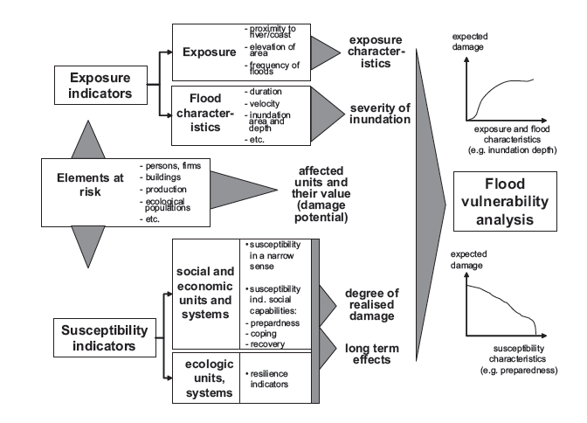

Figure 2. 1; Indicator-Based Flood Vulnerability Analysis
Source: Adopted from (Schanze et al., 2006)

Exposure indicators
The proponents distinguished exposure indicators into two categories. This aspect is required to identify the different types of elements that are exposed to flood risk (e.g. farms, houses, individuals, etc). The indicators provide facts on the site of the elements exposed to the flood risk, their closeness to the flooded area or floodprone zones, and the different kinds of floods in the floodplain. These are pointers that inform us about the occurrence of flood in the floodplain and how it threats the various kinds of elements exposed to the risk of flood. The second type emphasis on the flood features like velocity, duration, volumes, and the depth of the flood. These indicates the severity of the floods and as well, the dissemination across space and time. In summary, the exposure pointers discuss explicit evidence about the hazardous threats of the different elements that are at risk of flooding (Schanze et al., 2006).
Elements-at-risk indicators
The objective of investigating vulnerability to flood is to alleviate the impacts on the groups or individual elements-at-risk of being hurt by the inundations. The elements-at-risk indicators stipulate the quantity of economic, social or ecological systems that are at risk of being hurt by various hazards in a particular zone such as households, firms, private and public buildings, and ecosystem, situated in proximity to a hazardous zone. The degree of destruction can be valued in financial or non-financial terms based on the data gathered concerning “which and how” many of the elements are likely to be damaged by the inundation. This reflects the total maximum potential flood damage. Since the elements at risk are more or less exposed to the incidence of the flood and are more or less vulnerable to the floods, susceptibility and exposure indicators are largely linked to the elements at risk indicators which significantly contribute to the investigation of vulnerability to flood (Schanze et al., 2006).
Susceptibility indicators
The susceptibility indicators measured how sensitively an element at risk behaves when it is challenged with some kind of hazard. The proponents relate susceptibility units to the affected economic, social and ecological systems. Concerning the economic and social structures, an essential group of factors mentions susceptibility in its narrow sense as the relative or absolute measure of flood effects on the specific elements exposed to flood risk. Exemplifying this, the effect of flood depth and its duration on a building is often a main concern in damage examination to categorise the buildings with related susceptibility features. The susceptibility and damage caused by flood to a wooden structures, stone building or a cement block building are much more different. Susceptibility broaderly relates to a system characteristics which include the social context for the flood damage, particularly the preparedness (before flood), their capacity to cope with, and adapt to the threat (during flooding), and their ability to recover form the flood effects (after the flood event) (Schanze et al., 2006).
Though various scholarly works have been conducted regarding vulnerability to the socioecolgical system in term of vulnerability in a larger sense, several factors have been suggested in that context, and the proponents outlined three indicators.
- Awareness and preparedness: the elements reflects the communities and households knowledge and their readiness to deal with the hazardous floods events. For instance, the quantity of homes that are protected against the flood effects by employing technical measures, the quantity of individuals and households with disaster insurance like flood damage, are there people ready to action in disaster management, as well as the quality of flood prevention strategies and disaster management organisation.
- Since the capacity of the social structures to cope with the inundation effects is mostly linked to the overall socioeconomic factors, the coping measures embrace general information on age, structure, poverty, gender, race, education, social relations, institutional development, the proportion of the population with special needs (children, elderly) and the like. This category also includes indicators for technical systems, because the social impact of floods significantly relates to the susceptibility of basic infrastructure and lifelines, which support the population´s supply of basic needs. Technical susceptibility indicators specify flood-specific weaknesses and the ability of socio-technical systems like drinking water supply, wastewater treatment, communication systems, and energy supply to withstand the consequences of flood events.
- Social vulnerability broaderly relates to the inability of the individual households or a community to mitigate the effects of the risk and reinvent the previous situations, while the indicators for recovery are intended to evaluate this aspect. The indicators among others include; the financial capacity of victisms, communities, the ability to substitute the lost items, the social structures cohesion, and the external assistance received from families, government, and charity donors. Moreover, long-term impacts of inundations on the living standards and health problems of the people can also be valued in physical units, reflecting the time needed to accomplish circumstances that are akin to the period before the hazardous phenomenon.
Also, regardless of the few investigations on the economic systems, and their vulnerability to flood, quite a few indicators of vulnerability exist concerning the effects of inundation on the economic elements such as firms and the production processes. Unlike social systems, the indicators of economic preparedness account on the social and technical preparedness of the actors, systems, and on disaster insurance and the capacity to relocate their firm to other sites. In managing the floods event, the indicators assessed the strength of actors, whereas the indicators for recovery provide information on the long-term effects such as output, effectiveness, and economic failure as well as account on the period of time necessary to restore the previous situations. Despite the essential import for floodplain ecosystems by the recurrent flooding, which are typically referred as the valuable outcome of floods, there is a significantly negative environmental effects. Particularly floodwater is polluted or sedimentation processes occurs, socioecological system can be interrupted significantly and hence, necessitate the assessment of flood susceptibility of ecological systems as well. However, the proponents argued that it is not positive to link the vulnerability to the individual unit, but feasible to develop the vulnerability indicators in a larger perspective and linked to the entire socioecological system. These pointers can be developed from the discussion regarding ecosystem resilience. An ecosystem resilience is an advantage to a system and its ability to absorb the external turbulences. In that perspective, indicators that denote the extent of variation or disturbance a system can uphold are important. Also important are its ability to be proficient of self-organisation, adaptation, and the degree at which it attains balance after the shock (Schanze et al., 2006).

2.6.2 Action theory of adaptation
Action Theory of Adaptation as propounded by Eisenack and Stecker, (2012) acknowledges that, adaptation is a process within entities and systems or any adjustments that are made by human systems. Adaptation to any stimuli (like a flood) requires actions, role players, and an intention, which typically refers to only the individuals and the collective role players. The intention is to mitigate the impacts of the climate change stimuli. Also, the action theory of adaptations necessitates the use of resources as means to achieve the intended ends. The theory served as a simple core configuration and a basic unit for analysing complex real-world adaptations. Hence, the framework of figure 2.2 shows the action theory of adaptation.
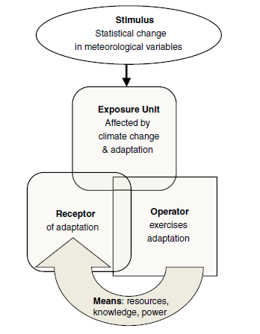

Figure 2. 2; Action Theory of Adaptation
Source: Adopted from (Eisenack & Stecker, 2012)
The diagram above is a representation of some core concepts of the Action Theory of Adaptation. The rounded corner boxes can both take the position of the biophysical units or role player, whilst operators constantly remain role players. In the schematic, the receptor, operator, and exposure components are not essentially identical as showed by intersecting boxes. The large and straight arrows indicate a causal and teleological relation respectively.
In describing the components or concepts of the theory, the proponents (Eisenack & Stecker, 2012) indicated that the theory should begin with a stimulus. A stimulus as defined by the proponents is a change in biophysical (particularly meteorological) variables associated with climate change. The authors distinguished this from weather events in very precise meaning. Stimuli refers to the changed values of numerical factors such as frequency, average intensity or higher arithmetical momenta (e.g., variance). There is also a difference between strictly meteorological effects, such as temperature and precipitation patterns on the one hand, and more or less indirect effects such as rising sea level or greater frequency of river floods. For this study, a stimulus is a flood that demands action.
The authors state that a stimulus is only relevant for adaptation when it influences an exposure unit. Exposure unit broadly refers to all those actors, social, technical, or non-human systems that depend on climatic conditions, and are therefore exposed to stimuli (flood). The abstract term is necessary to encompass the broad diversity of affected systems or entities that may be considered in an adaptation assessment(Eisenack & Stecker, 2012). The exposure unit in this study encompasses communities, households, individuals, farms, etc.
The theory stipulated that collective role player or a person who exercises the response is a operator. A clear distinction is desirable since actors would perform other task in the framework. A operator could be (e.g. household, an individual, farmer-based group, a firm, or a governmental actor such as NADMO, etc). But in any case, they are social units and all objects, and machines are excluded as operators (Eisenack & Stecker, 2012).
The system or actor as the main purpose of the adaptation is the receptor. The receptors are either biophysical units such as houses, crops, business structures, or social systems like community and household, depending on the objective of the analysis. It does not require that the receptor of an adaptation be an exposure unit at the same time.
Proponents further argued that to implement the adaptation, the operator needs resources known as means. Though these means can vary they could include financial assistance, material resources natural resources, social networks, legal authority, available information or knowledge. Action is shaped by the limitations and resources which are managed by the operator; they are known as conditions (Eisenack & Stecker, 2012). The means this research could include employment status, social networks, income level, insurance policy, and early warming information of extreme stimuli (flood) that determine their adaptive capacity.

2.6.3 Conceptual framework
Based on the literature review and the two theoretical propositions; a conceptual framework has been developed to guide the study. This conceptual framework explains the key variables or concepts and the relationships between them that require investigation. The framework demonstrates how ideas are organised to achieve the research purpose and explanation is the most common method employed. The framework explains the relationship between flood vulnerability dimensions that influence adaptation to floods. Figure 2.3 shows the various components of flood vulnerability that influence each other in various ways. The framework demonstrates a causal relationship starting from a meteorological situation either inland or at the coast Source/Causes of flood through the discharge and inundation Exposure Indicators and the physical impacts on the Elements-at-Risk to Flooding to the assessment of the Effects/Impacts of Floods and the Recovering Capacity. The link between the source, exposure/pathway, and element-at-risk/receptor refers to the physical processes, while the assessment of the effects/impacts, recovering capacity are more of societal values.

Figure 2. 3; Conceptual Framework
Source: Author’s construct, 2022
Source/Causes of floods
A stimulus, as defined by Eisenack and Stecker (2012), is a change in the meteorological variables associated with climate change. It is also a changed value of numerical indicators like the frequency, average intensity or higher arithmetic momenta. They are also referring to sudden extensive happenings in the ecosystem. The stimulus in this study is flooding. The incidence of flooding in this context is viewed as natural resulting from several meteorological and hydrological events such as heavy rainfall, dam failure, and urban sewer capacity overflow. Though the occurrence of floods is assumed to be natural, it is exacerbated by the current growth in the anthropogenic radioactivity altering the global water cycle and causing more intense and extreme precipitation. This is because climate change indicators are often not measurable from the limited available records, huge collective discharge replication offers insights into the anthropogenic effects on floods. When flooding occurs, the runoff takes its natural course, and any element or property before or close to overflow becomes exposed to the flood hazard (Hirabayashi et al., 2021).
Exposure Indicators
The literature has it that, a stimulus (flood) is relevant for adaptation when it influences an exposure unit. Exposure units comprise all those elements at risk or located in proximity to the flood plains, river catchment, channels, coastal zones, and the frequency of flood incidence in the area. Exposure is distinguished into two categories; first, exposure assesses the different elements at risk such as settlements, farms, buildings, and individuals while the second one emphasizes the general flood characteristics such as duration, velocity, volumes, debris load, and inundation depth. This indicates the severity of the flood as well as the distribution across space and time(Schanze et al., 2006). In this framework, the exposure unit of urban and peri-urban communities include; farms, households, livelihood structures, and housing units, among others that may be located in proximity to the watercourses. In short, exposure discusses the exact evidence of the hazardous flood threats to the vulnerable elements.
Elements-at-Risk to Flooding
The elements-at-risk to flooding component of the framework, presents the potential elements that are susceptible to the inundation. Susceptibility indicators are measured to determine the sensitivity of the elements expose a hazard acts as it is challenged by the flood. The elements-at-risk are specified amounts of social, economic, and ecological systems such as people, crops, households, public structures, national assets and ecosystem that are at risk of being affected as they are located in proximity to the hazardous area. The information about “which” element is vulnerable and the quantity of elements that are at risk of being damaged by the incident of flood, the extent of destruction can be valued either in monetary or nonmonetary terms to determine the maximum damage.
Effects of Floods
The impact component of the framework focuses on the negative consequence of the flood on the various elements at risk or susceptible to damage. The immediate effect of the inundation is the direct loss caused via the interaction of floodwaters and commercial assets, national heritage, and the inhabitants, resulting in loss of lives, livelihoods, infrastructure, injuries, and displacement of people. Floods do not impact only homes, agriculture, and public properties, but human health and safety. Thus, the negative impacts of floods are ranging from injuries, loss of life, loss of assets/livelihood, infrastructure elements, lasting health problems, destruction of social networks, and others.
Recovering Capacity
This component attempts to measure the adaptive capacity of the community, household, and individual to determine their ability to design and implement better adaptation strategies to alleviate the vulnerability as well as the impacts of floods. The scales of a household's capacity to resist, cope, recover and adapt to flooding depends on some degree of enabling environment of the community. The recovering capacity of a community is reflective of the processes and the availability of resources in the area. The capacity of a community, household, or an individual to adapt to changes in a hazardous zone depends on the population, age, sex, income, employment, educational level, knowledge about weather conditions, and their social networks including government institutions (e.g., NADMO) that provide relief services to victims’. These elements and others determine the adaptive capacity of the community, household, or individual to floods. The adequacy of these elements leverage the development of better strategies to overcome the inundation and vice versa. This is because adaptive capacity is context-specific and varies among communities, households, individuals (e.g., men, women, children, and the aged), and over time. The difference is not only in terms of value but according to nature.
Vulnerable Social Groups
These are mostly the groups of people in a community or a household. These groups of people are exposed to flooding due to the proximity of their settlements to waterbodies. They are also among those potentially at risks to flooding as a result of their exposure indicators. When the issue of flood emergency occurs, one or all of these groups (men, women, children, aged and the physically challenged) would be affected. But the effects or impacts may vary based on their individual ability to adapt to, and recover from the hazardous impacts. A high adaptive capacity means high potentials of recovery from the flood effects, whereas low adaptive capacity results in low recovery from the shocks of the floods. This therefore influences the social vulnerability to flood disasters.
Social Vulnerability to Floods
The vulnerability of urban and peri-urban communities is a reflection of exposure, susceptibility, and the adaptive capacity of the communities to the impacts of floods. Thus, a community that is more exposed and susceptible to flooding is more vulnerable, whilst a community with more adaptive capacity tends to be less vulnerable to flooding. Broadly, this conceptualisation indicates how the vulnerabilities of communities are moulded. A situation where the adaptive capacity is low relative to exposure and susceptibility contributes to high vulnerability, whilst higher adaptive capacity reduces the negative impacts of exposure and susceptibility, and eventually reduces social vulnerability to flooding. However, it does not necessitate the numerical measuring of the vulnerability components (exposure, elements-at-risk, and recovering capacity) to compare the relative vulnerability of the urban and peri-urban communities. This is because vulnerability and its components exposure, susceptibility, and adaptive capacity, and their causes are dynamic; that is, they vary from the stimulus (e.g., flood) to stimulus, over time, and they are spatial and system-specific.

2.7 Conclusion
Several viewpoints on flood vulnerability and adaptation have been reviewed. The vulnerability has been described by various scholars with diverse perspectives(Adger, 2006; Cutter et al., 2003; Derbile et al., 2021; Turner et al., 2003). Globally, communities and individual households are vulnerable to floods, but the level of vulnerability and adaptive capacity varies. Thus, communities or households with high adaptive capacity are less vulnerable to the impacts of floods whereas households with low adaptive capability are more susceptible to the impacts of inundations. Understanding vulnerability to floods assists communities, households, and government agencies to implement the appropriate flood adaptation and management strategies. Therefore, assessing flood vulnerability levels in the Wa Municipality is essential for examining the adaptation strategies.

CHAPTER THREE

METHODOLOGY

3.1 Introduction
There are several methodological options acknowledged in social science research, but the choice of research methods and methodology largely depends on the philosophical stance of the researcher. This chapter presents a description of the study area, the philosophical stance, the research methods and methodologies employed in collecting and analysing data.

3.2 Study Area and Context
This research was carried in the Wa Municipality of the Upper West Region. The Wa Municipal is the oldest municipality among the five (5) municipalities in the Upper West Region. The 2010 population and housing census indicated that the Municipality has a total population of 107, 214 with 50% being males and 51% females (GSS, 2014). Whilst 34% of the population lives in Wa town as the (urban area), 66% resides in the peri-urban and rural communities of the Municipality. Also, the Municipality has 18,891 households with an average of two households per a house. About 58% of housing units are compound houses, 23% are separate houses and semi-detached houses represent 10%. About 55% of these housing units are owned by members of the households, 27% are privately owned, 11% represent relatives who are owners but not members of the household while government owned housing units are only 4% (GSS, 2014). The main construction material for about 60% of houses in the Municipality is blocks molded with sand and cement; while about 36% of housing units are made with mud or earth bricks. Iron sheets and mud/earth are the main roofing materials, constituting about 92% and 2% of dwellings units respectively (GSS, 2014).
Geographically, the Municipality lies between longitude 9°32W to 10°20W and latitude 1°40N to 2°45N. The Municipality is bounded by Nadowli District to the north, south-east is Wa East District, and south-west by Wa West District. It has occupied land area of about 579.86Km² that is six percent of the Region. The landscape of the Municipality is generally flat with undulant average height of 160m and 300m above sea level due to its location in the guinea savannah high plains and is characterised by drought-resistant short trees such as shea, dawadawa, kapok, teak, and baobab, cashew and mango trees (GSS, 2014). Figure 3.1 shows the Wa Municipality.
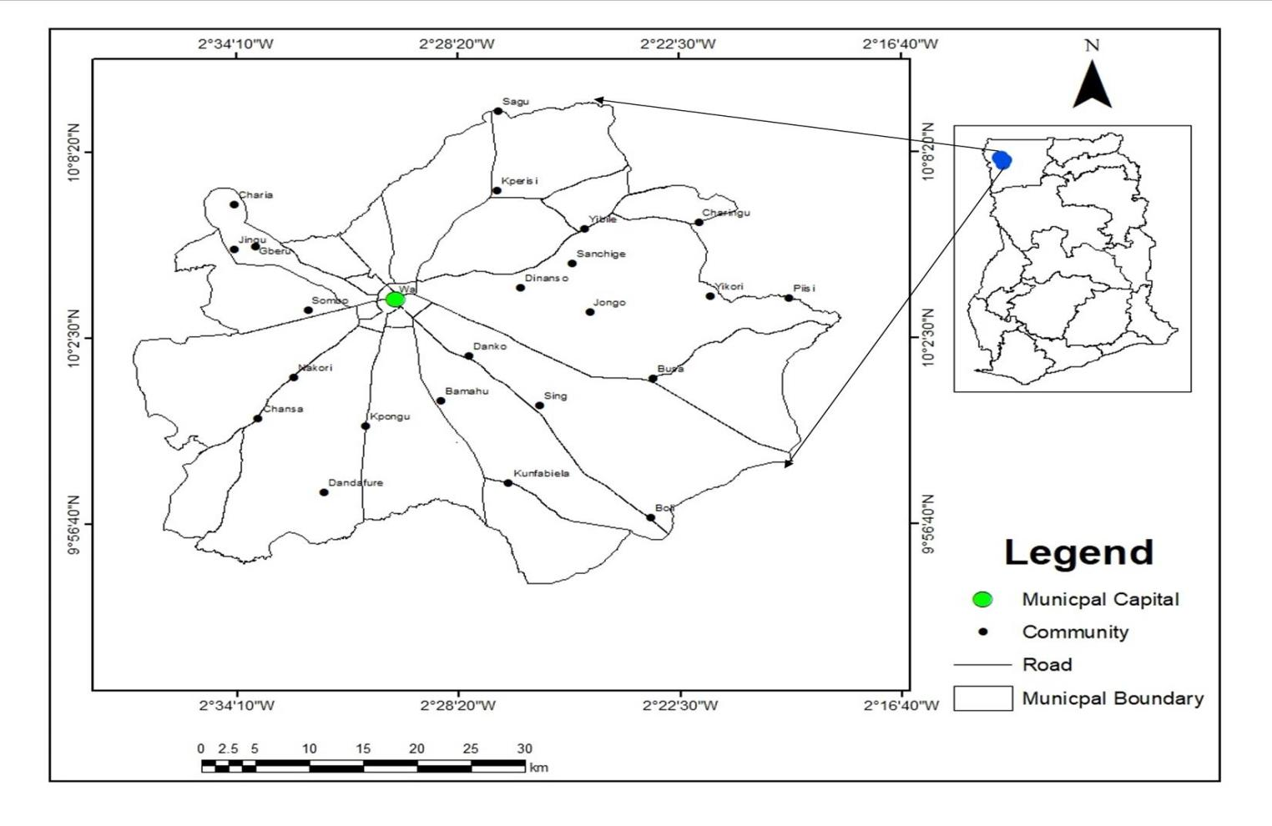

Figure 3. 1; Map of Wa Municipality
Source: Modified form Wa Municipal 2022.

The climate of the Municipality is characterized by a short and stormy wet season followed by a long, windy and hot dry season. The wet season occurs between May and October, and the long dry season often lasts from November to April. The rainfall distribution is one factor that influence vulnerability to flooding in the Municipality. The Ghana Statistical Services (GSS, 2014) established that, the mean annual rainfall varies between 840mm and 1400 mm in the Municipality.
However, the rainfall data between (2010-2020) collected from the Ghana Meteorological Agency (GMet) of the Wa Municipality was used in determining the average monthly and annual rainfalls in the Municipality. The average monthly rainfall is (78.1mm/month) whereas the average annual rainfall is (937.6mm) in the Municipality during the seasons of rains. It became evident in (Figure 3.2) that, the months of January and December are largely dry with no rains, whilst February and November always experience few rainfalls. The peak rainfall in the Municipality is the months of August and September for each raining season from 2010 to 2020. As a result, most flooding events have been recorded in the months of August and September in each raining season.

Figure 3. 2; Rainfall Pattern
Source: Field Date from GMet, Wa Municipal
The pattern of rainfall is inconsistent and mostly interrupted by pro-longed droughts and rainstorms, and floods. This disturbs the moisture levels, cropping, and the general livelihoods. Due to this, some communities in the Municipality such as Charia, Dobile, Konta, Mangu, Kambali, Kpaguri, Kumbiehi, Bamahu, Kperisi, Dapouha, Kulkpara and Busa experienced perennial flooding because they are located close to watercourses and low-lying area. The valleys in these low-lying zones collect and holds water for a period of time during the rainy season. This has given rise to the two major drainage systems, such as the Sing-Bakpong and its tributaries to the south and Billibor and its tributaries to the north(GSS, 2014). Though, these streams dry up in the dry season, inhabitants along these zones experience flooding every year during the rainy season.
The economically active population of the Municipality is about 55%, while 45% are inactive with students being the largest proportion. Whilst 92% of the economically active are employed, 9% are unemployed. The employed population, (29%) are engaged in agricultural, fishery and forestry work, whereas 26% are engaged in services and sales. About 19% are engages in craft and its related trades and 9% are professionals. The informal private sector is the principal employer in the Municipality, engaging 80% of the population with females having the largest proportion (58%) compared to males (48%), while the formal sector employs 14% of the population(GSS, 2014).

3.3 Research Methodology
Research methodology is the approach by which the study problem is solved methodically (Mishra & Alok, 2019). It is within the research methodology that the researcher generally adopts the various steps in investigating a research problem along the various rationalities. It is crucial for the researcher to identify not only the research methods but likewise the methodology (Korthari, 2004). The aim of the research methodology is to describe and analyze the methods, throw more light on their limitations and resources (Patel & Patel, 2019), while a research design is the general process the researcher adopt to combine the study components in a logical and consistent manner. The research design is an outline for the collection and analysis of data to answer the research questions (Mishra & Alok, 2019). The research design in essence is a conceptual arrangement within which the study is conducted. It constitutes the outline for measurement, data collection and analysis(Korthari, 2004). It stands for an advanced planning of the methods to be adopted in collecting the relevant data and the appropriate techniques to be employed in the analysis, considering the research objective and the availability of staff, time and finances (Korthari, 2004). It also comprises a strategy for interpreting the analysed data to provide acceptable results and conclusions to enable the researcher to make appropriate recommendations based on the inverstigation (Asenahabi, 2019).
This clearly reveals that a research design has a significant bearing on the entire structure of the research work and the reliability of the research findings. As a result, this study, based on its philosophical orientation, employed the exploratory sequential mixed method as the design to inverstigate the incidence, causes, effects or impacts, and social vulnerability to flooding in the Wa Municipality. The section also presents the methods of gathering data and the analysis.

3.3.1 Philosophical Underpinnings
A research philosophy is a system of assumptions and beliefs about development of knowledge and the nature of that knowledge (Saunders et al., 2009, 2019). It is describe as a collection of theories that dictate what ought to be investigated, how it should be investigated and how the findings should be analysed and interpreted. Creswell (2009) viewed it as the basic set of beliefs that guide the research action. Creswell contended that, the worldview is a general orientation the researchers hold about the world and the nature of the study. According to Saunders et al. (2009, 2019), these worldviews include (but are not limited to) assumptions about the realities that the researcher encounters in his/her study (ontological assumptions), about human knowledge (epistemological assumptions), and the extent and ways the researcher own values influence the study process (axiological assumptions). Worldviews according to Creswell (2009) are shaped by the discipline of the researcher, the beliefs of the supervisor and past experiences. The kind of assumptions and beliefs held by the individual researchers often embrace a quantitative, qualitative or a mixed methods approach in their study. Similarly, Saunders et al. (2019) ascertained that, these assumptions inevitably outline how the researcher understands the research problem, questions, the methods to use and how to interpret the research findings. It is clear that, a well-organized and reliable set of assumptions constitute a credible research philosophy, which underpins the study’s methodological choice, strategies, data collection techniques and analysis procedures. This allows the researcher to employ a coherent research design, in which all the elements of the study fit together. On these bases, various philosophical worldviews have been uncovered by scholars which underpin varied studies. Whilst Creswell (2009) identified four different worldviews which include; post-positivism, constructivism, advocacy/participatory and pragmatism, Saunders et al. (2009, 2019) unveiled five philosophical worldviews comprising positivism, critical realism, interpretivism, postmodernism and pragmatism. Saunders et al.(2019) and Creswell (2009) all stipulate that each of these paradigms makes assumptions about the nature of reality (ontology), how knowledge is constructed (epistemology) and assumes that, the values (axiology) the researcher employed in choosing a research method, participants, data collection, analysis and interpretation influence the research process.
This study adopts pragmatism. Pragmatism claims that, the most crucial determinant of the ontology, epistemology and axiology a researcher adopts is the research question. That is, one may be more appropriate in answering a particular question than the other. Ontologically, pragmatists believe that, there is an external world independent of our thoughts, and they as well deny that ‘truth’ can be determined once and for all. Pragmatists hold the belief that researchers may be both subjective and objective in epistemological orientation over the course of investigating a research question (Saunders et al., 2009; 2019).
Pragmatists believe in the axiological grounds that inquiry is value free. They believe that values play a large role in conducting research and drawing conclusions from their findings(Saunders et al., 2019). This means pragmatists recognise that, there are several ways of interpreting the world and conducting studies, and no single point of view can ever give the entire picture (as in positivist and interpretivist philosophy) and that there may be multiple realities (Saunders et al., 2019). Pragmatism as a philosophy has been acknowledged as a mixed method approach for exploring research problems that can neither be investigated by only quantitative or qualitative methods to obtain accurate results. This paradigm reconciles the conflict between objectivism and subjectivism (Creswell, 2009; Saunders et al., 2019). Logically, there is a great concern about the application of “what works” in a particular subject under study. Researchers focus attention on the research problem by employing pluralistic approaches to explore, understand and obtain knowledge about the problem(Creswell, 2009). This view insists that mixed methods, both qualitative and quantitative are possible, and perhaps very appropriate within a single study (Saunders et al., 2009).
This investigation embraces the mixed method approach between the two interpretations of reality (subjectivism and objectivism), with the faith that there is a natural world which, to some degree, can be examined via structured means with human beings playing a significant role as the social actors to interpret and adapt to the environment. The subject under investigation is, to assess the incidence of flood and social vulnerability to floods in flood-prone segments of the Wa Municipality. It recognizes the significant influence from the social players more precisely the populations who are associated with this phenomenon, i.e residents (households) and regulators (Municipal Assemble). The contributions of both residents and experts enhances the understanding of realities of the outside world through the opinion and interpretation of floods and how they adapt to it. Also, the study seeks to assess the social vulnerability of residents to flooding which is driven from an existing reality of the social system having an objectivist alignment.

3.3.2 Research Design and Processes
This study employed a mixed method research approach using Sequential Exploratory Design. Mixed methods research is an approach for conducting a study that involves collecting, analysing, and integrating qualitative and quantitative data in a single study. The combination of both qualitative and quantitative inquiries provides a better understanding of the spatial and social vulnerability to flooding and how local level planning influences the sustainability of floods adaptation strategies in the Wa Municipality than either approach alone (Creswell, 2007). Mixed methods research has the advantage of overcoming the disadvantages that are inherent when adopting either qualitative or quantitative methods of inquiries. Also, researchers have the opportunity of conducting mixed methods studies when only qualitative or quantitative methods cannot address the research questions (Creswell, 2007). This is because, the combination of interviews and survey in one study pulls together the depth and breadth advantages associated with these two methods. The outcome of mixing the results of these two methods is the prospect of providing a more complete picture of adaptation to floods in flood prone segments to generate complete and acceptable knowledge. Creswell, (2007; 2009) argues that, mixed methods studies go beyond the collection of qualitative and quantitative data to include connecting the data, embedding, or integrating both qualitative and quantitative data.
Exploratory Sequential Design
The exploratory sequential strategy involves collecting and analysing qualitative data first, followed by the collection and analysis of quantitative data which builds on the qualitative results (Creswell, 2009), unlike in explanatory sequential design where the quantitative data is collected and analysed first (Creswell, 2012). The researcher initiates the study with the qualitative phase to collect the views and experiences of the participants and the analysis of the qualitative data then informs the structure of the quantitative phase. The qualitative phase also facilitates the construction of suitable instruments for the sample of the study, looking out for the appropriate instruments to use in the quantitative phase, and/or to identify variables to use in the quantitative phase (Hafsa, 2019). Similarly, this design first explores the phenomenon by gathering qualitative data first, identifying themes, designing instruments and then collecting the quantitative data to explain the relationships found in the qualitative data (Creswell, 2012). The most basic purpose of this design is to use the quantitative data and results to assist in interpreting the qualitative findings. Most researchers employ this strategy when there are no existing instruments, variables and measures available for the population under investigation. This strategy aids in determining the distribution of a phenomenon within a selected population (Creswell, 2009, 2012).
The most advantageous aspect of the strategy is that, it allows the researcher to identify measures actually grounded in the data gathered from the participants. Researchers initially explore views of the participants by listening to them rather than approaching the topic with well-established variables. However, this design has its challenges as it necessitates extensive data collection and a considerable time for the processes. Also, this design challenges researchers on decisions about the most appropriate qualitative data (e.g., quotes, codes, themes) to use in the follow-up quantitative phase of the study. This is similar to Hafsa's (2019) assertion that, the most challenging aspect of this design is about concentrating on the specific qualitative findings to employ and selection of sample for both phases of the research.
In this study, the researcher first collected and analysed the qualitative data and the results set the basis for the quantitative phase. Interviews (KIIs and FGDs) were conducted first to understand the incidence, causes, effects and social vulnerability of flooding in the study communities which established the appropriate variables for the quantitative strands (survey). This approach was useful in developing better measurements with detailed population samples to determine whether data from qualitative strands can be generalised to a larger population in the quantitative strands(Creswell, 2009, 2012). The combination of both qualitative and quantitative methods provided a comprehensive understanding of the incidence of social vulnerability to floods in the real-life context of inhabitants in the Municipality.
In the presentation of the data, the terms qualitative and quantitative have been shortened to read as "QUAL or qual" and "QUAN or quan" respectively. The mixed methods strategies are explained using notation that has been advanced in the mixed methods research field. These notations provide shorthand labels and symbols that carries important aspects of mixed methods study, which provide a precise way that mixed methods researchers can simply communicate their procedures. Figure 3.2 shows the notation adopted in this study for Exploratory Sequential Mixed Methods researches as given by (Creswell, 2012).

Figure 3. 3; Exploratory Sequential Mixed Method Research (Creswell, 2009, 2012)

3.3.3 Methods of Data Collection and Analysis
The overall aim of this study is to address the research questions. To answer the research questions, data was gathered from both secondary and primary sources. However, the study relied heavily on the primary data which were gathered through Focus Group Discussions (FGDs), Key Informant Interviews (KIIs) and Survey. The information gathered through FGDs and Key Informant Interviews using focus group discussion guide (FGDG) and Key Informant interview guide (KIIG) respectively formed the qualitative data which informed the questionnaire design for the survey data collection. Secondary data such as floods reports and rainfall data were collected from NADMO and GMet respectively. These data collection methods, techniques and analysis are further elaborated in the subsequet sections.
Focus Group Discussions (FGDs)
The study applied Focus Group Discussion (FGD), a qualitative research method which is mainly useful in the social sciences. Focus Group Discussions are forms of group interviewing held with a small group of people normally 6 to 12 people who have practical knowledge on a particular subject under investigation(INTRAC, 2017; L. Mishra, 2016). The discussion is usually facilitated by an interviewer, researcher, moderator, or a project team. The course of discussion is typically planned in advance and most interviewers or researchers rely on a focus group discussion guide to solicit information to ensure that all topics and sub-topics are covered. Focus Group Discussion is an in-depth interview proficient in a group, whose assemblies present characteristics defined with reverence to the size, proposal, composition, and interview procedures and the object of analysis is the interaction inside the group (L. Mishra, 2016). They are applied to find out the perceptions and attitudes of a homogenous group of people (INTRAC, 2017). The participants of FGDs influence each other through their responses to the ideas and contributions throughout the discussion. FGDs harvest a lot of information more quickly and at lower cost compared to individual interviews.
A total of seven focus group discussions were conducted using a focus group discussion guide. Two focus group discussions were conducted with women only and two with men only. The women numbered ten in each group while the men were nine in each group. One FGDs was held with the physically challenged people involving fifteen participants, seven males and eight females and finally two FGDs were conducted with children between 14 to 17 years of age involving twelve participants per session. These groups of individuals were purposively selected for this study. Since floods do not affect people equally, it was necessary to bring together people with similar characteristics or experiences to discuss the issues on the incidence and vulnerability to floods in the municipality. The FGDs were useful in offering diverse opinions and experiences on the subject under investigation which enabled the researcher to obtain in-depth understanding of the issues. The FGDs were undertaken by a three member team; a facilitator, note-taker and an audio-recorder, who were all native speakers of the local language (Waali and Dagaare). The facilitator led and controlled the discussions, the note-taker took keynotes while the discussions were audio-recorded by the audio-recorder with the consent of the participants. The audio-data was transcribed verbatim from Waale/Dagaare into Engish text. The transcriber understands both languages and for that matter meanings of the data was not lost in the transcription process. The data was coded and analysed in accordance with the research objectives and with specifics to Braun et al's. (2016) and Clarke and Braun's (2013) phases of qualitative thematic data analysis.
Key Informant Interviews (KII)
The study applied key informant interviews using a key informant interview guide as the data collection instrument to solicit data from paticipants. Key Informant Interviews (KIIs) is a research technique used to gather specific qualitative information, from “informants” who are usually experts and decision-makers, about a subject matter or a situation in a study community. KIIs are qualitative in-depth interviews conducted among people such as residents, community leaders and professionals who have fair knowledge about what is going on in a particular study area. The experts, with their specific knowledge and understanding of the community offer insight on the phenomenon under study and recommend appropriate solutions (Ali et al., 2013). It involves interviewing a selected group of individuals who are likely to provide the needed information, ideas, and insights on a specific topic. Though a KII provides rich and detailed information, clarifies questions and offers opportunity to build rapport with respondents, it also has its shortcomings. Choosing the appropriate experts as Key Informants (KIs) can be tricky. It is also difficult to approach experts and set interview meetings with them due to their work schedules. Also, controlling the discussion and maintaining focus on the specific question is always challenging (Ali et al., 2013).
This study applied KIIs to solicit information from the Head of Physical Planning Department (PPD), the Municipal NADMO Director, and the Director of the Municipal Meteorological Agency (GMet), chiefs, women’s leaders (Magazie), and Assembly members. These key informants (KIs) were purposively selected based on their roles and expert knowledge on floods in the study area and the Municipality as a whole. A key informant interview guide was employed to solicit their views on the incidence of floods and social vulnerability to floods in the municipality.
A total of twelve key informant interviews (KIIs) were conducted in the study area. One was conducted with each of these institutional heads:NADMO, PPD and GMet, three Chiefs, three Assemblymembers and three “Magazie”. During the interview sessions, keynotes were taken by the researcher and with the consent of the interviewee, the discussion was audio-recorded and later transcribed verbatim, coded and analysed.
Household Survey
Surveys are systems for collecting data to describe, compare, and predict attitudes, opinions, values, knowledge, and behaviours. Surveys are used to collect data on a broad range of subjects of interest in various fields such as education, sociology, demography, health, psychology, economics and law (Fink, 2003). A survey according to Scheuren, (2004) is a method often used in gathering data from a sample of individuals, groups, or from institutions. This “sample” is typically a fraction of the elements being studied (ibid). A critical component of any survey is the design or the environmental arrangement in which data is collected, analysed, and interpreted (Fink, 2003). This study used a cross-sectional survey design. A cross-sectional survey gathers descriptive data at one fixed point in time (Fink, 2003). The data is collected through a standardized procedure to ensure that, every individual or group is asked the same questions in a more or less the same way. The intention is not to describe the specific individuals who, by chance, are part of the sample but to find a composite profile of the population being studied (Scheuren, 2004).
In determining the sample size for this study, the Taro Yamane formula was employed whilst the proportionate stratified sampling procedure was used to determine the samples for each of the strata (Mangu, Kambali, Konta and Kumbiehi). The sum of affected households in the four flood-prone communities (strata) was 725 which served as the sampling frame for the study (NADMO-Wa, 2018). The sample size was therefore determined by employing the Yamane formula as; $n= \frac{N}{1+N\left(e\right)²}$ where n=sample size to be determined, N=population size and e= represents the margin of error with confidence level of 95%. By substituting 725 and 0.05 into the formula; $n= \frac{725}{1+725\left(0.05\right)²}$ given n = 258 as the sample size for the study (Uakarn et al., 2021). This sample size (258) was proportionately distributed among the strata (Mangu, Kambali, Konta and Kumbiehi). With proportionate stratification, the sample size of each stratum is proportionate to the population size of the stratum. A proportionate stratified sampling ensures that each subgroup or strata of a given population is adequately represented within the whole sample population for the study. The proportionate stratified random samples were obtained (Table3.1) by dividing the sample size (258) by the total population of the strata, multiplied by each stratum size:
$$\frac{Sample Size}{Population Size}×Stratum Size$$
The advantages of stratified proportionate sampling are that, it guarantees the representation of all the subgroups in the population required (Acharya et al., 2013; Bhardwaj, 2019) and produce better results as compared to other sampling methods (Bhardwaj, 2019). Also, characteristics of each stratum can be estimated and comparisons can be made. In addition, it reduces variability from systematic sampling. However, the limitations are that, it requires accurate information on the proportions of each stratum. Besides; it is expensive to prepare a stratified list (Acharya et al., 2013).

Table 3. 1; Sample frame and size
Community | Affected population(2018) | Proportions
Mangu | 237 | 84
Kambali | 354 | 126
Konta | 72 | 26
Kumbiehi | 62 | 22
Total | 725 | Sample size = 258
Source: Author’s construct, 2022.

A structured questionnaire was deployed into kobocollect and administered to households to solicit their responses on the incidence and causes of floods, the effects of floods and social vulnerability to flooding in the Municipality. Kobocollect is a mobile data collection software which assists researchers to collect data both online and offline. The questionnaires were systematically administered to every third household and for generalisation reason, 270 households responded to the questionnaire.
The precoded and answered questionnaires were viewed in the kobotool box to check completeness, accuracy and consistency of responses in order to eliminate errors. The data was downloaded from a Kobotool box into Statistical Package for Social Sciences (SPSS) version 20. Descriptive analyses were conducted and the results were visually presented in tables, percentages, frequencies, and graphs. Also, the geospatial data (points, lines and areas) collected from the GIS were downloaded and saved as shapefiles, using the WGS1984 coordinates system and projected to Universal Traverse Mercator (UTM) zone 30N. A 300m buffer zone analysis was done using ArcGIS version 10.8 based on the points collected which gives a clear picture of the elements that are exposed and susceptible to flooding in the study areas.

3.4 Secondary Data Review
Secondary data is data that has been collected through primary sources for its main purpose and made readily available for other users. Secondary Data Review is a rigorous process of data gathering, synthesis and analysis building on relevant information available from different sources such as books, published and unpublished theses, journals and magazines. For the purpose of this study, the secondary data was collected from the Municipal Disaster Management Organisation (NADMO) and the Municipal Meteorological Agency. A situational report on the incidence of floods was collected from the Municipal Disaster Management Organisation (NADMO) which details the flood-prone communities, the effects and some of the causes of the perennial floods in the Municipality. The report also points out the groups that are socially vulnerable to flooding in the Municipality. These data validate the study results on the experience, effects and causes of floods in the Municipality. Also, a daily rainfall data (2010 to 2020) was collected from the Municipal Meteorological Agency (GMet). This data was used to analyse the average monthly rainfall and the annual rainfall patterns over the years 2010 to 2020. The results revealed August as the peak month of rainfall which supports the study findings.

3.5 Research Validity and Reliability
Validity describes how well the collected data cover the defined subject under investigation. It is basically measuring what is planned to be measured while reliability is the level to which the measurement of an event produces constant and consistent findings. Also, it is about obtaining repeated results. For instance, a test is only reliable when repeated measurements are made under constant situations to generate similar results (Taherdoost, 2016). Therefore, pre-testing for validity and reliability is very essential for ensuring consistency across all parts of the research instruments. Sarantakos, (2005) stipulated that, in order to validate and ensure consistency, multiple instruments must be employed to gather data from various points of view. In that respect this study made use of a focus group discussion guide, a key informant interview guide and a questionnaire to collect data from the field. In order to ensure reliability and validity, these research instruments were carefully scrutinised before data collection. Also, the questionnaire was pretested to evaluate the appropriateness of the questions, ensure consistency, help research assistants to be conversant with the questionnaire, and the average time required to administer a questionnaire. The necessary modification was made after receiving feedback from the pre-test exercise. The questionnaires were administered face-to-face to participants. The field assistants were also natives and were able to interpret the questions into the local language (Waali or Dagaare) to the illiterate to give the appropriate responses.

3.6 Ethical Considerations
There are several ethical issues that researchers need to pay attention to when conducting a research and these problems may overlap each other. Bhandari (2022) stipulated that, ethical considerations in social science research are a set of values that guide the conduct of research, and researchers must always adhere to this code of conduct when collecting data from human participants. In this study, the ethical principles of social science research were observed at all levels. An introductory letter was obtained from the Department of Governance and Development Management of Simon Diedong Dombo University of Business and Integrated Development Studies as an ethical control. This ensured the researcher’s identity to instil some forms of confidentiality assurance on the participants. The investigator sought the participants’ approval before the focus group discussions, key informant interviews, and questionnaire administration. Also, the consent of participants was sought before interviews, audio-recordings and pictures were taken. Participants were clearly informed that, there are no direct benefits for them, but the information gathered would aid policy makers to make policies to undertake pragmatic floods adaptation strategies to mitigate the incidence of social vulnerability to floods in the Municipality. The privacy of participants was protected by taking charge and ensuring the confidentiality of the information they provided.

CHAPTER FOUR

DATA ANALYSIS AND DISCUSSION

4.1 Introduction
This chapter presents the data analysis, results and discussion. The chapter examines the incidence and causes of floods, effects or impacts of floods and recovery, and social vulnerability to flooding in the Wa Municipality. The chapter is presented in four sections. The analysis starts with the socioeconomic characteristics of the participants that determined social vulnerability to flooding. The second and third sections examine the incidence and causes of floods, the effects of floods and vulnerability to floods respectively. In the final section, the results are discussed.

4.2 Data Analysis and Presentation

4.2.1 Socioeconomic Background of Participants
This section presents the socioeconomic features of respondents. The sex, age, educational levels, employment status, income levels, dwelling types, and household size are important characteristics in determining social vulnerability to flooding. In contemporary development planning and management gender issues and roles are mostly considered. The first demographic variable considered in this study is gender (sex). In the context of flood vulnerability all sexes, ages, educated or uneducated, married or single, employed or unemployed, poor or rich, are affected by floods one way or the other. Table 4.1 presents the analysis of these socioeconomic variables of the respondents.

Table 4. 1; Sociodemographic characteristics of respondents
Demographic characteristics | Frequency | %
Sex  Male  Female  Age Category (years)  18 – 20  20 – 39  40 – 59  60 & Above  Marital Status  Married  Single  Widowed  Divorced  Household Size  1 – 5  6 – 10  11 & Above  Dwelling Type  Block with iron roofing  Mud with iron roofing  Mud with mud roofing  Educational Level  No Formal Education  Primary  JHS  SHS  Tech/Vocational  Tertiary  Employment status  Unemployed  Employed  Self- Employed  Income Per Month  Less than GHȼ1000  GHȼ 1000 – 1500  GHȼ 1501 – 2000  Above GHȼ 2000  Expenditure Per Month  Less than GHȼ1000  GHȼ 1000 – 1500  GHȼ 1501 – 2000  Above GHȼ 2000 | 120  150  10  148  71  41  169  76  15  10  53  158  59  230  39  1  39  50  36  41  79  25  54  46  170  156  86  23  5  192  60  11  7 | 44.4  55.6  3.7  54.8  26.3  15.2  62.6  28.1  5.6  3.7  19.6  58.5  21.9  85.2  14.4  0.4  14.4  18.5  13.3  15.2  29.3  9.3  20.0  17.0  63.0  57.8  31.9  8.5  1.9  71.1  22.2  4.1  2.6
Sample Size = 258 Questionnaires Administered = 270
Source: Field Data, 2022

From the analysis (Table 4.1), more than half (i.e. 55.6%) of the respondents were females and 44.4% were males. More than half 54.8% of the participants fall within the 20-39 age category whereas 3.7% are within the 18-20 age group. The study also showed that, 62.6% constituting majority of the participants were married, 28.1% single, 5.6% widowed and 3.7% divorced. For household size, 58.5% constituting majority of the participants have household sizes between 6-10, 19.6% have household sizes between 1-5 and 21.9% have household sizes to be 11 and above. In terms of dwelling types, 85.2% of participants dwell in block houses with iron roofing, over 14.4% of the participants reside in mud houses with iron roofing and 0.4% dwells in mud-houses with mud roofing.
In terms of educational attainment, 29.3% of the participants have attained technical/vocational education and only 9.3% have reached the tertiary level. Results for participants employment status show that, majority i.e. 63% of the participants were self-employed (e.g, dressmaking, hair-dressing, food vending, plumbing, carpentering pito-brewing, petty trading, farming etc), 17% were employed and 20% were unemployed.
On incomes more than half 57.8% of the household earned less than GHȼ1,000.00 per month, over 1.9% who earned above GHȼ2,000.00 per month. Finally, participants expenditure per month was considered to compare how much they earned and how much they spent per month to determine their ability to recover from floods socks. The results showed that, 71.1% of the participants spent less than GHȼ1,000.00 per month, and 2.6% spent above GHȼ2,000.00 per month.

4.2.2 Incidence and Causes of Floods in the Municipality
This section presents results of the assessment of the incidence and causes of floods in the Wa Municipality. It starts with the incidence, causes and summarises the findings.

Incidence of floods
In assessing the views of participants on the incidence of flooding, it was revealed that, flooding in the Municipality is a perennial issue. An interaction with Key Informants (KIs) and focus groups discussants unveiled that they experience floods almost every year. According to participants most of these floods occur between the months of August and September in each rainy season. They described the floods situation to be very serious due to the destructions caused by floodwaters. Floodwaters normally take some minutes, hours and days to subside or run off. Residents reported experiencing flooding two to three times within a rainy season. This is what women in Kumbiehi said in reply to the question on the last time they experienced flooding:
Every season we do experience flooding in Kumbiehi here. Even this year 2022, the first heavy rain that came flooded our homes. The last time we experienced serious flooding in Kumbiehi here was 2018 when a lot of people and things were affected. Almost everybody who dwells here was affected one way or the other. This happened between August and September 2018. It was very serious because you could measure the water around your knees even in your house but the outside especially along the river side, if you dare the water will carry you away. We experience flooding two to three times within the same season depending on the frequency of the rains and the soil saturation level. But nowadays, the rains are not predictable (FGDs, 24/05/22).
The Human Resource Manager from the Wa Municipal National Disaster Management Organization shared similar views that flooding is frequently experienced in the Municipality. He said;
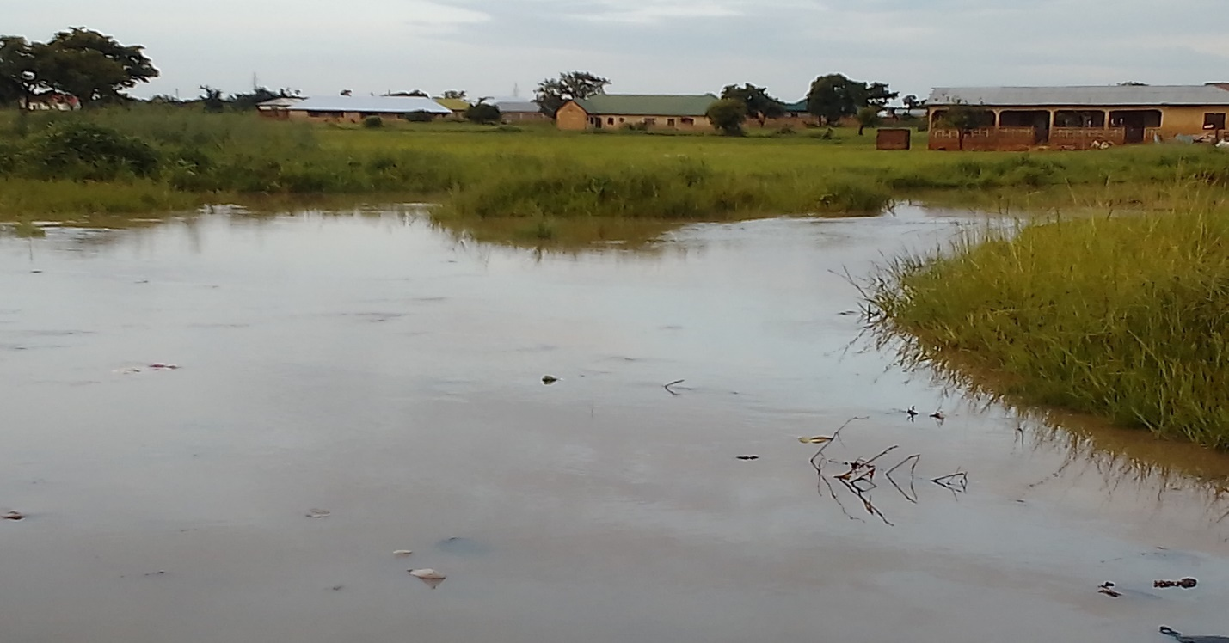
The last time we experienced serious flooding with a lot of destruction in the Municipality was 2018. Recently, around 2020 there were floods but that one didn’t affect people and houses, but it only flooded the roads around Konta-Jumboree area through to Mangu. Flooding occurs between June, July and August. It took three to four days for the water to drain down. The 2018 flood was severe because it affected almost ten to fifteen communities in the Municipality and that even prompted the Vice President of Ghana to come to Wa to donate some relief items to the victims. The volume of the water was measured around the waist level (laughter, …). Other communities that are always affected by the floods include; Konta-Jumboree area, Kambali, Mangu, Kumbiehi, Kpaguri, Dori, and Zendele (KII, NADMO-Wa Municipality, 31/05/22).

Figure 4. 1; Field picture showing flooding in Kumbiehi taken on 01/08/22
Source: Survey Data, 2022

A parallel view was given by another key informant (KI) that, flooding in the Municipality is perennial especially in Mangu where all the waters always drain through naturally to exit the Municipality. He said;
We have been experiencing flooding almost every year. The last time we experienced severe flooding in Mangu was between August-September 2018 when the Vice President of Ghana (Dr. Mahamudu Bawumia) himself was at Mangu to deliver some items to the affected persons. The flood lasted for about 2 to 3 hours before the water went down. The occurrence as well as the effects of flooding varies over the years. The 2019 flooding was one of the severest when we experienced flooding 3 to 4 times. in 2020 we experienced it 2 to 3 times and 2021 we experience it 2 times. But this year, 2022, the rains have just started; we don’t know whether we will experience it. But we have no option because all the waters naturally drain into the valley in Mangu; that is the reason we experience flooding every year (KII, 19/05/22).

The qualitative data corroborate the survey results. As can be seen in Table 4.2, out of the 270 administered questionnaires, majority (65.6%) of households have experienced floods whereas 34.4% have not experienced floods. As indicated, the last time households experienced severe flooding was 2018 with 31.6% while 2017 has the least 5.6%. Even this year 2022, 9% of the households have experienced flooding in the Municipality. As many as 32.8% reported that the floodwater mostly takes one hour to drain down, while some take more than a day. It has also been revealed that, in each season, flooding always occurs about two time between August and September which is mostly measured around the knee or thigh level.

Table 4. 2: Incidence of floods
Variables | Responses | Freq | %
Household Flood Experience | Yes | 177 | 65.6
Household Flood Experience | No | 93 | 34.4
Household Last Time Flood Experience | This year 2022 | 16 | 9
Household Last Time Flood Experience | Last year 2021 | 30 | 16.9
Household Last Time Flood Experience | Last two years 2020 | 40 | 22.6
Household Last Time Flood Experience | Last three years 2019 | 25 | 14.1
Household Last Time Flood Experience | Last four years 2018 | 56 | 31.6
Household Last Time Flood Experience | Last five years 2017 | 10 | 5.6
Time taken for last floodwater to drain | About 30 minutes | 46 | 26
Time taken for last floodwater to drain | About 1 hour | 58 | 32.8
Time taken for last floodwater to drain | More than 1 hour | 36 | 20.3
Time taken for last floodwater to drain | 1 day | 25 | 14.1
Time taken for last floodwater to drain | More than 1 day | 12 | 6.8
Flood occurrence in season | None | 28 | 10.4
Flood occurrence in season | Once | 82 | 30.4
Flood occurrence in season | Twice | 95 | 35.2
Flood occurrence in season | Three times | 43 | 15.9
Flood occurrence in season | More than three times | 22 | 8.1
Months of occurrence | May, June | 7 | 2.6
Months of occurrence | June, July | 27 | 10
Months of occurrence | July, August | 100 | 37
Months of occurrence | August, September | 136 | 50.4
Level of measurement | Knees | 196 | 72.6
Level of measurement | Waist | 41 | 15.2
Level of measurement | Chest | 12 | 4.4
Level of measurement | Neck | 14 | 5.2
Level of measurement | Thigh | 7 | 2.6
The study reveals that, there is territorial flooding in the Municipality during and after any heavy thunderstorm. Majority of the households, i.e 65.6% experienced floods and as many as 31.6% of these households experienced flooding in 2018. Mostly residents’ experience flooding twice between the months of August and September . The floodwater mostly takes about one hour to drain. Majority of the participants (72.6%) reported that they have had the level of the floodwater measured around their knees in the municipality.
Causes of floods
The occurrences of floods result from rainfall intensity and the features of the drainage systems. Though, the causes of floods are diverse, they are largely the accumulated results of urbanization and meteorological factors. As a result, the study attempted to examine the factors that cause flooding in the Municipality. Also, assessing the causes of flooding was vital because it will aid stakeholders and policy-makers to plan and address the incidence of flooding and its negative effects on development in the Municipality. From the responses, the following were identified as the primary causes of flooding in the municipality:
Developers or house owners building on waterways, poor drainage systems, and dumping of solid waste into drains that choke the drains and prevent the free flow of runoff water when it rains. These causes of floods have confirmed the general observation made in the 2018 situational report on floods in the Wa Municipality that the causes of the perennial flooding in the Municipality include; poor planning of buildings, poor drainage systems, improper disposal of refuse, silting and choking of drains and improper enforcement of laws on building construction and sanitation resulting in unauthorized structures on waterways (NADMO-Wa, 2018). Table 3.2 displays the analysis of the investigation on the causes of floods in the Municipality.

Table 4. 3: Causes of floods in the Wa Municipality
Causes of Floods | Responses
Causes of Floods | Yes | % | No | %
- Building on waterways | 235 | 87 | 35 | 13
- Indiscriminate dumping of waste | 252 | 93.3 | 18 | 6.7
- Inadequate drainages/gutters | 263 | 97.4 | 7 | 2.6
- Narrow gutters | 186 | 68.9 | 84 | 31.1
Overall Average (%) |  | 87 |  | 13
Source: Survey Data, 2022

From the multiple response analysis of the survey data (Table 3.2), 87% of the participants responded “yes” to building on waterways as a cause of flooding in the municipality, 93.3% responded “yes” to indiscriminate dumping of solid waste resulting in choked gutters causing floods, while 97.4% responded “yes” to inadequate drainages/gutters as a cause of flooding and 68.9% of the participants agreed that narrow gutters cause flooding in the municipality.
Building on waterways
The qualitative results corroborate the survey findings in many ways. For example, during a focus group discussion, participants indicated that, land-owners always sell parcels of land including waterways and as the place is developed it blocks the natural free flow of runoff water causing flooding every season. The summary of what they said is as follows;
… land owners always sell their lands including waterways and developers also build on the waterways thus causing the flooding. But who are you a woman to advise them? So, places that are supposed to be waterways become someone’s plot and the person also builds, blocking the free flow of the water that always results in flooding. So, after building on the waterway definitely when there are heavy rains it will affect you, even you would be lucky if you do not drown. One other problem is that they are building the place but they are not leaving space. If they see a space that a room can be built on the next day you will see someone putting up a building there. And if you want to talk, the person will tell you that I bought the place. People built without 10m, if there is no space and the whole area is also built up, where will the water go if there is heavy down pour? Definitely it will enter our rooms. Also, Kumbiehi here we need big gutters so if it rains, the water will pass through the gutter into the river but there are no gutters even along the road (FGDs, 24/05/22).
This is evident in Figure 4.2, which shows how residential structures are developed on waterways in the municipality which is a very serious threat to residents’ lives and properties. This could be the result of the low prices of parcels of land along or on waterways. As most participants (Table 4.1) are self-employed or unemployed, or are low wage earners, they tend to purchase these types of parcels of land but lack the financial capacity to properly develop them.

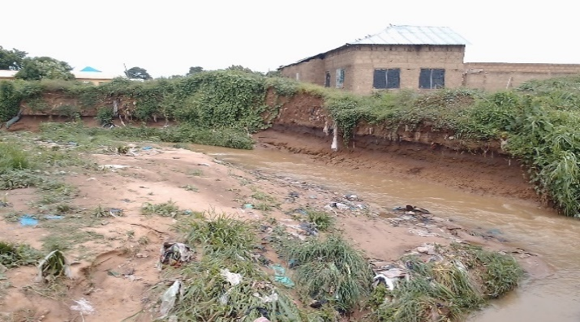
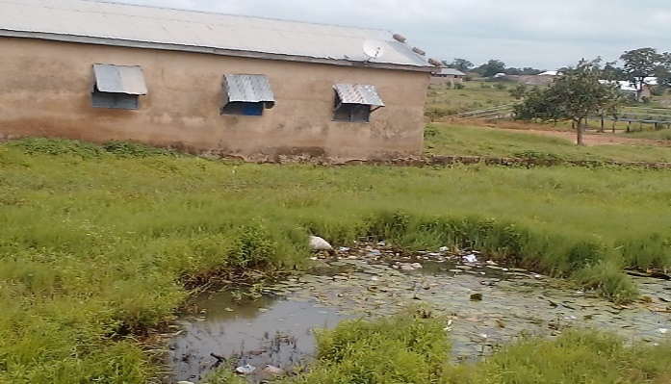

Figure 4.2: Pictures showing Buildings on waterways
Source: Field Picture, 2022

Indiscriminate dumping of solid waste
According to the study participants, the way some households dispose their solid waste has caused the blocking of the available drains causing flooding in the municipality during rainy season. The solid waste always chokes the gutters preventing the free flow of runoffs after any heavy downpour resulting in flooding in most of the areas within the municipality. This is what a key informant said;
I will say poor drainage system is one cause of flooding because our gutters are very narrow, and due to that when there is heavy downpour it always overflows. Second, building on waterways also causes flooding, because they always block the free flow of water and the way some of us always dump our waste that blocks the gutters causing flooding during the raining seasons. I think these are the few I can reflect on right now (KII, 23/05/22).
Picture 4.3 shows how indiscriminate solid waste disposal results in choking the available drains causing most of the flash floods in the Wa Municipality affecting thousands of lives and livelihoods.
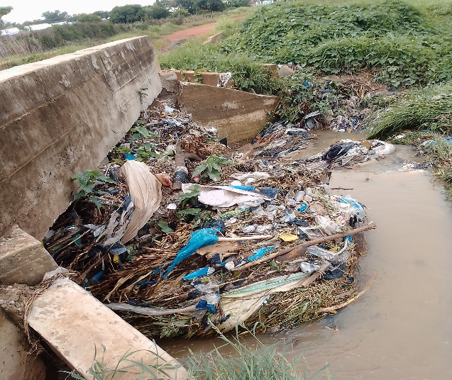
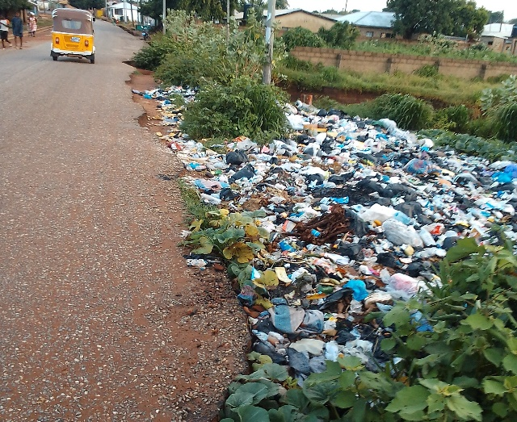

Figure 4.3: Indiscriminate Dumping of Waste and Choked Drains
Source; Field Data, 2022

Inadequate drainages/gutters
Also, during a focus group discussion, discussants bemoaned the lack of drains or gutters in the Kumbiehi community which has been one of causes of flooding. The discussants hold the view that if there were gutters it would have reduced the incidence of flooding. The focus group discussants’ expressed the lack of constructed gutters or drains in Kumbiehi community of the Wa Municipality as follows:
In Kumbiehi here, we needed to have big gutters because the place is hilly. If there were gutters and it rains heavily even if the gutters are filled with water and overflows it will not affect us that much. But there is no gutter even along the main road to contain and direct the volumes of water into the valley after heavy rainfalls resulting in flooding each year (FGDs, 24/05/22).
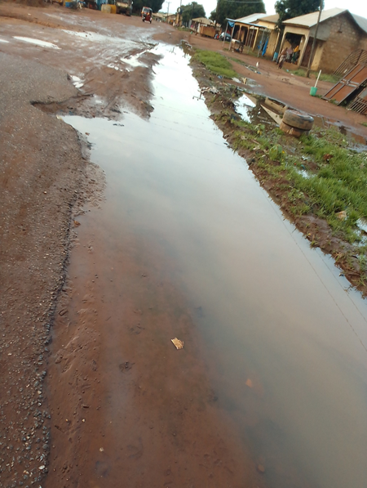
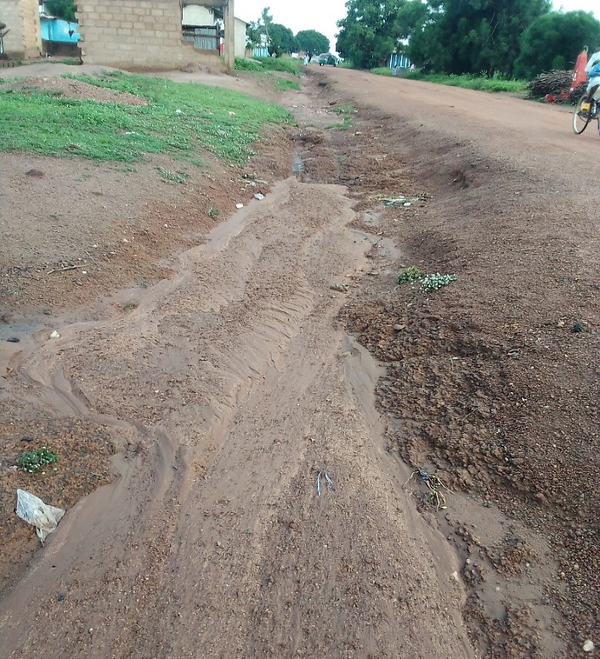

Figure 4.4: Lack of Constructed Gutters/Drains
Source; Field Data, 2022

Narrow drains/gutters
One other cause of flooding in the Municipality according to a key informant is narrow drains or gutters. The few available gutters or drains are not large enough to contain the volumes of runoffs after heavy downpours and with the blockage by solid waste the water always overflows into the residential areas. This has always resulted in a lot of damage. This is what the key informant (Kambali Chief) said:
The flooding always occurs due to the narrow gutters and bridges along the road. When it rains, water from Sombo will drain down to the Kambali junction here and water from Kpaguri comes to add up making it to overflow the road into our houses. That is the reason why when there is any heavy downpour we always experience flooding in Kambali. But thank God that they have started constructing a gutter at the new filling station there which has reduced the incidence for the past two years (KII, 27/05/22).
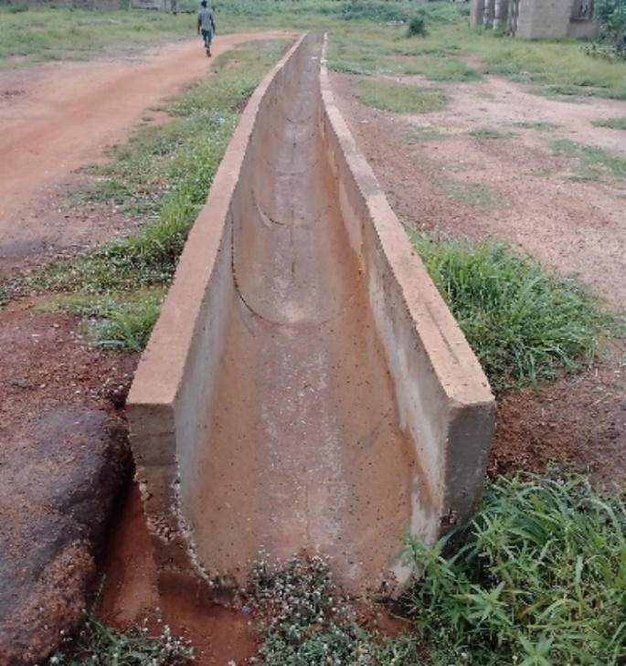
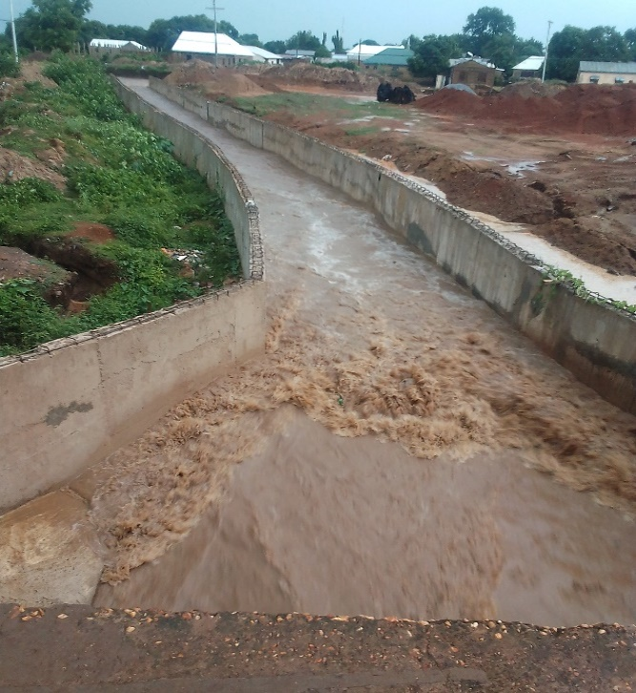

Figure 4.5; Narrow Drainage/Gutters
Source; Field Data, 2022

The frequent occurrence of floods is as a result of human activities and heavy rainfall. The human causes of floods were reported to be building on waterways, poor planning of buildings, poor drainage systems, inappropriate dumping of waste, silt-up and choked drains/gutters and ineffective enforcement of building and sanitation bye-laws.

4.2.3 Effects of Floods and Recovery
The study also sought to examine the effects and impacts of floods on the socio-economic development of the municipality. The results revealed the destruction caused by seasonal flooding in the Municipality. The effects of floods could be direct or indirect as well as tangible or intangible. The study revealed that residents were impacted negatively by perennial flooding in the Municipality. Participants of this study reported that they have suffered from physical losses, economic losses and health problems as indicated in Table 4.4.

Table 4. 4: Effects of flood on households in the Municipality
Impacts of flood on households | Responses
Impacts of flood on households | Yes | % | No | %
- Injuries and loss of lives | 143 | 53 | 127 | 47
- Collapse of buildings | 218 | 80.7 | 52 | 19.3
- Destruction of clothes and beds/mattresses | 260 | 96.3 | 10 | 3.7
- Destruction of home appliances | 253 | 93.7 | 17 | 6.3
- Destruction of books and other documents | 245 | 90.7 | 25 | 9.3
- Loss of farm crops | 225 | 83.3 | 45 | 16.7
- Loss of turnovers (eg. Earnings/profits) | 81 | 30 | 189 | 70
- Traffic disruptions | 222 | 82.2 | 48 | 17.8
Overall Average (%) |  | 76.24 |  | 23.76
Source: Survey Data, 2022

From the multiple response analysis in Table 4.4 majority of participants responded ‘yes’ to injuries and loss of life, collapse of buildings, destruction of clothes and beds, home appliances, documents, loss of farm crops and traffic disruptions as the effects of flooding in the Municipality. Majority of the participants agreed that injuries and loss of life, collapse of buildings, destructions of clothes and beds, home appliances, documents, loss of farm crops and traffic disruptions are the effects of flooding on residents in the Municipality.
Effects of floods on housing
The survey results corroborate the findings that, flooding in the Municipality has tremendous effects on the residents. A key informant lamented that flooding affects their houses and home appliances and results in loss of life. In response to a question on the effects of floods in the household, this was what she said:
Oh! … many things were destroyed including farm crops. People’s houses collapsed, foodstuffs, cooking utensils, mattresses, cloths, TVs, and other properties were destroyed. People’s crops like yams and maize were destroyed. A certain church over there, almost all their documents and their musical instruments were destroyed. The last time flood occurred to the extent that we cannot cross the road because it was covered with water and you cannot determine the safe place to pass. About four years ago, a child drowned when she attempted following the mother to the market without the mother’s notices (KII, 23/05/22).
A similar view was expressed by another key informant that flooding has serious effects on residents in the Municipality. This is what he shared;
When the water entered our rooms, it destroyed our foodstuff, our beds/mattresses, our TVs, and other appliances. Mostly the “atakpaama-houses” (mud-houses) collapse but scarcely do block houses collapse. No one lost a relative during the flooding (KII, 27/05/22).
In the same vein, another key informant revealed how flooding affects people’s homes, life, home appliances, farm crops and their returns and makes movements very difficult. He said:
People’s houses collapse and they were rendered homeless. Some got injured when they were conveying their belongings to safe places. Even we lost a life during the flooding. Some people lost their foodstuff, cloths and home appliances (KII, 19/05/22).
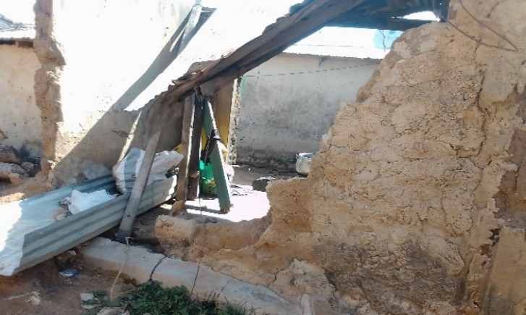
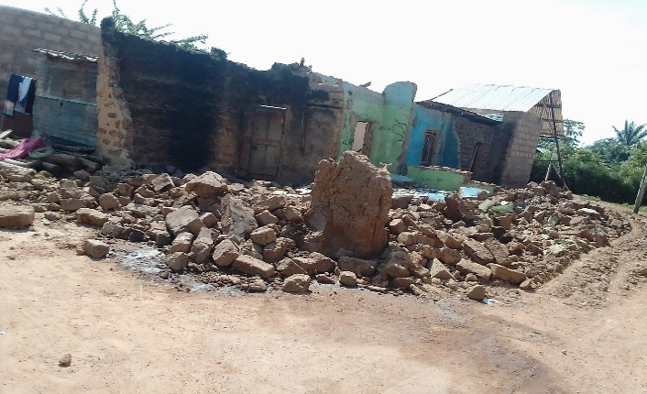

Figure 4.6: Picture of Collapsed of Buildings
Source; Field Data, 2022

Effects of floods on livelihoods
In this study, participants have asserted that, agriculture which is the major livelihood in the municipality and the country at large, has been negatively impacted by floods. The floods have submerged farmlands and crops such as maize, rice, beans, and yams. This resulted in food insecurity and worsened inequalities.
Last year, people’s farms and crops were submerged especially those around the valleys. Crops such as beans, rice and maize were affected. For maize and beans farmers, they did not harvest anything except the rice farmers. It was a total lost to them and they had nothing. It can carry your animals away but we have not experienced such (FGD, 24/05/22).
Similarly, a key informant shared his view on the effects of flooding. He said;
Our farm crops such as rice and maize were destroyed along the valley. Those who farm maize lost everything because maize does not want too much water but the water covered the crops for about two days and everything was destroyed (KII, 19/05/22).

Picture 4.7, is clear evidence of the flood’s destruction of agricultural production in the Wa municipality of Ghana. The maize farmers according to the participants suffered for nothing because they did not harvest anything.
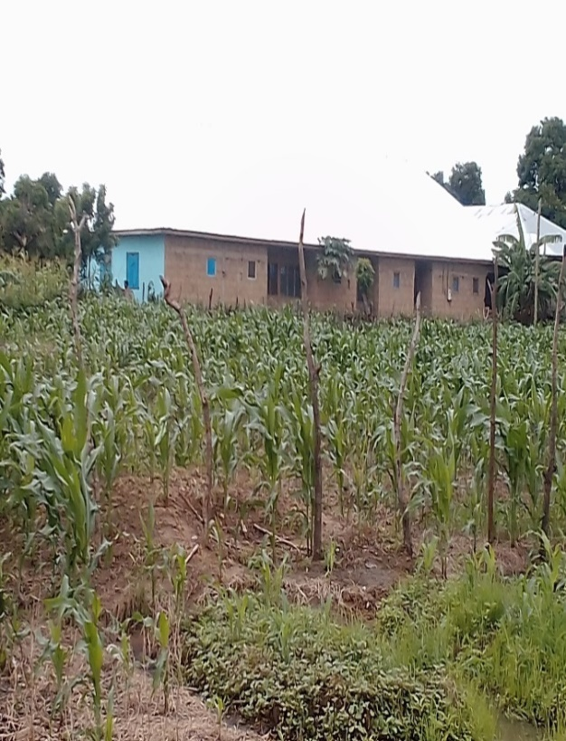
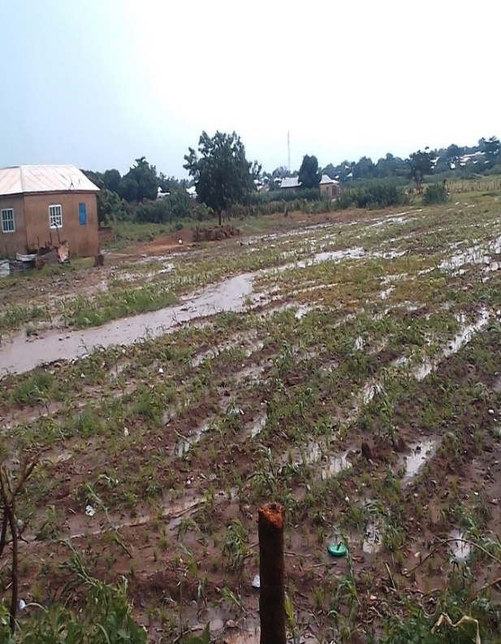

Figure 4.7: Effects of Flood on Farms in the Municipality
Source; Field Data, 2022

Effects of floods on road infrastructure
Also, it has been reported that, the occurrence of floods in the municipality has affected transport networks causing traffic disruption. In this study, it was observed that, the road that links Mangu community to the New Regional Market was under construction but floodwater washed away the compacted gravel and motorists cannot plough that road which has affected the movement of goods and services. Also, whenever there is flooding in Kumbiehi, part of the community is cut-off from accessing goods and services at the other side of the community and the central business district (CBD) at large. This has actually affected turnovers since some residents cannot go to their workplace so they lose their daily earnings.
In an interview with a key informant, this is what he shared;

The road was covered with water making it very difficult and scary for pedestrians and motorists to cross because they don’t know what could happen in the middle of the road. As a result, they could not go to work and that has affected their revenues and the little that they have saved was used for repairing of the buildings and buying of other lost properties (KII, 19/05/22).

It is evident from figures 4.8 and 4.9, how farmers, government workers, business men and women were struggling to plough through the road linking Mangu community and the New Regional Market and other parts of Kumbiehi respectively during the raining seasons.

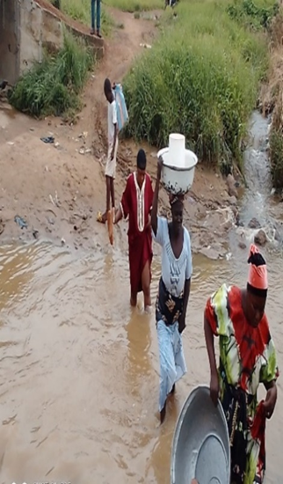
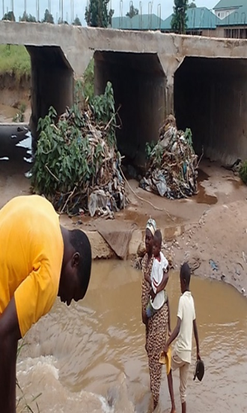
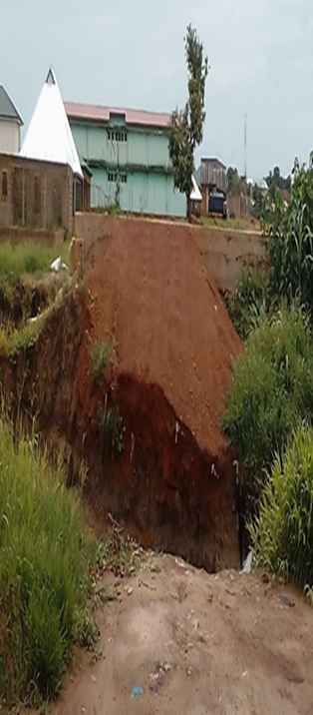

Figure 4.8; Difficulty in Accessing Road linking Mangu and the New Regional Market of Wa
Source: Field Pictures Taken on 16/07/22

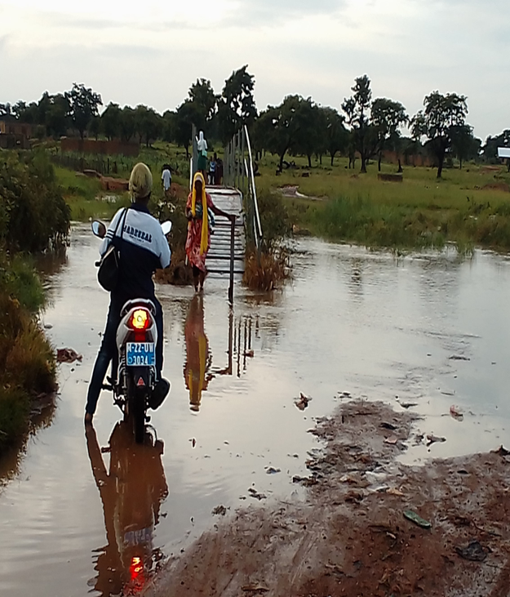

Figure 4.9; Difficulty in Accessing other parts of Kumbiehi (01/08/2022)

The impacts of floods have spanned space and time and is experienced by every social group in the municipality. The study has shown that flooding has impacted negatively on housing infrastructure, road infrastructure, human lives and health, livelihoods, agriculture among others. This results from the intensity of rainfall and location of the affected assets.

Household recovery after flood
It was necessary to assess the duration of households’ recovery after flood disasters in the municipality. This aids to determine their ability to recover after the destruction of floods. During the interviews, various recovering times were expressed by the participants. It took some households one month, some two to six months, others one year, and some others more than two years,whilst there are others who never recovered from the impact of flood in the Municipality. However, the duration of recovery depends on the magnitude of the destruction to the individual households.

Figure 4.10; Duration of households’ flood recovery
Source: Survey Data, 2022.

Figure 4.10, indicates the duration of households’ recovery after the occurrence of floods in the Municipality. Out of the 270 participants, 36.3% of the participants indicated that it takes one year for households to recover from the impacts of floods. As many as 21.5% of the participants affirmed that it takes 2 to 6 months for households to recover from the effects of floods, while 17.4% of the participants indicated that, it takes more than 2 years for households to recover from the flooding impacts, and 15.9% of the participants also confirmed that it takes one month for households to recover from the effects of floods whereas 8.9% of the participants mentioned that, there are other households who never recovered from the shock of the floods.
The survey results agree with the responses from key informants and focus group discussants reporting similar times of recovery after the incidence of floods. For instance, during an interview with a key informant on the duration of households’ recovery from the impacts of flooding, he said;
It takes sometimes about 3 to 5 months for people to recover. For most people it takes a year or more to recover from the effects of flooding. There are others who have not been able to recover from the shocks of the floods because they cannot afford to repair their homes and they are still living in the dilapidated houses (KII, 19/05/22).
During an interview with another key informant (Kumbiehi Assemblyman) he disclosed that recovery after flooding varies from among one household to another. This results from the kind of damage caused to the household and their adaptive capacity to bounce back to their normal stage.
This is what he said:
Recovering after flooding varies among the individual households. There are some of them who have not recovered yet. There are two to three households who are still staying in their collapsed mud-houses (atakpaama-houses) as a result of the flooding. Some have to leave their homes and come back in the dry season to renovate them and it can take them not less three months to renovate the house (KII, 18/05/22).
A focus group discussion with men Mangu revealed similar responses on the duration of households’ recovery after the occurrence of floods.
The destruction caused by floodwaters varies from community to community and household to household and even individuals. So, it is difficult to generally say this number of months or years but most households are able to come to their normal stage of life after one year of the flood disaster. However, there are some who always recover within a short time because they have the financial capacity but majority of the households recover after one year or two. There are others too who cannot recover even over three years if they don’t get help from people. So, recovering from flooding is really a serious burden for some households. Imagine how some households struggle to get their daily bread and floods also come to pull down their house. This kind of household will suffer for years to recover from the shock (FGD, 22/05/22).
The study also revealed that, about 36% of households take a maximum of one year to recover from the effects of floods whereas 9% of the households never recovered from the shock and destructions of floods in the municipality. This is due to their low adaptive capacity to resist, cope with, and recover from the impacts of the flood.

4.2.4 Vulnerability to Floods
This section presents the findings on how vulnerability to flooding is differentiated among the population. The section first looked at vulnerability by location of settlements and houses, vulnerability by gender, vulnerability of children to floods, vulnerability of the aged, vulnerability of the physically challenged and the most vulnerable social groups.

Vulnerability by location of settlements and houses
From the results, and the application of GIS it was revealed that the vulnerability of the population was dependent on the location of settlements and households in the municipality. The data collected through the GIS were used to generate spatial flood vulnerability maps which portrayed the spatial characteristics of the Municipality. Also, a 300m buffer zone analysis was conducted in the four study communities (Mangu, Kambali, Konta and Kumbiehi) as the standard issued by the Physical Planning Department as a shielding zone for waterbodies in the country. Physical development is mandated to offset 300m between waterbodies and development areas, but the situation seems to be different on the ground. The 300m buffer zone of each community’s waterbody was generated by applying the GIS displaying the waterbody or waterway in the middle as reference. Figure 4.11 shows the map of flood-prone communities in the Municipality.
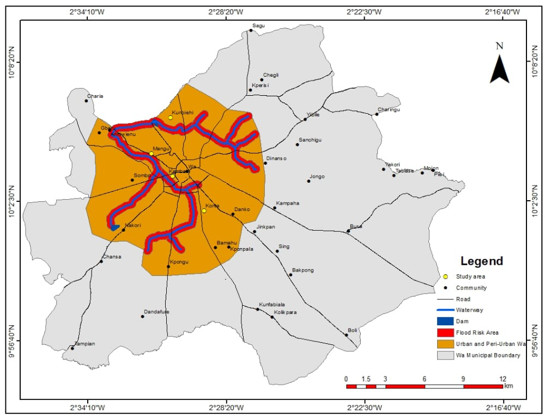

Figure 4.11: Map Showing Flood-prone Areas in Wa Municipality

Figures 4.12 and 4.13 display the buffer zones of Mangu and Kambali, and Kumbiehi and Konta in the Municipality respectively. It is clear in the figures that the spatial distribution of physical structures has spread into the standard protective buffer zone of 300m. There are clustered areas of residential structures in the selected waterbodies or waterways in the Municipality. There are 368 physical structures mapped in the buffer areas, out of which Mangu had 95 structures, Kambali 63 structures, Kumbiehi 115 and Konta 95 structures were captured. Thus, it is evident from the analysis that, the Municipality is vulnerable to flooding. This has been validated by the 2018 situational report on floods in Municipality that the most flooded communities were Kpaguri, Mangu, Kumbiehi, Konta, Water Village (New Hospital Area), Kambali, Dobile and Chokor (NADMO-Wa, 2018).
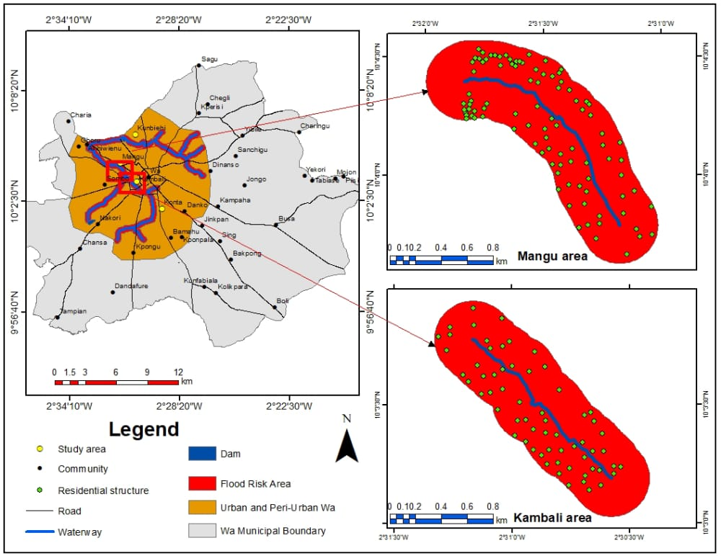

Figure 4.12: Map Showing 300m Buffer Zones of Mangu and Kambali of Wa Municipality

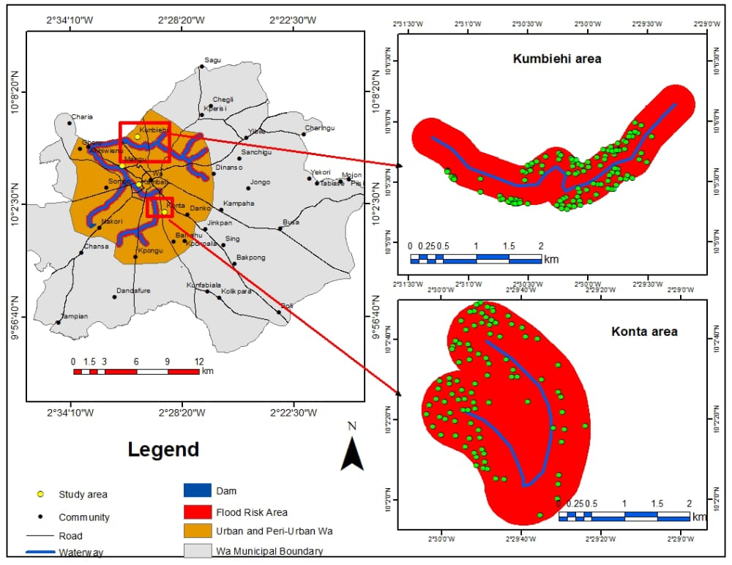

Figure 4.13: Map Showing 300m Buffer Zones of Kumbiehi and Konta of Wa Municipality

Vulnerability by gender
Vulnerability of men
As the effects of flooding are variously distributed among social groups in the household, this section discovered some of the effects of floods on men in the Municipality. During a focus group discussion with men in Mangu, it was revealed that flooding affects men in diverse ways including destruction of farmlands and crops, collapse of houses, and destruction of home appliances. They added that after destruction caused by floods in the house the responsibility rests on the shoulders of the man to repair or provide for the family. This is their response:
In this our society men are regarded as the head of the family. So, whatever destruction that is caused by the floodwater, it is the man who must see to it that the family comes back to life. For instance, if flood destroys your house and home appliances, and farm crops who is going to suffer more? It is you the man who will renovate or provide food and shelter for the family. Thus, everything always rests on the man in the family. So, sometimes the pressure on men is too much and some can lose their lives (FGD, 22/05/22).
A similar view was expressed by the Assemblyman of Mangu that flooding claims the lives of men, their farmlands and crops. Thus:
For men, it is their farm crops that are always destroyed. One man was on a bridge smoking and the floodwater carried him to Mangu and he died and Police came for his corpse. Aside that, whatever that is destroyed in the family it is the responsibility of the man to provide for the family. So, the men always protect their families from the effects of the flood (KII, 19/05/22).
Another key informant shared same view that men are the heads of the family and must take charge in the repair and provision of food, clothes, shelter among other things that are necessary for the family to survive. This is what he said:
You know, man whatever you do, you are the head of the family. So, if there is flooding whatever you have saved, you have to use it to invest in the family. For instance, if your house collapses, you the man must work hard to repair it, and provide food, clothing, books, uniforms, and other necessary items to bring the family back to life (KII, 18/05/22).
In the same vein, a key informant (Magazia) shared a similar opinion on how men are the family leaders and are struggling to provide for their families. This is how she expressed it:
Men, because they are the head of the family, they are the most affected persons in the household. They are responsible for providing everything in the family. If something is lacking in the family, they have to provide it for the family be it food, shelter, or clothing, it is their responsibility. So, when the water destroy their farm crops and house how to get food to feed the family is always very difficult for them. Some men are really struggling to take care of their families (KII, 22/05/22).
The qualitative data was used in developing themes which were used in the survey to ascertain whether participants agreed on the effects of floods on men in the Municipality. The survey results have revealed that men are diversely affected by floods in the Municipality. More than half (78%) confirmed that the effects of floods on men in the Municipality include collapse of buildings, injuries and loss of life, destruction of farm crops, clothes, bed/mattresses, home appliances, and foodstuffs (Table 4.5).

Table 4. 5: Effects of Floods on Men
Effects | Responses
Effects | Yes | % | No | %
- Collapsed buildings | 182 | 67.4 | 88 | 32.6
- Injuries and loss of life | 96 | 35.6 | 174 | 64.4
- Destruction of farms | 200 | 74.1 | 70 | 25.9
- Destructions of clothes and beds/mattresses | 202 | 74.8 | 68 | 25.9
- Destruction of homes appliance | 205 | 75.9 | 17 | 24.1
- Destroyed foodstuffs | 84 | 31.1 | 186 | 68.9
Overall Average (%) |  | 59.8 |  | 40.2
Source: Survey Data, 2022

Vulnerability of women
Flooding affects almost everyone depending on your spatial location and the climatic conditions. As a result, the effects of floods on women were explored in the Wa Municipality. During the exploratory interview with a key informant on the effects of floods on women, this is what he disclosed:
Flooding affects women’s dwelling places, clothing, foodstuffs, and business/trading activities. Imagine that you don’t have food to eat and your child is crying and following you; what would you do? You would become frustrated. They don’t have anything to wear, nor a place to sleep; how would they feel? So, women suffer a lot when floods occur and destroy their properties. If the place is wet, how can they set fire especially on the local stoves to cook? It will be difficult for them unless they use something to cover the ground before they set the fire (KII, 18/05/22).
Similarly, the effects of floods on women in the Municipality was shared by another key informant that women are sometimes frustrated when such incidents occur. He said:
Mostly it is the women that are affected. …. at times you know we men we can wear one attire for three days even a week but women cannot wear single set of clothing for even two days. There are days that women cannot even wear the same set of clothes for a whole day. So, when flooding occurs and destroys their clothing it affects them a lot. As you are the man, you would provide for your woman to prepare the food and you eat. Even in those areas it affects them because going out to beg someone for a space in a corner to cook in, they don’t have their own privacy. Maybe your family wanted to eat gari but because you are now staying with someone you would want to do things beyond your capacity. So, the effects of floods on women are both mental and physical (KII, 23/05/22).
A focus group discussion with Kumbiehi men also confirmed some of the effects of floods on women to include; destruction of clothing, foodstuffs, farm crops, and cooking utensils. It also affects their returns since they cannot go to work or do their businesses. This is what the men said;
Floods destroy women’s foodstuffs, clothing, and bedrooms. It also carries away their cooking utensils such as cooking pots, plates, bowls among others. When the place is flooded, women cannot go to their work places such as farms, provision shops, hair dressing shop, and dress-making shop and this affects their earnings in the end (FGD, 19/05/22).
Based on the qualitative data, themes were developed and used in the survey to establish the extent to which participants agree on the effects of floods on women in the Municipality. The survey results revealed that women were diversely affected by floods in the Municipality. As can be seen in Table 4.6, more than half (74.6%) of the respondents confirmed that, the effects of floods on women in the Municipality include collapse of buildings, injuries and loss of life, destruction of farm crops, clothes, beds/mattresses, home appliances, foodstuffs and difficulty in setting fire.

Table 4. 6: Effects of Floods on Women
Effects of floods | Responses
Effects of floods | Yes | % | No | %
- Collapse of building | 137 | 50.7 | 133 | 49.3
- Injuries and loss of life | 178 | 65.9 | 92 | 34.1
- Destroyed farm crops | 189 | 70 | 81 | 30
- Destroyed clothes and beds/mattresses | 257 | 95.2 | 13 | 4.8
- Destroyed homes appliance | 262 | 97 | 8 | 3
- Destroyed foodstuffs | 195 | 72.2 | 75 | 27.8
- Difficulty in setting fire | 192 | 71.1 | 78 | 28.9
Overall Average (%) |  | 74.6 |  | 25.4
Source: Survey Data, 2022

Vulnerability of children to floods
The effects of floods on children were assessed to determine the extent to which children are impacted by floods in the Municipality. It has been argued that children less than fourteen years are more vulnerable to flooding. Children are the future leaders and knowledge on the extent to which floods affect them will aid policy-makers to execute projects that can mitigate the impacts of floods on the children. The study discovered that children are affected by floods in various ways. An interaction with children between 14 to 17 years in Mangu Junior High School revealed how flooding affects them in the Municipality. The children disclosed that, whenever flood occurs, it destroys their books, clothing, shoes, uniforms and they cannot go to school. They complained of health problems during the peak of the rainy season in the Municipality. This is what they said:
We cannot go to school whenever flooding occurs. It always destroys our clothing, books, uniform and shoes. Sometimes we don’t go to school when floods occur because we can’t cross the water, and that has been affecting our performance in school. If we dare to cross, we can get carried away by the water or slip and fall and all our books and uniforms will get soaked. We easily get malaria and cold when the place is too wet (FGD, 24/06/22).
In an interview, a key informant revealed that flooding claims children’s lives and affect their educational performance since they are always unable to go to school during the season. He said:
Flooding affects children’s lives and education. In 2019, floods claimed a child’s life at Mangu here. Flooding has affected children’s education because whenever there is flooding, children cannot go to school. Children’s books and uniforms are always destroyed by the floodwater. Some even drop-out from school as a result (KII, 19/05/22).
Also, a focus group discussion with women unveiled the health effects of floods on residents especially children during the peak seasons of rains in the Municipality. They said:
(Singing a song) In August, the whole place is always full of water and children easily fall sick as a result. During this time, there are always a lot of illnesses on the children. Even we the adults are not safe, what more our children? When you send the child to the clinic, the nurse will tell you, we don’t have this medicine but will prescribe for you to go and buy (FGDs, 24/05/22).
Similarly, in a focus group discussion in Kumbiehi men also confirmed some of the effects of floods on children in the Municipality as follows:
Floods destroyed and carried away children’s clothing, sandals/shoes, books, and bags. They cannot go to school when there is flooding. Children easily drown or get carried away by the floodwater when they are returning from school and the place is flooded (FGD, 19/05/22).
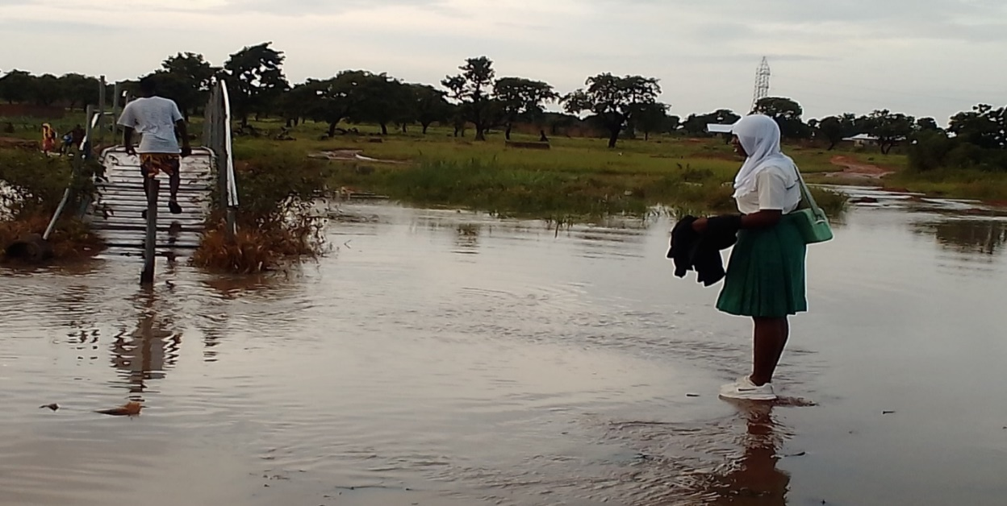
The argument made by the discussants has been confirmed in figure 10. As it clearly showed how school children are challenged in crossing a valley at Kumbiehi after returning from school to meet the valley flooded.

Figure 4.14; Difficulty of School Children Accessing a Road
Source: Field Picture taken on 01/08/22
A number of themes were developed from the qualitative data which were used in the survey to establish whether participants agree on the effects of floods on children in the Municipality. The survey results have validated the finding that children are diversely affected by floods in the Municipality. As more than half (87.8%) have confirmed that, the effects of floods on children in the Municipality include illness and loss of life, destruction of books and uniforms, clothes, beds/mattresses and absence from school (Table 4.7).

Table 4.7: Effects of floods on children in the Municipality
Effects | Responses
Effects | Yes | % | No | %
- Illness and loss of life | 238 | 88.1 | 32 | 11.9
- Their books and uniforms are always destroyed | 209 | 77.4 | 61 | 22.6
- Their clothes and beds/mattresses are always destroyed | 250 | 92.6 | 20 | 7.4
- Absence from school | 251 | 93 | 19 | 7
Overall Average (%) |  | 87.8 |  | 12.2
Source: Survey Data, 2022.

Vulnerability of the aged to floods
It has been argued that persons above sixty-four years are more vulnerable to flooding (Munyai, 2017). As a result, the effects of floods on the aged were assessed to determine the extent to which the aged are impacted by floods in the Municipality. An interview with participants revealed that flooding affects the aged just as every person in the society. It affects the health and life of the aged, destroys their belongings including; dwelling places, beds/mattresses, clothes, and foodstuffs.

This is what a key informant shared during an interview;
It is their properties such as clothing and other assets that are always destroyed. Mostly it is the family members that always rescue them from the flood incidents. No matter what, if they are in the room the water cannot enter their room to the point of killing them. The aged don’t go out when there is flooding because outside there, the water can easily carry them away (KII, 19/05/22).
Another key informant shared a similar view in an interview. This is what he said:
Just as it affects everyone, it also destroys the clothing of the aged, their foodstuffs, and their rooms. There are some who are so weak that without the assistance of the family or community members they will perish. So, there is no one that floods don’t affect. Because some of them are very weak, there is nothing they can do to prevent the water from entering their rooms (KII, 23/05/22).
In an interview with Kambali Magazie, she expressed the same view that the aged are affected just as anybody and more because they are helpless without the assistance of their family members. This is what she said:
An old person is just like a child; they can’t do anything. When the water comes it always destroys their properties such as clothing, foodstuffs, and make their rooms and beds wet. Some of the aged are even helpless without the assistance of the family members, so running for safety becomes a challenge to them when the place is flooded. If you cannot even walk, how do you prevent the water from entering your room? (KII, 27/05/22).

The survey results as clearly shown in (Table 4.8) that 72.5% of the respondents on average have attested to the fact that, the effects of floods on the aged include injuries and loss of life, destruction of foodstuffs, clothes and beds.

Table 4. 8; Effects of floods on the aged
Effects | Responses
Effects | Yes | % | No | %
- Injuries and loss of life | 150 | 55.6 | 120 | 44.4
- Clothes and beds/mattresses are always destroyed | 240 | 88.9 | 30 | 11.1
- Foodstuff destroyed | 197 | 73 | 73 | 27
Overall Average (%) |  | 72.5 |  | 27.9
Source: Survey Data, 2022.

Vulnerability of the physically challenged to floods
The effects of floods on the physically challenged were assessed to determine the extent to which they are susceptible to flooding in the Municipality. It has been argued that the physically challenged are highly susceptible to flooding (Munyai, 2017). Knowledge of the extent to which floods affect the physically challenged will inform policy-makers to execute projects that can mitigate the impacts of floods on the physically challenged in the Municipality and the country at large. The study discovered that, the physically challenged are affected by floods in several ways. Flooding affects the life of the physical challenged, destroys their bedrooms, clothing, foodstuffs, and makes it difficult for them to move their tricycles or carry away their tricycles. Various opinions were shared during an interview with focus groups and key informants. In an interview with a key informant (Kambali Magazie) she revealed that;
Belongings of the Physically Challenged are always destroyed by the water. Just like other people their foodstuffs, clothing, rooms, beds, and even their tricycles can be carried away by the water. The physically challenged, children, and the aged are always protected by members of the household because most of them are helpless when a flood occurs (KII, 27/05/22).

In an interview with the physically challenged they disclosed similar effects of floods on them. This is what they said:
For us the physically challenged, we only cry for help because there is nothing we can do when the floodwater comes. We the physically challenged, and the children, and the aged we are all the same unless someone comes to our rescue. But whatever that is affected in the household affects us more such as houses, crops, clothing; we always find it difficult moving our tricycles when floods occur. The water can even carry us away including our tricycles and we can die if there is no one around to rescue us (Physically Challenged, 23/05/22).
A similar view was expressed at a focus group discussion with Kambali women.
Floods destroyed foodstuffs, and clothing, of the physically challenged, and their dwelling places. It affects their movement since some crawl on the floor, some use tricycles, and others walk with crutches. So, the water mostly carried away their tricycle, crutches, or walking sticks and this affects their movement. There are others who are equally visually and hearing impaired (FGD, 24/05/22).
The qualitative data was used in the development of themes for the survey data. In all five themes were developed which include; injuries and loss of life, destruction of houses, clothes, beds/mattresses, tricycles carried away/destroyed, difficulty to move and destruction of foodstuffs were used to seek participants views on the effects of floods on the physically challenged in the Municipality. The results as indicated in table 4.9 revealed that more than half (71.5%) of the participants agreed that flooding affects the physically challenged in varied ways in the Municipality.

Table 4. 9; Effects of floods on the physically challenged
Effects | Responses
Effects | Yes | % | No | %
- Injuries and loss of life | 170 | 63.0 | 100 | 37.0
- Clothes and beds/mattresses are always destroyed | 240 | 88.9 | 30 | 11.1
- Tricycle carried away/destroyed | 207 | 76.7 | 63 | 23.3
- Difficulty to move tricycle | 204 | 75.6 | 66 | 24.4
- Foodstuff destroyed | 144 | 53.3 | 126 | 46.7
Overall Average (%) |  | 71.5 |  | 28.5
Source: Survey Data, 2022.

Most vulnerable social group
Vulnerability to flooding is socially differentiated among households and individuals. It was necessary to identify the social group that was most vulnerable to flooding to ensure social targeting intervention in the Wa Municipality. In assessing the social groups (women, men, children, the aged, and the physically challenged) most vulnerable to floods in the households, it was revealed that every living being is always affected. But it has been established that some are more vulnerable to floods due to their limited physical strength, access to information and social network.
In response to the question which social group is mostly affected by floods in the household, a key informant replied saying:
Flooding affects everybody because, let’s take this room; this is where we live. I have a wife and children, so if we sleep here and a flood occurs, where are we going to? We have to be up standing for some time, even if we will get a place to sleep it will take us time before. So, definitely it affects everybody including the community members because you have to depend on others to get food to eat, a place to put your properties, creating inconveniences and others. Let’s say, if my room doesn’t have enough space and a flood victim carries his belongings here, where will I and my family sleep? Where will I give to the flood victims to put their belongings and also sleep? So, flooding affects everybody within the community (KII, 23/05/22).
In the same vein, the Assemblywoman of Konta is of the view that even though flooding affects everyone, parents most especially women are the most affected social group. This is what she said:
Mostly when the flooding occurs, everyone is affected in one way or the other. But parents, especially women, are mostly affected because a man doesn’t stay at home. We the women, because we are always caring, you the men you are not caring. When it happens like that, they just move away and go to sleep at their girl-friend’s place or the other wife’s house leaving you the woman and your children. That night you will know what to do (KII, 23/05/22).
Another key informant argued that even though floods affect everyone the burden is always on the men as the heads or the bread winners of the family. In his own words;
Floods affects everyone. It doesn’t select some people to destroy their things and leave others. Everyone that is within the flood scene is affected one way or the other. You know, the man is always the head of the family so whatever that is affected in the family, it is the man that will provide, and ensure the family’s safety, so he is the most affected person even though the women help but their help is always meagre (KII, 27/05/22).
Also, in an interview with the Municipal NADMO Human Resource Personnel, this is what he said:
Women and children are mostly affected by floods in the Municipality because we (NADMO) have a data sheet that we always fill out which indicates that women and children are the most affected social groups in the communities. The data reveals that women and children are the most affected by the floods. Women and children are vulnerable and have limited resources (KII, NADMO 31/05/22).
The view of the Municipal NADMO Human Resource Personnel has been validated by 2018 the situational report on floods in Wa Municipality. The report revealed that about 567 children and 447 women were affected by the floods whereas 406 men were affected across the nine communities in the Municipality (NADMO-Wa, 2018). However, no data was given on the affected aged and physically challenged individuals in the flood affected communities in the Municipality.
Figure 4.15 shows the most vulnerable social groups to flooding in the Municipality. In the survey, respondents were asked to determine the most vulnerable social group to floods in the household and out of the 270 respondents, women had (34.4%), men (6.3%), children (42.2%), the aged (9.3%) and the physically challenged obtained (7.8%). This clearly showed that the most vulnerable social group to flooding within the households in the municipality is children closely followed by women, the aged, the physically challenged and men as the least. This is confirmation that floods affects everybody especially those within the inundation area.

Figure 4.15; Most vulnerable social group
Source: Survey Data, 2022.

The result revealed that social vulnerability to flooding is dependent on the location of settlements and houses in the municipality. Communities and households that are located in proximity to waterbodies or valleys are more exposed to the hazards of flood compared to households located on highlands in the municipality. The buffer zone analysis revealed that, households that are located in Mangu, Kambali, Kubiehi and Konta are vulnerable to flooding due to their physical exposure to rivers, valleys, floodplains, and wetlands. The study established that households and individuals that are located along the rivers, valleys, floodplains, and wetlands are economically vulnerable and cannot afford to rent at highlands or purchase parcels of land at the highlands to erect their houses. The study further revealed that, households’ vulnerability is socially differentiated and the most vulnerable social group is children, followed by men, women, the aged and the physically challenged as the least.

4.3 Results and Discussions

4.3.1 Incidence and causes of floods in the municipality
The result show that there is frequent incidence of floods in the Municipality. Every rainy season, communities and households in the municipality experience flooding not less than twice. Many households have suffered from flooding and continue to experience floods each year in the seasons, even early this year 2022. Many participants reported that their yards or compounds and rooms get flooded every year. The affected households mostly live with flood conditions ranging from 30 minutes to more than one day as reported. Evidence showed that the 2018 floods were more devastating as many victims and communities were affected (NADMO-Wa, 2018). Similarly, Rahman (2014) found a recurrent flood phenomenon in Bangladesh . Also, a study by Ansah et al. (2020) has established that in 18 out of the last 50 years Ghana has documented substantial flooding incidences(Ansah et al., 2020). Mensah and Ahadzie (2020) and Abass (2020) recognized that, flooding in Ghana especially urban flooding has become a perennial issue in terms of the scale and affected population. Abass (2020) revealed that there is rising incidence of flooding in Kumasi every year as, during and after any moderate and heavy rainfall, residents experience flood. In 2010 Ghana recorded an unprecedented flood incident (Mensah & Ahadzie, 2020) and the most devastating flood incident was recorded on the 3rd June 2015, after a heavy downpour coupled with an explosion of a fuel station (Ansah et al., 2020). The African continent is ranked second in flood disasters in terms of the incidence of flood events recorded (Ansah et al., 2020). It has also been reported that, the average annual flood incidence has increased by 181% (McLennan, 2021). This shows that the incidence of floods has spread across space.
It has been revealed in this study that the increasing incidence of flooding in the Municipality is caused by nature; rainfall intensity and anthropogenic activities even though the rainfall patterns in the municipality have been intermittent. Mostly anthropogenic activities such as building on waterways, poor planning of buildings, poor drainage systems, inappropriate dumping of waste, silted and choked drains/gutters and ineffective implementation of building and sanitation laws exacerbates the incidence of floods in the municipality. Rahman (2014) found causes of floods to include construction of roads and culverts without considering flooding, narrow drainage capacities and crowded settlements. Vazhuthi and Kumar (2020) discovered the factors that cause urban floods to include; meteorological, hydrological and human factors. Findings from Feloni et al. (2020) reported heavy downpour coupled with human activities and urbanization as the substantial causes of flood incidence. Mensah and Ahadzie (2020) established that, poor urban planning and development, poor and inadequate drainage facilities, poor environmental attitude, and extreme rainfall are the top causes of flooding in urban areas. Adelekan et al. (2015) discovered the factors that contribute to the rising incidence of flooding to include unplanned rapid urbanization, poor watershed management, and alteration in land cover, particularly in ﬂood plains. It is evident that land-use and development controls are ineffective in Ghana precisely in the Wa Municipality (Abugtane, 2015). The failures of local institutions have caused delays in the approval of permits, poor inspections of physical developments, non-compliance with development controls and poor enforcement of development controls as the factors influencing the rising incidence of floods. These institutional weaknesses have given room for potential developers and landholders to flout land-use and building regulations. Thus, the rising construction of residential structures on wetlands, rivers and other flood-prone locations increase the incidence of floods(Tasantab, 2019). Similarly, Abass (2020) established that the increasing incidence of floods is rooted in the weak institutional and legal frameworks. Likewise, Cobbinah et al. (2019) discovered that weak agency framework and coordination challenges such as logistics and enforcement of laws are factors contributing to the inability of cities to manage the incidence of floods. This has resulted in urban sprawl, unplanned city development, poor sanitation management practices and institutional ineffectiveness. Echendu (2020) also discovered poor or non-existent drainage systems, weak implementation of planning laws and corruption, unregulated urbanisation, and poor sanitation management system as the reasons for flooding in Nigeria. In the same vain, Adetunji and Oyeleye (2013) discovered poor waste management practices and high-rate of residential buildings situated on watercourses as the causes of the increasing incidence of flooding. As a result, Tasantab (2019) advised that permits should be approved on time, and physical development controls should be enforced by ensuring compliance as a strategy to reduce the incidence of flooding. In this study, it is established that land owners take advantage of the institutional weaknesses to sell out parcels of lands in floodplains and wetlands to developers causing the high incidence of flooding. A study by Mensah and Ahadzie (2020) revealed that, traditional rulers took great advantage of the inefficiencies of the local government departments and trade out parcels of lands in wetlands and along valleys. The actions of land owners and developers have significantly influenced the occurrence of floods. Abass (2020) stipulated that effective land-use and development controls, coupled with efficient waste management practices, are crucial for reducing the incidence of floods. In order to build sustainable communities and cities, it is therefore paramount for national and local levels planning agencies to rise up to their duties to ensure that physical development conformed with planning standards.

4.3.2 Effects of floods and recovery
Floods have a devastating effect on all sectors in the Municipality. It has been revealed in the study that flooding resulted in the collapse of houses and rendered many people homeless. Inundation of yards and rooms destroyed their home appliances, clothing, documents, books, and beds/mattresses. Similarly, Abass (2020) found that the occurrence of floods in Kumasi resulted in the collapse of buildings making many households homeless. It has been underscored in this study that the collapsed houses are mostly the mud-houses (atakpaama houses) which are weak and cannot withstand the volumes of floodwater under their foundations.
The study uncovered that flooding in the municipality claimed a number of lives. Similarly, on 3rd June 2015 a flood in Accra caused an explotion in a fuel station claimed over 152 lives in Ghana (Ansah et al., 2020; Mensah & Ahadzie, 2020). Flood disasters in Bangladesh accounted for over 30% lives lost (Rahman, 2014). Also, McLennan (2021) highlighted that flooding claimed over 250, 000 lives between 1980 and 2020 across the globe.
The study also found traffic disruption resulting from the negative impact of floods on road networks in the Municipality. Participants reported damage to roads and bridges which cut-off some communities and disrupted mobility. The collapse of bridges and roads made it very challenging for adults to go to their work places and for children to go to school. The implications are low returns on the part of adults and low educational performance on the part of children. This shows how transport systems support economic activity by aiding mobility of goods and services. In the situation of the Wa Municipality extreme flood events damage these transport networks, cutting-off communities from the central business district (CBD), and affected movements of goods and services and the rippling effect may be loss of lives, low returns, and other negative consequences. Pregnolato et al. (2017) noted that extreme flood events cause direct and indirect damage to transport infrastructure posing serious threat to human safety, significant mobility disruption, and economic costs. Also, transport networks are very crucial in emergency service delivery because they facilitate the process of restoration of lives (Bank, 2016). Thus, if road networks are disrupted, it can result in delays in rescuing flood victims, and delay in providing medical care and critical services to people in emergencies. Flood events also increase the task and cost of renovating roads by road authorities. This shows how damaged roads pose a threat to traffic, and human life.
Participants underscored the negative impact of floods on agricultural production. They reported that floods submerge their farm crops such as maize, beans, yam, rice and others. Ochieng et al. (2017) have it that the recurring floods is a menace to agricultural activities due to their destruction of grazing and farm lands, animals, and livelihoods. In same vain, Tuwilika (2016) found that, rural farmlands, crops, grazing lands, animals and trees were destroyed by floods. Also, Ara (2019) established that, flooding incidence has been frustrating farmers in Bangladesh by destroying their only sources of livelihoods especially in the low-lying landscapes.
Flooding in the municipality has impacted negatively on households’ health. It leads to injuries, outbreaks of diseases, flood debris, and emotional and psychological traumas. This study revealed that children easily fall sick during the peak of rainy seasons. Psychological trauma can occur when people lose a precious one or property. Dziwornu and Kugbey (2015) discovered psychological traumas amongst flood victims and proposed quick redress of their psychological needs. Floods not only devastate homes, agriculture, and public goods but they are a threat to human health and safety (Husain et al., 2018). The incidence of floods has worsened the health status of inhabitants through the incidence of water-borne diseases, animal bites, and injuries mainly among the poor (Songsore, 2017). It has also been established by Ochieng et al. (2017) that flooding destroys health infrastructure and impedes the accessibility to healthcare services.
This study also underscored the economic loss of residents in the municipality as a result of floods. Many individuals and households reported to have lost their livelihoods, turnovers and incurred costs for repairing or renovating their properties. Izevbuwa and Adeolu (2015) found that, flooding had increased income inequality by 123% among flood victims despite government compensation. Yamamoto and Naka (2021) discovered that floods hurt the ratio of profit to sales in the manufacturing industry and this tends to increase for firms located in Municipalities that experienced floods. The direct and indirect economic losses resulting from floods in Namibia has been estimated to be US$136.4 million (Tuwilika, 2016). A study by McLennan (2021) discovered that, the rippling effect of floods has increased the average annual economic losses by 275%. Evidence therefore shows that as flooding incidence increases, the effect also rises as individuals, households, organisations and the society are negatively affected. This has aggravated the inequality levels mostly in the poorer regions like the Upper West.
Recovering after flooding varies greatly among individual households. This study has revealed that some households typically took one month, some two to six months, others one year, and some others more than two years to recover, whilst there are others who never recovered from the impact of flooding in the Municipality. The duration of recovery depends on the magnitude of the destruction caused by floodwaters to the individual households and the ability of these households to bounce back to their normal life or even better. The inability of households to recover is due to their socioeconomic vulnerability which makes these households incapacitated to prepare, resist, cope with, adapt to, and recover from the flood’s impacts. Erman et al. (2018) in their study found that more than 30 percent of the affected households report not having recovered two years after the shock, and the ability of households to recover was driven by the magnitude of their losses, sources of income, and access to coping mechanisms, but not by their poverty, as measured by the annual expenditure level. Similar findings have been made by other scholars. Mtembenuzeni and Kushe (2018) noted a long duration of flood recovery typical among the more vulnerable individual households over households with access to relief services. Households who have access to shelter, food, wealth, and land recovered fast from the flood hazard and others circumvented the impacts, unlike households without resources who depended on government relief services and other organizations for relief. In the same way, Kurosaki (2017) found that, households with a high magnitude of damage to their properties recovered slowly because recovery continued after one year. This is as a result of the magnitude of the flood destruction and perhaps their economic vulnerability has also influenced their inability to recover on time. It was underscored that gender disparities influence the duration and capacity of recovery from flood effects. The study established that women are resource limited compared to men, hence lack the capacity to recover on time unlike men. It is in this vein that, Gaisie et al's. (2021) study found that female-headed families lack the capacity to prepare for, cope with, and recover from the effects of floods due to their projected gender roles, comparatively larger household sizes, care responsibilities, lower employment levels, and inadequate resources. The gender disparities disclose a sensitivity to disaster recovery and resilience planning and management.

4.3.3 Social vulnerability to flooding in the Municipality

Vulnerability by Location of Settlements and Houses
The study revealed that social vulnerability to flooding is dependent on the location of communities and households. Households that are located close to rivers, watercourses, wetlands and floodplains are more exposed to flooding as compared to households located upland. Social vulnerability is the predisposition of a community or household to be affected by flooding (Pathak et al., 2020). The location of communities and households in floodplains or near rivers in the Wa Municipality increases their vulnerability to flooding. The 300m buffer zone analysis discovered 368 physical structures located in the inner zones which are excluded from physical development by the Ghana physical planning unit, which depicts the vulnerability of the municipality. This has resulted in the high incidence of flooding, even with less or moderate rainfalls in the municipality. Thapa and Thapa (2021) discovered more than 3,000 settlements in Nepal vulnerable to flooding due to their proximity to streams and waterlogged areas. A high physical vulnerability was discovered by mapping the elements located within the flood risk zones (Hoque et al., 2019). Daura and Mayomi (2015) discovered Benue Basin to be highly vulnerable to flood. Similarly, Mayomi et al. (2014) found communities almost located in the Niger valley that are highly vulnerable to flood while others located in the plains were vulnerable to floods. Ha et al. (2021) found a high and very high flash flood susceptibility in Vietnam. Warlina and Guinensa (2019) discovered high susceptibility with 19%, moderate susceptibility with 35%, and low flood susceptibility 45% in their flood susceptibility mapping in Indonesia . Akukwe and Ogbodo (2015) also uncovered an increase in the physical patterns of the vulnerability levels towards the northwest, southwest, south, and northeast, with a decrease toward central Port Harcourt. Hoque et al. (2019) found that, communities that are located within the eastern and south-western parts of the study area were highly vulnerable to floods due to their low elevation, proximity to the active watercourses and more socially vulnerable than other parts. Similarly, Hamidi et al. (2022) discovered that the southern zones of Pakistan were highly exposed to flood disasters because they have the larger sum of inundation sites, lowlying areas and very short distances away from the rivers with larger family sizes, more aged persons, women and children, high uneducated and low economic ability to cope with the incidence of floods. Evidence showed that, vulnerability to flooding is influenced by the socioeconomic and demographic structures. As established by Mahmood and Hamayon (2021) vulnerability to flooding in their study communities resulted from their socio-demographic and economic characteristics.
Therefore, it is underscored in this study that, the households that are located along rivers, valleys, wetlands, or floodplains are financially limited individuals who found it challenging to rent at highlands or purchase a parcel of land upland to erect their houses. Evidence from Table 4.1 shows how employment and income status explained the vulnerability of participants to flooding. Majority (63%) are self-employed and earn less income per month which limits their ability to adapt to the flooding situation. Households with low-income are unable to prepare for, relocate, adapt to, and recover from flood shocks. Jamshed et al. (2020) highlighted that the income level of households affects the demand for urban goods, and the area of employment determines their ability to resist, mitigate, cope with, or recover after flood events. McLennan (2021) argued that floods are social justice issues, unduly affecting individuals and households at the bottom stages of the socioeconomic hierarchy. Marginalised groups mainly with lower incomes and lower levels of socioeconomic security, are often more exposed and more vulnerable to flood disasters. This explained why households of flood-prone zones are unable to prepare for, and cope with the floods resulting in the rising losses of lives, livelihoods and other properties in the municipality.

Vulnerability by Gender
Gender is a significant variable in determining social vulnerability to floods because the impact of floods varies between males and females. In this study, women were the second most vulnerable and susceptible social group to floods as compared to men in the Municipality (figure 4.5). Rana and Routray (2018) also found that males are less vulnerable to floods than females due to their physical strength and mobility. Rana et al. (2020) however contested the view that the types of jobs and income influences the flood hazard perception. It has also been established that employment shapes individuals’ and households’ ways of living due to financial weakness or strength (Munyai, 2017). In this study, female vulnerability to flooding results from their low-income levels compared to males because most of the participants were self-employed (e.g, dressmaking, hair-dressing, food vending, pito-brewing, petty trading, farming etc) and earned less income per month. This has affected females’ ability to prepare for, cope with, and recover from the impacts of flood disasters in the municipality. Jamshed et al. (2020) and Munyai et al. (2021) noted that females are more vulnerable due to their limited physical strength, social networks and access to information resulting from traditional and cultural norms. Generally, women’s access to resources especially in Northern Ghana is disproportionate to men and that has reduced their flood adaptive capacity thereby making them more vulnerable. It is clear that females are more destitute compared to males. Kirby et al. (2019) found that females experience more challenges in the process of recovering from flood disasters than men due to their lower wages and household tasks. Females have less representation in full-time jobs compared to men, perhaps as a result of their low educational attainment and responsibility of child care making them more vulnerable to disasters. Naz and Saqib (2021) revealed that the effects of floods vary for females and males and that overall females were more susceptible to floods due to their gender associated customs. The disparities in the males and females’ vulnerabilities affected their adaptive capacities to prepare for and recover after the floods or adapt to new strategies. This contradicts Salvati et al's. (2018) findings that, males are more susceptible to inundations and landslides for most age groups than females. This finding supports a statement made by a key informant in this study that “Floods affect everyone. ….., the man is always the head of the family so whatever that is affected in the family, it is the man that will provide, and ensure the family safety, so he is the most affected person even though the women help but their help is always meagre (KII, p:105)”. As a result, Rana et al.(2020) established that there are no gendered disparities that influence flood risk perception.
Vulnerability of Children to Floods
The study revealed that children’s vulnerability to flood includes illness and loss of life, destruction of books and school uniforms, destructions of clothes, and beds/mattresses, and absence from school. The results further indicated that children are the most vulnerable and susceptible social group to flooding in the Municipality (figure 4.15). In this study, children under 18 years are considered to be vulnerable to flood disasters. Children in the earliest ages cannot defend themselves in the event of disasters like floods because they are physically feeble, lack the needed resources, knowledge, or the experiences to effectively resist, escape, or cope with the flood situation. A study by Makaruk and Afridi (2020) found that under five years children are the most vulnerable age group to the flood hazard in Punjab. Also, Stoklosa et al. (2021) found that the occurrence of floods resulted in child trafficking, whereas Ardales et al. (2016) discovered that floods cause damage to a school which resulted in the halting of normal teaching and learning. As a result, it disrupted children’s attendance to school, teaching and learning, and performance of pupils. Similarly, Kousky (2016) found that flood disasters interrupted children’s education through the displacement of families, collapse of schools and as well pushed children into labour force to assist their parents meet family needs. This study also discovered that floods negatively affect children’s health and increase cost of treatment while others lost their lives. This has been confirmed in the study of Kousky (2016) that floods disproportionately affect children’s physical health through injuries or drowning, or diarrheal illness, or malnutrition caused by disruptions in the food supply chain. They may also suffer mental health problems resulting from losing a precious one or property. On the contrary, Sajid et al.,(2021) in their overall analysis found weak floods impacts on children’s health in their study area.
Vulnerability of the Aged to Floods
Age is a necessary variable in determining social vulnerability to floods. In this study persons 60 years and above were considered as aged, and the result revealed that the aged are the third most vulnerable social group (figure 4.15) to flood disasters due to their physical weakness, financial limitations, and limited social networks. Also, living alone, or having cognitive challenges, the aged are more exposed to flood hazards. Most of these aged need special assistance, and family members might be unable to assist them during the event of flood disasters. Omolo and Mafongoya (2019) established that elderly women were the most vulnerable group, followed by elderly men to climate-related disasters like floods because they are fragile and economically deprived individuals in the community. Munyai (2017) discovered that physical weakness and the economic dependence of most aged aggravate their social susceptibility to floods. Similar findings were discovered by Kirby et al. (2019) that individuals who are 65 years and older, are more susceptible to flooding and are mostly challenged in preparing for, coping with and recovering from flood disasters. Also, Lee and Vink (2015) exposed in their goodness-of-fit test that individuals with their ages “greater than or equal to seventy” were vulnerable to flood fatalities. Their study concluded that individuals with ages greater than or equal to seventy are more than three times vulnerable to flood hazards and fatalities than individuals with ages less than seventy. This could be as a result of their physical weakness and economic susceptibility to resist, prepare for, adapt to, or mitigate the effects of floods.
Arguably, the aged must not be disregarded because to their old age; they are the people who have the experience and have established various mitigation and methods of coping with floods and its effects (Munyai et al., 2021).
Vulnerability of the Physically Challenged to Floods
The effects of floods on the physically challenged were reported to include; injuries and loss of life, destruction of clothes and mattresses, loss of tricycles, difficulty to move tricycle, and destruction of foodstuffs which showed how susceptible this social group are to flooding in the municipality. The study showed that the physically challenged were the fourth most vulnerable and susceptible social group to flood disasters in the municipality (figure 4.15). This is because they are mobility limited individuals and may not be able to escape or relocate without the assistance of others when floods occur. Also, they are resources limited individuals and thus, cannot prepare for, adapt to, and recover from the effects of floods. Jamshed et al. (2020) found that households having persons suffering from mental or physical handicap are more susceptible to flood events. Munyai (2017) discloses that persons with disabilities face a lot of limitations in preparing for, adapting to disasters by relocating or using sand-bags to block floodwater. In a similar vein, Gaskin et al. (2017) found that the physically challenged individuals are vulnerable to climate-related hazards like floods mainly due to inequalities and their exclusion from mitigation and adaptation actions.
It has been revealed that the physically challenged disproportionately and differently suffered from the impacts of floods disasters, and as a result, Chisty et al. (2021) stipulated that dissemination of early warning disaster information is a significant way to mitigate the impacts of disasters on persons with disabilities. Arguably, even if the physically challenged receive flood warning information but lack the capacity to prepare for, resist, cope with, or adapt to, they are likely to still suffer from impacts of floods.

4.4 Conclusion
The study reveals that there is perennial flooding in the Wa Municipality. It mostly occurs twice between the months of August and September. The frequent occurrence of floods is caused by rainfall intensity and human activities like building on waterways, poor planning of buildings, poor drainage systems, inappropriate dumping of waste, silted and choked drains/gutters and ineffective application of building and sanitation laws.
The study also found that the frequent occurrence of floods, impacted negatively on housing infrastructure, road infrastructure, human lives, health, livelihoods, agriculture among others. It took majority of the households a maximum of 1 year to recover from the impacts of the flood while others never recovered from the flood shock due to their low socioeconomic capacity to resist, cope with, and to recover from the impacts of the floods.
The result further showed that, social vulnerability to flooding is dependent on the location of settlements and households in the municipality. Communities and households that are located in proximity to waterbodies or valleys are more vulnerable to flooding compared to households that are located on highlands in the municipality. The geospatial analysis revealed that households that are located in Mangu, Kambali, Kubiehi and Konta are more vulnerable to flooding due to their physical exposure to rivers, valleys, floodplains, and wetlands. The study established that households and individuals that are located along these waterbodies are economically vulnerable and cannot afford to rent at highlands or purchase parcels of land at the highlands to erect their houses. The study further revealed that households’ vulnerability is socially differentiated and the most vulnerable social groups are children due to their socioeconomic and physical characteristics.

CHAPTER FIVE

CONCLUSION AND RECOMMENDATIONS

5.1 Introduction
This study set out to explore the incidence of social vulnerability to floods in Wa Municipality of the Upper West Region of Ghana. This chapter presents the conclusions and some recommendations.

5.2 Conclusions
Incidence and causes of floods
The analysis reveals that inundations occur annually in the Municipality during and after any thunderstorm. Mostly residents experienced flooding twice between the months of August and September. The frequent occurrence of floods results from human activities and heavy rainfall. The human causes of floods were reported to be building on waterways, poor planning of buildings, poor drainage systems, inappropriate dumping of waste, silt-up and choked drains/gutters and ineffective enforcement of building and sanitation laws.
Effects of floods and recovery
The impacts of floods span space and time and is experienced by every social group in the municipality. The study shows that flooding has impacted negatively on housing infrastructure, road infrastructure, human lives, health, livelihoods, agriculture among others. This results from the intensity of rainfall and location of the affected assets. The study also revealed that 36% of households take maximum 1 year to recover from the effects of floods whereas 9% of the households never recovered from the shock and destruction of floods in the municipality. This is due to their low adaptive capacity to resist, cope with, and recover from the impacts of the flood.
Social vulnerability to flooding
The results show that social vulnerability to flooding is dependent on the location of settlements and houses in the municipality. Communities and households that are located in proximity to waterbodies or valleys are more susceptible to floods compared to households located on highlands in the municipality. The buffer zone analysis revealed that households that are located in Mangu, Kambali, Kubiehi and Konta are more vulnerable and susceptible to flooding due to their physical exposure to rivers, valleys, floodplains, and wetlands. The study established that households and individuals that are located along the rivers, valleys, floodplains, and wetlands are economically vulnerable and cannot afford to rent at highlands or purchase parcels of land at the highlands to erect their houses. The study further revealed that households’ vulnerability is socially differentiated and the most vulnerable social group is children and closely followed by women due to their physical weakness and socioeconomic status.

5.3 Recommendation
The perennial flooding in the Municipality is viewed to be caused by both rainfall variations and human activities such as building on waterways, poor planning of buildings, poor drainage systems, inappropriate dumping of waste, silt-up and choked drains/gutters and ineffective enforcement of buildings and sanitation bye-laws. Therefore, this study puts forward the following recommendations:
- The study recommends effective enforcement of the National Building Regulations 1996, (LI 1630) by the Municipal Assembly in order to eradicate the human causes of flooding to reduce the incidence and effects of floods in the Municipality. This can be achieved through the Municipal Planning Authorities as mandated by the Local Government Act, 1993 (Act 462) to enact building bye-laws, issue and approve permits at the appropriate site before a physical development project can be carried out. The effective enforcement of these building regulations will ensure order in settlement development and prevent disasters like floods.
- Also, adequate drainage systems should be constructed by the Municipal Assembly. The existence of proper drainage systems allows the free flow of runoff water into rivers or reservoirs thereby reducing the incidence and effects of floods in the municipality. It is also suggested that, the Municipal Assembly should educate households on the implications of indiscriminate disposal of waste and intensify waste collection and management in the Municipality to prevent the siltation and choking of drains/gutters thereby reducing the incidence of floods.
- Furthermore, the study recommends the provision of flood early warnings to flood-prone communities or households by the National Disaster Management Organisation in collaboration with Ghana Meteorological Agency to enable the residents to prepare for, cope with and recover from flood disasters. Also, a quick delivery of emergency and relief services to victims during and after flooding by NADMO will help alleviate the effects of floods on the affected people.
- Finally, this study highlights the need for the Municipal Assembly to undertake practical and healthy adaptation planning to shape the resilience of residents to floods. The Municipal Planning Authorities can do this by educating flood-prone residents and encouraging them to relocate with some support from the Municipal Assembly. In addition, unauthorised buildings or buildings located on sites liable to flooding and without adequate provision for flood control should be demolished by the Municipal Assembly.

REFERENCE
Aabeyir, R., & Aduah, M. (2014). Assessment of encroachment of urban streams in Ghana: A case study of Wa Municipality. Journal of Natural Resources and Development, 10–17. https://doi.org/10.5027/jnrd.v4i0.02
Abass, K. (2020). Rising incidence of urban floods : Understanding the causes for flood risk reduction in Kumasi , Ghana. GeoJournal, 9. https://doi.org/10.1007/s10708-020-10319-9
Abugtane, A. F. (2015). Assessing the effectiveness of physical development planning and control mechanisms inGhana:The experience of Wa Municipality. Kwame Nkrumah University of Science and Technology,.
Academy of Disaster Reduction and Emergency Management, Ministry of Emergency Management - Ministry of Education National Disaster Reduction Center of China, M. of E. M. I. institute of the M. of E. M. (2019). 2018 Global Natural Disaster Assessment Report. Wonderful Wasteland and Other Natural Disasters, 46–47. https://www.emdat.be/
Acharya, A. S., Prakash, A., Saxena, P., & Nigam, A. (2013). Sampling: why and how of it? Indian Journal of Medical Specialities, 4(2), 3–7. https://doi.org/10.7713/ijms.2013.0032
Adelekan, I. (2015). Integrated Global Change Research in West Africa : Flood Vulnerability Studies. https://doi.org/10.1007/978-3-319-16477-9

Adelekan, I., Johnson, C., Manda, M., Matyas, D., Mberu, B. U., Parnell, S., Pelling, M., Satterthwaite, D., & Vivekananda, J. (2015). Disaster risk and its reduction: An agenda for urban Africa. International Development Planning Review, 37(1), 33–43. https://doi.org/10.3828/idpr.2015.4
Adetunji, M., & Oyeleye, O. (2013). Evaluation of the causes and effects of flood in Apete , Ido Local. Civil and Environmental Research ISSN 2224-5790 (Paper) ISSN 2225-0514 (Online) Vol.3, No.7, 2013, 3(7), 19–27. www.iiste.org
Adger, W. N. (2006). Vulnerability. Global Environmental Change, 16(3), 268–281. https://doi.org/10.1016/j.gloenvcha.2006.02.006
Afriyie, K., Ganle, J. K., & Santos, E. (2018). ‘The floods came and we lost everything’: Weather extremes and households’ asset vulnerability and adaptation in rural Ghana. Climate and Development, 10(3), 259–274. https://doi.org/10.1080/17565529.2017.1291403
Akukwe, T. I., & Ogbodo, C. (2015). Spatial analysis of vulnerability to flooding in Port Harcourt metropolis, Nigeria. SAGE Open, 5(1). https://doi.org/10.1177/2158244015575558
Ali, M., David, M. K., & Ching, L. L. (2013). Using the Key Informants Interviews (KIIs)Technique: A Social Science Study with Malaysian and Pakistani Respondents.
Almoradie, A., de Brito, M. M., Evers, M., Bossa, A., Lumor, M., Norman, C., Yacouba, Y., & Hounkpe, J. (2020). Current flood risk management practices in Ghana: Gaps and opportunities for improving resilience. Journal of Flood Risk Management, 13(4). https://doi.org/10.1111/jfr3.12664
Amoako, C., & Boamah, E. F. (2015). The three-dimensional causes of flooding in Accra, Ghana. International Journal of Urban Sustainable Development, 7(1), 109–129. https://doi.org/10.1080/19463138.2014.984720
Amoako, C., Kweku, D., & Inkoom, B. (2017). The production of flood vulnerability in Accra , Ghana : Re-thinking flooding and informal urbanisation. https://doi.org/10.1177/0042098016686526
Anande, D. M., & Luhunga, P. M. (2019). Assessment of Socio-Economic impacts of the December 2011 flood event in Dar es Salaam, Tanzania. Atmospheric and Climate Sciences, 09(03), 421–437. https://doi.org/10.4236/acs.2019.93029
Ansah, S. O., Ahiataku, M. A., Yorke, C. K., Otu-Larbi, F., Yahaya, B., Lamptey, P. N. L., & Tanu, M. (2020). Meteorological analysis of floods in Ghana. Advances in Meteorology. https://doi.org/10.1155/2020/4230627
Ara, M. J. (2019). Effect of floods on farmer’s livelihood: A case study for building agriculture resilient to floods in Bangladesh. International Journal of Science, Environment and Technology, Vol. 8, No 2, 2019, 334 – 344 ISSN, 8(2), 334–344. www.ijset.net
Ardales, G. Y. J., Lasco, D. R., Espaldon, M. victoria O., & Quimbo, M. A. T. (2016). Impacts of floods on public schools in the Municipalities of Los Banos and Bay, Laguna. Journal of Nature Studies 15 (1): 19-40 ISSN: 1655-3179. https://www.researchgate.net/publication/320490757
Asenahabi, B. M. (2019). Basics of Research Design : A Guide to selecting appropriate research design. 6(5).

Attipoe, S. K. (2014). An assessment of flood mitigation measures in Accra, Ghana. Kwame Nkrumah university of science and technology.
Balica, S. F., Douben, N., & Wright, N. G. (2009). Flood vulnerability indices at varying spatial scales. Water Science and Technology, 60(10), 2571–2580. https://doi.org/10.2166/wst.2009.183
Bank, W. (2016). Flood risk in road networks. International Bank for Reconstruction and Development / The World Bank, 1–24.
Bhandari, P. (2022). Ethical Considerations in Research:Types & Examples. https://www.scribbr.com/methodology/research-ethics/ Retrieved on October 4, 2022, from
Bhardwaj, P. (2019). Types of sampling in research. Journal of the Practice of Cardiovascular Sciences, 5(3), 157. https://doi.org/10.4103/jpcs.jpcs_62_19
Boakye, W. A., Bawakyillenuo, S., & Agbelie, I. (2018). Diagnoses of the adaptive capacity of urban households to floods: Th case of Dome community in the Greater Accra Region of Ghana. Ajol.Info, 10(2), 1–22. https://doi.org/https://dx.doi.org/10.4314/gjg.v10i2.1
Braun, V., Clarke, V., & Weate, P. (2016). Using thematic analysis in sport and exercise research. Routledge Handbook of Qualitative Research in Sport and Exercise, 213–227. https://doi.org/10.4324/9781315762012-26
Bubeck, P., Otto, A., & Weichselgartner, J. (2017). Societal impacts of flood hazards. Oxford Research Encyclopedia of Natural Hazard Science, 1–29. https://doi.org/10.1093/acrefore/9780199389407.013.281

Chisty, M. A., Nazim, A., Rahman, M. M., Dola, syeda E. A., & Khan, A. (2021). Disability inclusiveness of early warning system : a study on flood- prone areas of Bangladesh. https://doi.org/10.1108/DPM-05-2021-0177
Clarke, V., & Braun, V. (2013). Teaching thematic analysis : Overcoming challenges and developing strategies for effective learning Associate Professor in Sexuality Studies Department of Psychology Faculty of Health and Life Sciences University of the West of England Coldharbour Lane Br. 26, 120–123.
Cobbinah, P. B., Asibey, M. O., Opoku-Gyamfi, M., & Peprah, C. (2019). Urban planning and climate change in Ghana. Journal of Urban Management, 8(2), 261–271. https://doi.org/10.1016/j.jum.2019.02.002
Coq-Huelva, D., & Asián-Chaves, R. (2019). Urban sprawl and sustainable urban policies. A review of the cases of Lima, Mexico City and Santiago de Chile. Sustainability (Switzerland), 11(20). https://doi.org/10.3390/su11205835
Creswell, J. W. (2007). An introduction to mixed methods research. Research Methods in Public Administration and Nonprofit Management, 415–425. https://doi.org/10.4324/9781315181158-36
Creswell, W. J. (2009). Research design: Qualitative, quantitative, and mixed methods approaches (3rd editio).
Creswell, W. J. (2012). Educational Research Planning,Conducting, and Evaluating Quantitative and Qualitative Research (4th editio).
Cutter, S. L. (2010). Social Science Perspectives on Hazards and Vulnerability Science. https://doi.org/10.1007/978-90-481-3236-2

Cutter, S. L., Carolina, S., Boruff, B. J., Carolina, S., Shirley, W. L., & Carolina, S. (2003). Social Vulnerability to Environmental Hazards n. 84(2).
Dalu, M. T. B., Shackleton, C. M., & Dalu, T. (2018). Influence of land cover, proximity to streams and household topographical location on flooding impact in informal settlements in the Eastern Cape, South Africa. International Journal of Disaster Risk Reduction, 28, 481–490. https://doi.org/10.1016/j.ijdrr.2017.12.009
Daura, M. ., & Mayomi, I. (2015). Geo-spatial assessments of flood disaster vulnerability of Benue and Taraba States. 6(November), 166–183.
De Silva, M. M. G. T., & Kawasaki, A. (2020). A local-scale analysis to understand differences in socioeconomic factors affecting economic loss due to floods among different communities. International Journal of Disaster Risk Reduction, 47, 101526. https://doi.org/10.1016/j.ijdrr.2020.101526
Dekongmen, B. W., Kabo-bah, A. T., Domfeh, M. K., Sunkari, E. D., Dile, Y. T., Antwi, E. O., & Gyimah, R. A. A. (2021). Flood vulnerability assessment in the Accra Metropolis, Southeastern Ghana. Applied Water Science, 11(7), 1–10. https://doi.org/10.1007/s13201-021-01463-9
Derbile, E. K., Chirawurah, D., & Naab, F. X. (2021). Vulnerability of smallholder agriculture to environmental change in North-Western Ghana and implications for development planning. Climate and Development. https://doi.org/10.1080/17565529.2021.1881423
Doswell, C. A. (2003). Flooding. Journal of Planning and Environment Law, 7, 808–809. https://doi.org/10.5040/9781501397585.0009

Dottori, F., Mentaschi, L., Bianchi, A., Alfieri, L., & Feyen, L. (2020). Adapting to rising coastal flood risk in the EU under climate change. https://doi.org/10.2760/14505
Dzialek, J. (2019). Social vulnerability as a factor in flood. Springer Nature Switzerland AG. https://doi.org/10.1007/978-3-030-04594-4
Dziwornu, E., & Kugbey, N. (2015). Mental Health Problems and Coping among Flood Victims in Ghana : A Comparative Study of Victims and Non-Victims. https://doi.org/10.3844/crpsp.2015.
Echendu, A. J. (2020). The impact of flooding on Nigeria’s sustainable development goals (SDGs). Ecosystem Health and Sustainability, 6(1). https://doi.org/10.1080/20964129.2020.1791735
Eisenack, K., & Stecker, R. (2012). A framework for analyzing climate change adaptations as actions. Mitigation and Adaptation Strategies for Global Change, 17(3), 243–260. https://doi.org/10.1007/s11027-011-9323-9
Elliott, J. R., Loughran, K., & Brown, L. P. (2021). Divergent residential pathways from flood-prone areas. Social Problems, 713, 1–54.
Erman, A., Motte, E., Goyal, R., Asare, A., Takamatsu, S., Chen, X., Malgioglio, S., Skinner, A., Yoshida, N., & Hallegatte, S. (2018). The road to recovery:The role of poverty in the exposure , vulnerability and resilience to floods in Accra. (No. 8469).

Fadhil, M., Ristya, Y., Oktaviani, N., & Kusratmoko, E. (2020). Flood vulnerability mapping using the spatial multi-criteria evaluation (SMCE) method in the Minraleng Watershed, Maros Regency, South Sulawesi. E3S Web of Conferences, 153. https://doi.org/10.1051/e3sconf/202015301004
Fekete, A. (2010). Assessment of Social Vulnerability for River-Floods in Germany.
Feloni, E., Mousadis, I., & Baltas, E. (2020). Flood vulnerability assessment using a GIS-based multi-criteria approach – The case of Attica region. https://doi.org/10.1111/jfr3.12563
Few, R. (2003). Flooding, vulnerability and coping strategies: Local responses to a global threat. Progress in Development Studies, 3(1), 43–58. https://doi.org/10.1191/1464993403ps049ra
Fink, A. (2003). How to Design Survey Studies. How to Design Survey Studies. https://doi.org/10.4135/9781412984447
Flanagan, B. E., Gregory, E. W., Hallisey, E. J., Heitgerd, J. L., & Lewis, B. (2011). A Social Vulnerability Index for Disaster Management A Social Vulnerability Index for Disaster Management. Journal of Homeland Security and Emergency Management, 8(1). https://doi.org/10.2202/1547-7355.1792
Fujimi, T., & Fujimura, K. (2020). Testing public interventions for flash flood evacuation through environmental and social cues: The merit of virtual reality experiments. International Journal of Disaster Risk Reduction, 50(May), 101690. https://doi.org/10.1016/j.ijdrr.2020.101690

Gaisie, E., Adu-gyamfi, A., & Owusu-Ansah, J. K. (2021). Gender and household resilience to flooding in informal settlements in Accra , Ghana. Journal of Environmental Planning and Management, 1–24. https://doi.org/10.1080/09640568.2021.1930522
Gaskin, C. J., Taylor, D., Kinnear, S., Mann, J., Hillman, W., & Moran, M. (2017). Factors Associated with the Climate Change Vulnerability and the Adaptive Capacity of People with Disability : A Systematic Review. 801–814. https://doi.org/10.1175/WCAS-D-16-0126.1
Griego, A. L., Flores, A. B., Collins, T. W., & Grineski, S. E. (2020). Social vulnerability, disaster assistance, and recovery: A population-based study of Hurricane Harvey in Greater Houston, Texas. International Journal of Disaster Risk Reduction, 101766. https://doi.org/10.1016/j.ijdrr.2020.101766
GSS. (2014). 2010 Population and housing census District Analytical Report of Wa Municipality.
Ha, H., Luu, C., Bui, Q. D., Pham, D. H., Hoang, T., Nguyen, V. P., Vu, M. T., & Pham, B. T. (2021). Flash flood susceptibility prediction mapping for a road network using hybrid machine learning models. Natural Hazards, 109(1), 1247–1270. https://doi.org/10.1007/s11069-021-04877-5
Hadipour, V., Vafaie, F., & Kerle, N. (2019). An indicator-based approach to assess social vulnerability of coastal areas to sea-level rise and flooding : A case study of Bandar Abbas City , Iran. Ocean and Coastal Management, December, 105077. https://doi.org/10.1016/j.ocecoaman.2019.105077

Hafsa, N.-E. (2019). Mixed Methods Research: An Overview. International Journal of Social Science and Human Research, 03(09). https://doi.org/10.47191/ijsshr/v3-i9-04
Hamidi, A. R., Jing, L., Shahab, M., Azam, K., Atiq, M., Rehman, U., & Ng, A. W. M. (2022). Flood Exposure and Social Vulnerability Analysis in Rural Areas of Developing Countries : An Empirical Study of.
Hirabayashi, Y., Alifu, H., Yamazaki, D., Imada, Y., Shiogama, H., & Kimura, Y. (2021). Anthropogenic climate change has changed frequency of past flood during 2010-2013. Progress in Earth and Planetary Science, 8(1). https://doi.org/10.1186/s40645-021-00431-w
Hoque, M. A. A., Tasfia, S., Ahmed, N., & Pradhan, B. (2019). Assessing spatial flood vulnerability at kalapara upazila in Bangladesh using an analytic hierarchy process. Sensors (Switzerland), 19(6), 1–19. https://doi.org/10.3390/s19061302
Hosseini, F. S., Sigaroodi, S. K., Salajegheh, A., Moghaddamnia, A., & Choubin, B. (2021). Towards a flood vulnerability assessment of watershed using integration of decision-making trial and evaluation laboratory, analytical network process, and fuzzy theories. Environmental Science and Pollution Research, 28(44), 62487–62498. https://doi.org/10.1007/s11356-021-14534-w
Husain, N., Trak, T. H., & Meshram, L. (2018). Impact of flood-caused pollutants and micro-organisms on human health. International Journal of Science and Research, 7(2), 1375–1377. https://doi.org/10.21275/17021803

Ilam Vazhuthi, H. N., & Kumar, A. (2020). Causes and Impacts of Urban Floods in Indian Cities: A Review. International Journal on Emerging Technologies, 11(4), 140–147. www.researchtrend.net
INTRAC. (2017). Focus group discussions. 1–124.
Izevbuwa, O. D., & Adeolu, A. R. (2015). Economic analysis of effect of flood on income distribution among Farmers in Edo State , Nigeria. International Journal of Research in Agriculture and Forestry, 2(3), 7–13.
Jamshed, A., Birkmann, J., Ahmad Rana, I., & Feldmeyer, D. (2020). The effect of spatial proximity to cities on rural vulnerability against flooding: An indicator based approach. Ecological Indicators, 118(May), 106704. https://doi.org/10.1016/j.ecolind.2020.106704
Jamshed, A., Birkmann, J., Feldmeyer, D., & Rana, I. A. (2020). A conceptual framework to understand the dynamics of rural-urban linkages for rural flood vulnerability. Sustainability (Switzerland), 12(7), 1–25. https://doi.org/10.3390/su12072894
John, R. (2020). Flooding in informal settlements: potentials and limits for household adaptation in Dar es Salaam City, Tanzania. American Journal of Climate Change, 09(02), 68–86. https://doi.org/10.4236/ajcc.2020.92006
Jongman, B. (2018). Effective adaptation to rising flood risk. Nature Communications, 9(1), 9–11. https://doi.org/10.1038/s41467-018-04396-1

Kikwasi, G., & Mbuya, E. (2019). Vulnerability analysis of building structures to floods: The case of flooding informal settlements in Dar es salaam, Tanzania. International Journal of Building Pathology and Adaptation, 37(5), 629–656. https://doi.org/10.1108/IJBPA-07-2018-0056
Kim, Y., Eisenberg, D. A., Bondank, E. N., Chester, M. V., Mascaro, G., & Underwood, B. S. (2017). Fail-safe and safe-to-fail adaptation: decision-making for urban flooding under climate change. Climatic Change, 145(3–4), 397–412. https://doi.org/10.1007/s10584-017-2090-1
Kirby, R. H., Reams, M. A., Lam, N. S. N., Zou, L., Fundter, G. G. J. D. D. Q. P., & Kirby, R. H. (2019). Assessing social vulnerability to flood hazards in the Dutch Province of Zeeland. International Journal of Disaster Risk Science, 10(2), 233–243. https://doi.org/10.1007/s13753-019-0222-0
Korthari, C. R. (2004). Research methodology: Methods & techniques.
Kousky, C. (2016). Impacts of natural disasters on children. 26(1).
Kurosaki, T. (2017). Household-level recovery after floods in a tribal and conflict-ridden society. World Development, xx(22223003). https://doi.org/10.1016/j.worlddev.2016.12.039
Lee, D., Ahmadul, H., Patz, J., & Block, P. (2021). Predicting social and health vulnerability to floods in Bangladesh. Natural Hazards and Earth System Sciences, 21(6), 1807–1823. https://doi.org/10.5194/nhess-21-1807-2021

Lee, S., & Vink, K. (2015). Assessing the vulnerability of different age groups regarding flood fatalities : case study in the Philippines. 17, 1045–1061. https://doi.org/10.2166/wp.2015.089
Mahmood, S., & Hamayon, K. (2021). Geo ‑ spatial assessment of community vulnerability to flood. Natural Hazards, 106(3), 2825–2844. https://doi.org/10.1007/s11069-021-04568-1
Makaruk, N., & Afridi, I. U. (2020). Flood risk assessment of children under five years in Punjab , Pakistan Flood risk assessment of children under five years in Punjab , Pakistan Abstract : April, 0–22. https://doi.org/10.13140/RG.2.2.15798.24640
Manawi, S. M. A., Nasir, K. A. M., Shiru, M. S., Hotaki, S. F., & Sediqi, M. N. (2020). Urban flooding in the Northern Part of Kabul City: Causes and mitigation. Earth Systems and Environment, 4(3), 599–610. https://doi.org/10.1007/s41748-020-00165-7
Mason, K., Lindberg, K., Haenfling, C., Schori, A., Marsters, H., Read, D., & Borman, B. (2021). Social vulnerability indicators for flooding in Aotearoa New Zealand.
Mavhura, E., Collins, A., & Bongo, P. P. (2017). Flood vulnerability and relocation readiness in Zimbabwe. Disaster Prevention and Management, 26(1), 41–54. https://doi.org/10.1108/DPM-05-2016-0101
Mayomi, I., Kolawole, M. S., & Martins, A. K. (2014). Terrain analysis for flood disaster vulnerability assessment : A case study of Niger State , Nigeria. American Journal of Georaphic Information System, 3(3), 122–134. https://doi.org/10.5923/j.ajgis.20140303.02
McLennan. (2021). Sunk Costs:The socioeconomic impacts of flooding. www.mmc.com
Mensah, H., & Ahadzie, D. K. (2020). Causes, impacts and coping strategies of floods in Ghana: A systematic review. SN Applied Sciences, 2(5), 1–13. https://doi.org/10.1007/s42452-020-2548-z
Miller, J. D., & Hutchins, M. (2017). The impacts of urbanisation and climate change on urban flooding and urban water quality: A review of the evidence concerning the United Kingdom. Journal of Hydrology: Regional Studies, 12(January), 345–362. https://doi.org/10.1016/j.ejrh.2017.06.006
Mishra, L. (2016). Focus group discussion in qualitative research. TechnoLearn: An International Journal of Educational Technology, 6(1), 1. https://doi.org/10.5958/2249-5223.2016.00001.2
Mishra, S. B., & Alok, S. (2019). Handbook of research methodology: A compendium for scholars and researchers (Issue August 2017). Educreation Publishing. www.educreation.in
Mohanty, M. P., Mudgil, S., & Karmakar, S. (2020). Flood management in India: A focussed review on the current status and future challenges. International Journal of Disaster Risk Reduction, 49(July), 101660. https://doi.org/10.1016/j.ijdrr.2020.101660
Mondal, M. S. H., Murayama, T., & Nishikizawa, S. (2021). Determinants of household-level coping strategies and recoveries from riverine flood disasters: Empirical evidence from the right bank of Teesta River, Bangladesh. Climate, 9(1), 1–18. https://doi.org/10.3390/cli9010004
Mtembenuzeni, J., & Kushe, J. (2018). Theory and practice of vulnerability to disasters in flood prone areas in Chikwawa, Malawi. Environment and Ecology Research, 6(3), 137–146. https://doi.org/10.13189/eer.2018.060301
Munyai B., R., Musyoki, A., & Nethengwe, N. S. (2019). An assessment of flood vulnerability and adaptation: A case study of Hamutsha-Muungamunwe village, Makhado municipality. Jamba: Journal of Disaster Risk Studies, 11(2), 1–8. https://doi.org/10.4102/jamba.v11i2.692
Munyai B, R., Chikoore, H., Musyoki, A., Chakwizira, J., Muofhe, T. P., Xulu, N. G., & Manyanya, T. C. (2021). Vulnerability and adaptation to flood hazards in rural settlements of Limpopo Province , South Africa.
Munyai, R. B. (2017). An assessment of community flood vulnerability and adaptation: A case study of Greater Tzaneen Local Municipality, South Africa [university of Venda]. https://univendspace.univen.ac.za/handle/11602/941
Naazie, G. K., Dongzagla, A., & Derbile, E. K. (2021). Financing sustainable agriculture intensification for climate change adaptation among smallholder farmers in Northwestern Ghana. Ghana Journal of Agricultural Economics and Agribusiness Vol 3(1), August 2021, 3(August), 42–60.
NADMO-Wa. (2018). Situational report on floods in Wa Municipality on the 28th and 31st of August, 2018. Unpublished Report, 1–10.
Napogbong, L. A. (2019). Indigenous knowledge and climate change adaptation among herdsmen in Kpongu Community, Wa Municipality, Ghana [university for development studies, Wa]. http://udsspace.uds.edu.gh/handle/123456789/2430

Nassor, B. S., & Makame, M. O. (2021). Assessing community adaptation strategies to floods in flood-prone areas of Urban District, Zanzibar, Tanzania. Journal of Sustainable Development, 14(3), 95. https://doi.org/10.5539/jsd.v14n3p95
Naz, F., & Saqib, S. E. (2021). Gender ‑ based differences in flood vulnerability among men and women in the char farming households of Bangladesh. Natural Hazards, 106(1), 655–677. https://doi.org/10.1007/s11069-020-04482-y
Nazeer, M. (2019). No Title.
Nazeer, M., & Bork, H. R. (2021). A local scale flood vulnerability assessment in the flood-prone area of Khyber Pakhtunkhwa, Pakistan. Natural Hazards, 105(1), 755–781. https://doi.org/10.1007/s11069-020-04336-7
Nur, I., & Shrestha, K. K. (2017). An integrative perspective on community vulnerability to flooding in cities of developing countries. Procedia Engineering, 198(September 2016), 958–967. https://doi.org/10.1016/j.proeng.2017.07.141
Ochieng, S. B., Charles, A., Francis, P., & Ang, O. (2017). Effects of flooding on socio- economic livelihood of the Farmers in Lower Kano Plains ,. International Journal of Novel Research in Interdisciplinary Studies, 4(4), 8–16. www.noveltyjournals.com
Okaka, F. O., & Odhiambo, B. D. O. (2018). Relationship between flooding and out break of infectious diseasesin Kenya: A review of the literature. Journal of Environmental and Public Health. https://doi.org/10.1155/2018/5452938
Omolo, N., & Mafongoya, P. L. (2019). Gender , social capital and adaptive capacity to climate variability: A case of pastoralists in arid and semi-arid regions in Kenya. https://doi.org/10.1108/IJCCSM-01-2018-0009
Owusu, K., & Obour, P. B. (2021). Urban flooding, adaptation strategies, and resilience: Case study of Accra, Ghana. Springer International Publishing, 2387–2403. https://doi.org/https://dx.doi.org/10.1007/978-3-030-45106-6_249
Patel, M., & Patel, N. (2019). Exploring research methodology : Review article. International Journal of Research & Review (Www.Ijrrjournal.Com, 6.
Pathak, S., Panta, H. K., Bhandari, T., & Paudel, K. P. (2020). Flood vulnerability and its influencing factors. Natural Hazards, 104(3), 2175–2196. https://doi.org/10.1007/s11069-020-04267-3
Poku-Boansi, M., Amoako, C., Owusu-Ansah, J. K., & Cobbinah, P. B. (2020). What the state does but fails: Exploring smart options for urban flood risk management in informal Accra, Ghana. City and Environment Interactions, 5, 100038. https://doi.org/10.1016/j.cacint.2020.100038
Pregnolato, M., Ford, A., Wilkinson, S. M., & Dawson, R. J. (2017). The impact of flooding on road transport: A depth-disruption function. Transportation Research Part D: Transport and Environment, 55(September), 67–81. https://doi.org/10.1016/j.trd.2017.06.020
Pyatkova, K., Chen, A. S., Butler, D., Vojinović, Z., & Djordjević, S. (2019). Assessing the knock-on effects of flooding on road transportation. Journal of Environmental Management, 244(August), 48–60. https://doi.org/10.1016/j.jenvman.2019.05.013
Rahman, S. U. (2014). Impacts of flood on the lives and livelihoods of people in Bangaladesh: A case study of a village in Manikganj District. BRAC university, DHAKA, Bangladesh.
Rainey, J. L., Brody, S. D., Galloway, G. E., & Highfield, W. E. (2021). Assessment of the growing threat of urban flooding: A case study of a national survey. Urban Water Journal, 18(5), 375–381. https://doi.org/10.1080/1573062X.2021.1893356
Rana, I. A., Jamshed, A., Younas, Z. I., & Bhatti, S. S. (2020). Characterizing flood risk perception in urban communities of Pakistan. International Journal of Disaster Risk Reduction, 46(March), 101624. https://doi.org/10.1016/j.ijdrr.2020.101624
Rana, I. A., & Routray, J. K. (2018). Multidimensional model for vulnerability assessment of urban flooding: An empirical study in Pakistan. International Journal of Disaster Risk Science, 9(3), 359–375. https://doi.org/10.1007/s13753-018-0179-4
Rashetnia, S. (2016). Flood Vulnerability Assessment by Applying a Fuzzy Logic Method : A Case Study from Melbourne By Samira Rashetnia. August.
Red Cross. (2020). Come heat or high water: Tackling the humanitarian impacts of the climate crisis together -- World Disasters Report 2020. In World Disaster Report 2020. https://media.ifrc.org/ifrc/world-disaster-report-2020%0ACover
Rubiera-Morollón, F., & Garrido-Yserte, R. (2020). Recent literature about urban sprawl: A renewed relevance of the phenomenon from the perspective of environmental sustainability. Sustainability (Switzerland), 12(16), 1–14. https://doi.org/10.3390/su12166551
Sajid, O., Bevis, L. E. M., & Asia, S. (2021). Flooding and child health : Evidence from Pakistan. World Development, 146, 105477. https://doi.org/10.1016/j.worlddev.2021.105477
Salvati, P., Petrucci, O., Rossi, M., Bianchi, C., Pasqua, A. A., & Guzzetti, F. (2018). Science of the total environment gender , age and circumstances analysis of fl ood and landslide fatalities in Italy. Science of the Total Environment, 610–611, 867–879. https://doi.org/10.1016/j.scitotenv.2017.08.064
Samsuri, N., Bakar, A. R., & Unjah, T. (2018). Flash flood impact in Kuala Lumpur – approach review and way forward. International Journal of the Malay World and Civilisation, 6(SI)(1), 69–76.
Sarantakos, S. (2005). Social research: 3rd ed palgrave macmillan.
Sarmah, T., Das, S., Narendr, A., & Aithal, B. H. (2020). Assessing human vulnerability to urban flood hazard using the analytic hierarchy process and geographic information system. International Journal of Disaster Risk Reduction, 50(August), 101659. https://doi.org/10.1016/j.ijdrr.2020.101659
Saunders, M., Lewis, P., & Thornhill, A. (2009). Research methods for business students (fifth edit). www.pearsoned.co.uk
Saunders, M., Lewis, P., & Thornhill, A. (2019). Research methods for business students by Mark Saunders, Philip Lewis and Adrian Thornhill 8th ed. In Research Methods For Business Students (pp. 128–170).
Schanze, J., Zeman, E., & Marsalek, J. (2006). Flood risk management NATO science series. In J. Schanze, E. Zeman, & J. Marsalek (Eds.), Journal of Chemical Information and Modeling: Vol. vol.67. Published by Springer, P.O. Box 17, 3300 AA Dordrecht, The Netherlands. http://www.preventionweb.net/english/professional/publications/v.php?id=1068%0Ahttp://www.ncbi.nlm.nih.gov/pubmed/21605785
Scheuren, F. (2004). What Is a Survey? 100 Questions (and Answers) About Survey Research, 68. https://doi.org/10.4135/9781506348803.n5
Şen, Z. (2018). Flood modeling, prediction and mitigation. In Springer International Publishing AG 2018. https://doi.org/10.1007/978-3-319-52356-9
Shah, A. A., Ye, J., Shaw, R., Ullah, R., & Ali, M. (2020). Factors affecting flood-induced household vulnerability and health risks in Pakistan: The case of Khyber Pakhtunkhwa (KP) Province. International Journal of Disaster Risk Reduction, 42(January), 101341. https://doi.org/10.1016/j.ijdrr.2019.101341
Smit, B., & Wandel, J. (2006). Adaptation, adaptive capacity and vulnerability. Global Environmental Change, 16(3), 282–292. https://doi.org/10.1016/j.gloenvcha.2006.03.008
Songsore, J. (2017). The complex interplay between everyday risks and disaster risks: The case of the 2014 cholera Pandemic and 2015 Flood Disaster in Accra, Ghana. International Journal of Disaster Risk Reduction, 26(September), 43–50. https://doi.org/10.1016/j.ijdrr.2017.09.043
Stoklosa, H., Burns, C. J., Karan, A., Lyman, M., Morley, N., Tadee, R., & Goodwin, E. (2021). Mitigating trafficking of migrants and children through disaster risk reduction: Insights from the Thailand flood. International Journal of Disaster Risk Reduction, 60, 102268. https://doi.org/10.1016/J.IJDRR.2021.102268
Taherdoost, H. (2016). Validity and reliability of the research instrument ; How to test the validation of a questionnaire / survey in a research. International Journal of Academic Research in Management, 5(3), 28–36. www.elvedit.com%0AValidity

Tasantab, J. (2019). Beyond the plan : How land use control practices influence flood risk in Sekondi-Takoradi. 1–9.
Tascón-González, L., Ferrer-Julià, M., Ruiz, M., & García-Meléndez, E. (2020). Social vulnerability assessment for flood risk analysis. Water (Switzerland), 12(2), 1–25. https://doi.org/10.3390/w12020558
Thapa, P., & Thapa, N. (2021). Floods Risk Mapping and Assessing Vulnerability of Morang, Nepal. 1–7. https://doi.org/10.21203/rs.3.rs-150717/v3
Thomas, K., Hardy, R. D., Lazrus, H., Mendez, M., Orlove, B., Rivera-Collazo, I., Roberts, J. T., Rockman, M., Warner, B. P., & Winthrop, R. (2019). Explaining differential vulnerability to climate change: A social science review. Wiley Interdisciplinary Reviews: Climate Change, 10(2), 1–18. https://doi.org/10.1002/wcc.565
Turner, B. L., Kasperson, R. E., Matsone, P. A., McCarthy, J. J., Corell, R. W., Christensene, L., Eckley, N., Kasperson, J. X., Luers, A., Martello, M. L., Polsky, C., Pulsipher, A., & Schiller, A. (2003). A framework for vulnerability analysis in sustainability science. Proceedings of the National Academy of Sciences of the United States of America, 100(14), 8074–8079. https://doi.org/10.1073/pnas.1231335100
Tuwilika, S. V. (2016). Impact of flooding on rural livelihoods of the Cuvelai Basin in Northern Namibia. Journal of Geography and Regional Planning, 9(6), 104–121. https://doi.org/10.5897/jgrp2015.0536

Twum, K. O., & Abubakari, M. (2019). Cities and floods: A pragmatic insight into the determinants of households’ coping strategies to floods in informal Accra, Ghana. Jamba: Journal of Disaster Risk Studies, 11(1), 1–14. https://doi.org/10.4102/JAMBA.V11I1.608
Twumasiwaah, K.-A. (2016). Urban flood risk management: A case study of Aboabo, Kumasi. Kwame Nkrumah University of Science and Technology.
Uakarn, C., Chaokromthong, K., & Sintao, N. (2021). Sample size estimation using Yamane and Cochran and Krejcie and Morgan and Green formulas and Cohen statistical power analysis by G*power and comparisons. Apheit International Journal, 10(2), 76–88.
UN-Habitat. (2019). Addressing urban and human settlement issues in national adaptation plans: A supplement to the UNFCCC technical guidelines on the national adaptation plan process. www.unhabitat.org/publications
Wahab, B., & Falola, O. (2017). The consequences and policy implications of urban encroachment into flood-risk areas: The case of Ibadan. Environmental Hazards, 16(1), 1–20. https://doi.org/10.1080/17477891.2016.1211505
Warlina, L., & Guinensa, F. (2019). Flood susceptibility and spatial analysis of Pangkalpinang city, Bangka Belitung, Indonesia. Journal of Engineering Science and Technology, 14(6), 3481–3495.
Yamamoto, H., & Naka, T. (2021). Quantitative analysis of the impact of floods on firms’ financial conditions.

Yiran, G. A. B., Ablo, A. D., Asem, F. E., & Owusu, G. (2020). Urban sprawl in Sub-Saharan Africa: A review of the literature in selected countries. Ghana Journal of Geography, 12(1), 1–28. https://doi.org/10.4314/gjg.v12i1.1

APPENDICES

Appendix A: Focus Group Discussion Guide/Key Informant Interview Guide

SIMON DIEDONG DOMBO UNIVERSITY OF BUSINESS AND INTEGRATED DEVELOPMENT STUDIES
FACULTY OF PUBLIC POLICY AND GOVERNANCE
DEPARTMENT OF GOVERNANCE AND DEVELOPMENT MANAGEMENT

ASSESSING THE INCIDENCE OF FLOOD AND SOCIAL VULNERABILITY TO FLOODING IN THE WA MUNICIPALITY IN THE UPPER WEST REGION, GHANA

FOCUS GROUP DISCUSSION GUIDE/KEY INFORMANT INTERVIEW GUIDE
Dear participant, you are invited to participate in a research study conducted by BENJAMIN NAAH (PG0007421) an MPhil. student from the above-mentioned University. The overall aim is to reveal the incidence, causes, effects and the vulnerability of households’ to floods in the Municipality. The findings may provide better understanding to policy-makers to enable them implement appropriate adaptation measures to remedy the flooding situations in the Municipality.
The interview will take about an hour. You will be asked some questions regarding flood incidence and how you adapt to the flood’s situations. There are no anticipated risks to your participation. Any information that is obtained in connection with this research, and that can be identified with you will remain confidential and will be disclosed only with your permission. So, your maximum confidentiality is assured.

Q1. When was the last time your community/municipality experienced flooding, and how long did the flood event last?
- Probe for the last flood event (year and month), and the duration of the flood
- Probe for flood severity, the level of flood water (e.g Knees, Waist, Chest, Neck)
- Probe for the number times in a year, month and the most occurring month
- Probe for the causes of floods
Q2. What are the effects of floods in the community?
- Probe for the following; injuries and loss of life, houses, agricultural products (crops and animals), roads, market structures, schools among others
- Probe for recovering time or duration (eg. in days, weeks, months, or years)
- Probe for loss of turnovers, traffic disruptions, long-term health effects, destruction of social life
Q5. How are the following social groups impacted by floods?
- Women
- Probe for how women are affected by floods
- Men
- Probe for how men are affected by floods
- Children
- Probe for how children are affected by floods
- Aged/Elderly people
- Probe for how aged are affected by floods
- Physically challenged
- Probe for how the physically challenged are affected by floods
Q6. Which social group is most vulnerable to floods in the municipality?
- Probe for the most vulnerable social group to flooding in the household and explain.

THANK YOU FOR YOUR TIME

Appendix B: Households’ Questionnaire

SIMON DIEDONG DOMBO UNIVERSITY OF BUSINESS AND INTEGRATED DEVELOPMENT STUDIES
FACULTY OF PUBLIC POLICY AND GOVERNANCE
DEPARTMENT OF GOVERNANCE AND DEVELOPMENT MANAGEMENT

ASSESSING THE INCIDENCE OF FLOOD AND SOCIAL VULNERABILITY TO FLOODING IN THE WA MUNICIPALITY IN THE UPPER WEST REGION, GHANA
HOUSEHOLD’S SURVEY QUESTIONNAIRE
Dear participant, you are invited to participate in a research study conducted by BENJAMIN NAAH (PG0007421) an MPhil. student from the above-mentioned University. The overall aim is to reveal the incidence, causes, effects and the vulnerability of households’ to floods in the Municipality. The findings may provide better understanding to policy-makers to enable them implement appropriate adaptation measures to mitigate the flooding situations in the Municipality.
The interview will take approximately 30 minutes. You will be asked some questions regarding incidence, causes and effects of floods . There are no anticipated risks to your participation. Any information that is obtained in connection with this research, and that can be identified with you will remain confidential and will be disclosed only with your permission. So, your maximum confidentiality is assured.
SECTION A: Demographic and Socioeconomic Information
Q1. Study community
- Konta
- Kambali
- Mangu
- Kumbiehi
Q2. Sex of respondent
- Male
- Female
Q3. Age of respondent ……………. years.
Q4. Level of education
- None
- Primary
- Junior High School
- Senior High School
- Technical/Vocational
- Tertiary
Q4. Marital status
- Married
- Single
- Widow
- Divorce
Q5. Are you the household head?
- No
- Yes
Q6. Total household members ………………
Q7. Employment status
- Unemployed
- Self-employed
- Employed
Q8. How much do you earn in a month? ……………………………
Q9. Dwelling/building type
- Block house with iron sheet roofing
- Mud-house with iron sheet roofing
- Mud-house with thatch roofing
- Mud-house with mud roofing
- Others specify; ……………….
SECTION B: Incidence and causes of flood in the Municipality
Q10. Has your household ever experienced flooding? If No, Skip to Q13
- No
- Yes
Q11. When was the last time your household experience flooding?
- This year 2022
- Last year 2021
- Last two years 2020
- Last three years 2019
- Last four years 2018
- Last five years 2017
- Not applicable
- Others specify; ……………
Q12. How long did the water take to go down in the area?
- About 30 minutes
- About 1 hour
- More than 1 hour
- 1 day
- More than 1 day

Q13. In a raining season, how many times does floods occur in your community?
- None
- Once
- Twice
- Three times
- More than three times
Q14. Which month does the flood mostly occurred?
- May, June
- June, July
- July, August
- August, September
Q15. What was the level of floodwater during the last flooding event in your area?
- Knees
- Waist
- Chest
- Neck
- Others specify; ………
Q16. Which of these are the causes of flooding in your community? Please tick all that applies
- Building on waterways
- Indiscriminate damping of waste
- Inadequate drainages/gutters
- Narrow gutters
- Others specify; ……………….
Section C: Effects of floods on the socioeconomic development of the Municipality
Q17. What are the effects of these floods in the Municipality? Please tick all that applies
- Injuries and loss of lives
- Collapse of buildings
- Destroys clothes and beds/mattresses
- Destroys home appliances
- Destroys books and other documents
- Loss of farm crops
- Loss of turnovers (eg. Earnings/profits)
- Traffic disruptions
- Others specify; ……………
Q18. How long does it take a household to recover from the effects of the flooding?
- 1 month
- 2 to 6 months
- 1 year
- More than 2 years
- Never recovered
- Others specify; ……………
Section D: Social vulnerability to flooding in the Municipality
Q19. Which of these are the effects of flood on women? Please tick all that applies
- Collapse of building
- Injuries and loss of life
- Destruction of farm crops
- Destruction of clothes and beds/mattresses
- Destruction of homes appliances (eg. TV, etc.)
- Destruction of foodstuffs
- Difficulty in setting fire
- Others specify; ……………………
Q20. Which of these are the effects of floods on men? Please tick all that applies
- Collapse of building
- Injuries and loss of life
- Destruction of farm crops
- Destruction of clothes and beds/mattresses
- Destruction of homes appliances (eg. TV, etc.)
- Destruction of foodstuffs
- Others specify; ………………………….
Q21. Which of these are the effects of floods on children? Please tick all that applies
- Loss of life
- Destruction of books and uniforms
- Destruction of clothes and mattresses
- Absence from school
- Others specify; …………………………
Q22. Which of these are the effects of floods on the Aged? Please tick all that applies
- Injuries and loss of life
- Destruction of clothing and mattresses
- Destruction of foodstuff
- Others specify; ………………
Q23. Which of these are the effects of floods on the Physically Challenged? Please tick all that applies
- Injuries and loss of life
- Destruction of clothing and mattresses
- Tricycle carried away
- Difficulty to move tricycle
- Destruction of foodstuff
- Others specify; ……………….
Q24. Which one among these social groups is mostly affected by the floods?
- Women
- Men
- Children
- Aged
- Physically Challenged

THANK YOU FOR YOUR TIME
Appendix C: Pictures on the incidence, causes and effects of flooding

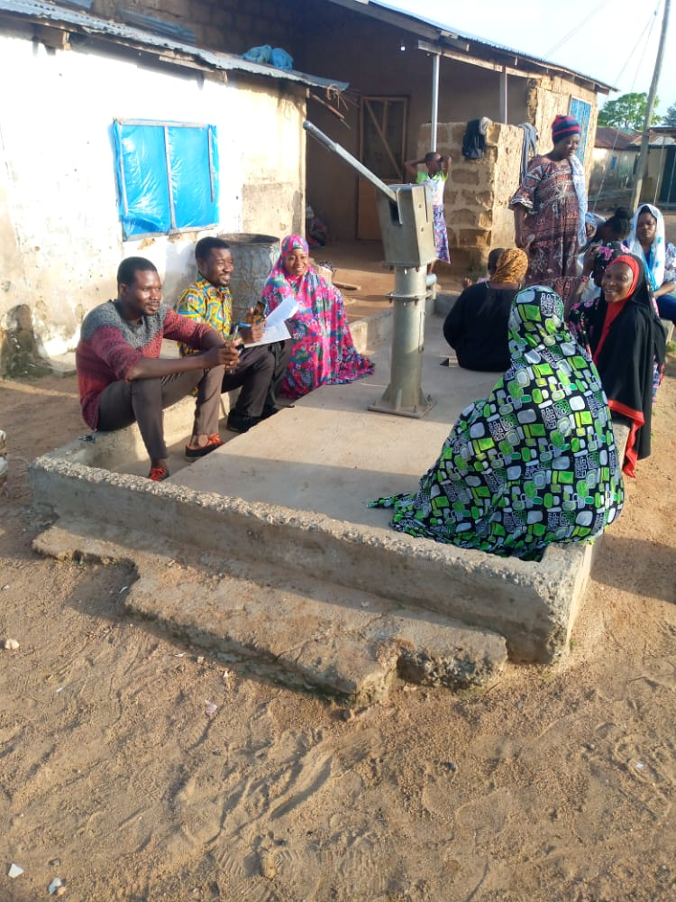
FGDs with Kambali Women

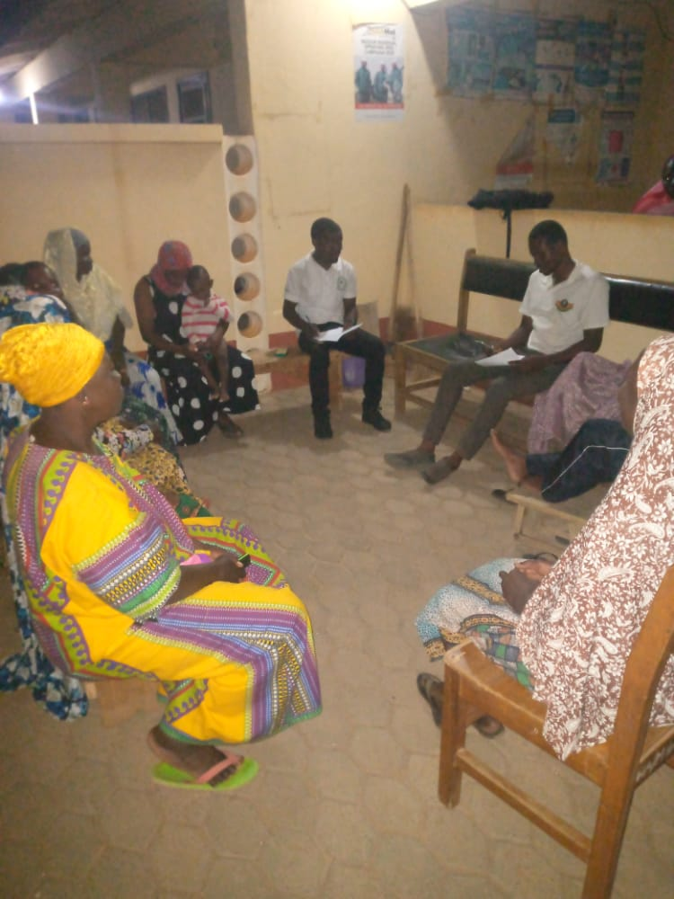
FGDs with Kumbiehi Women

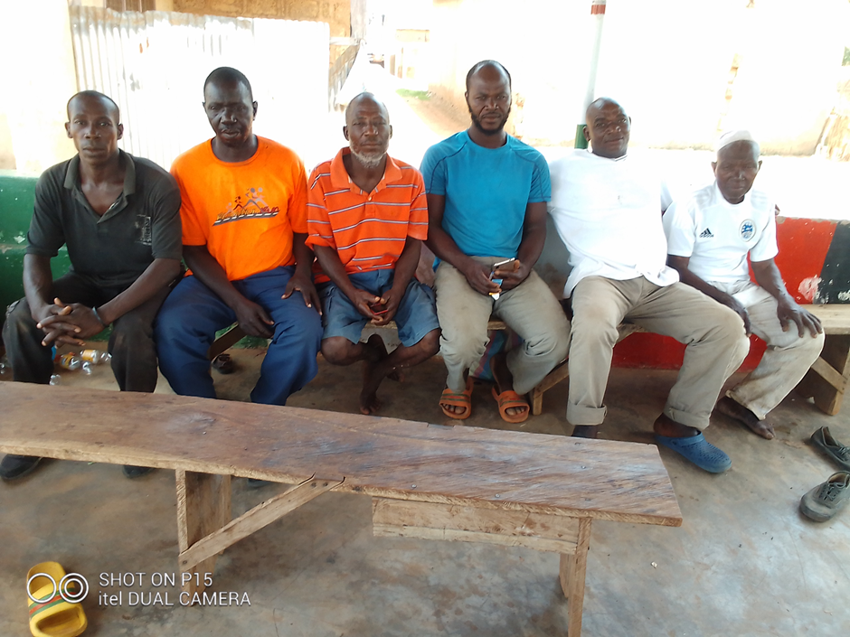
FGDs with Men at Kumbiehi

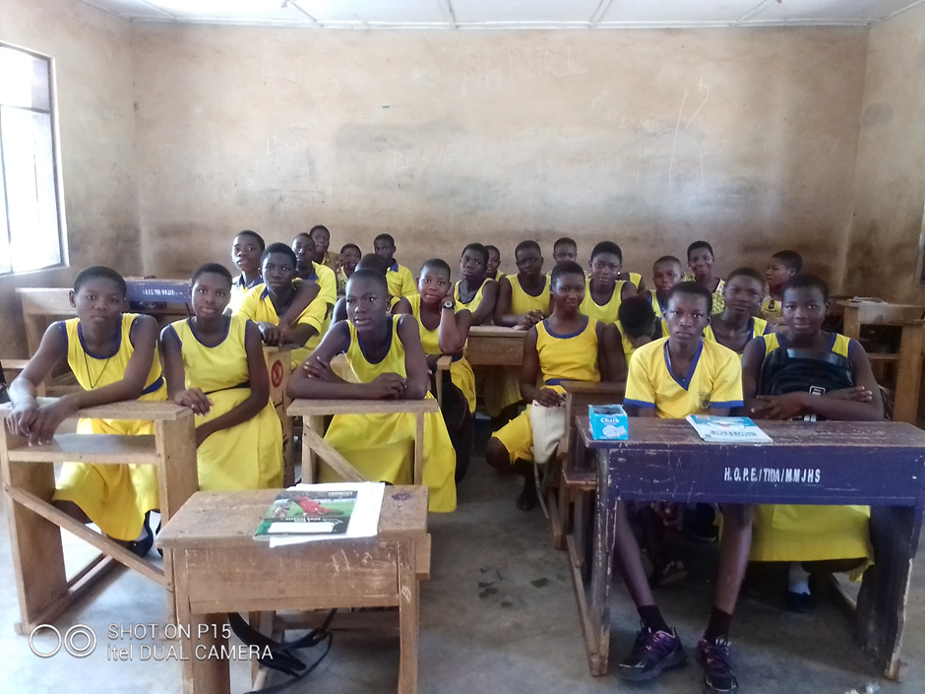
FGDs with Children

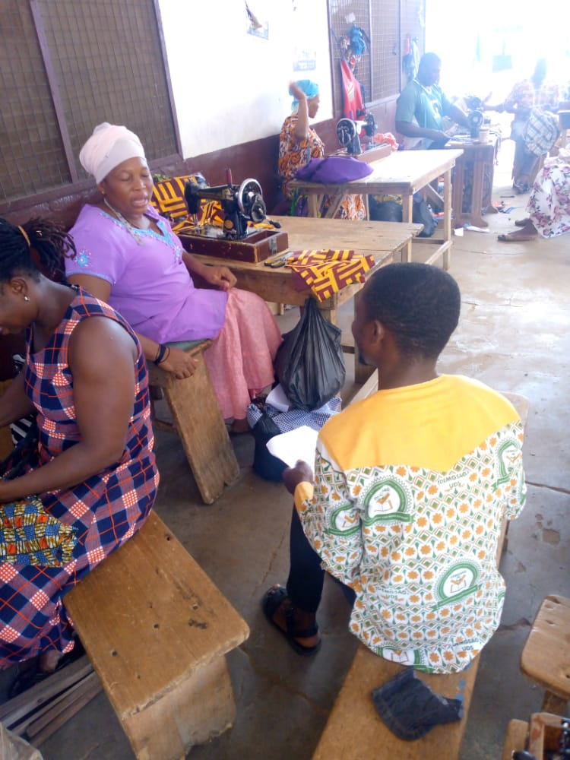
FGDs with the Physically Challenged

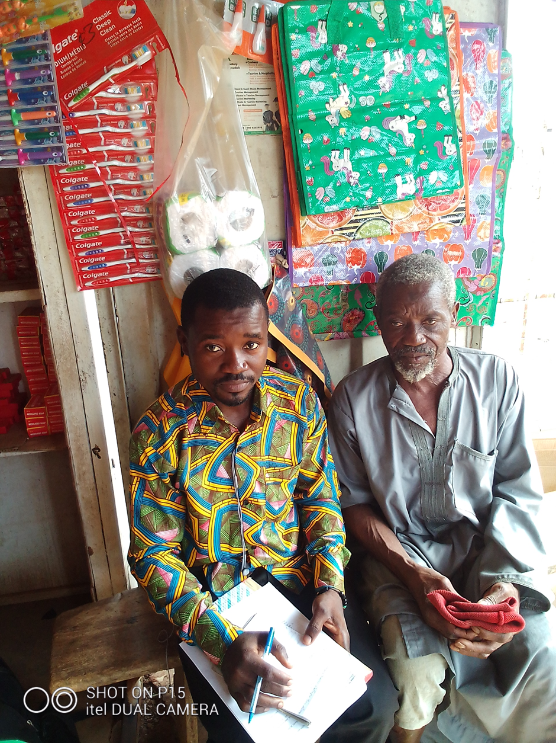
KIIs with Kumbiehi Naa (Chief)
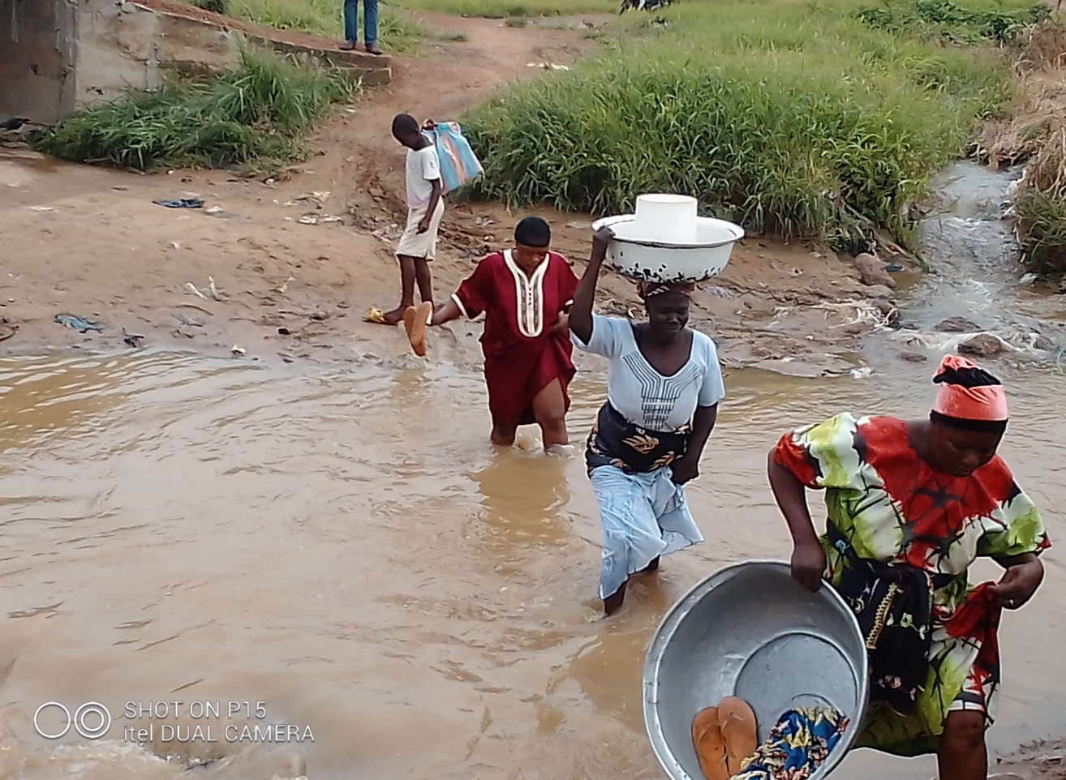
Market Women found it difficult to access road

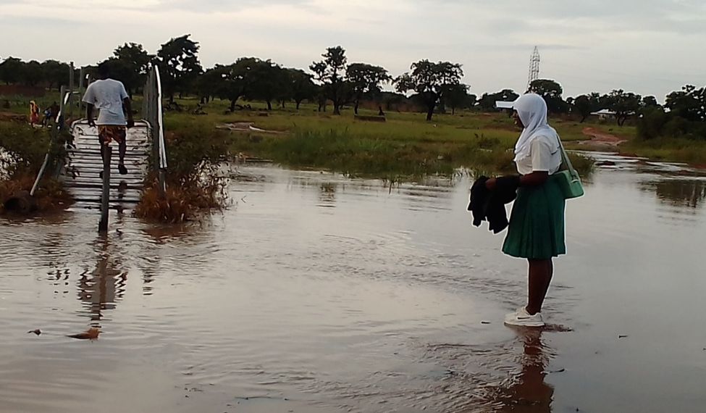
Effect on children

